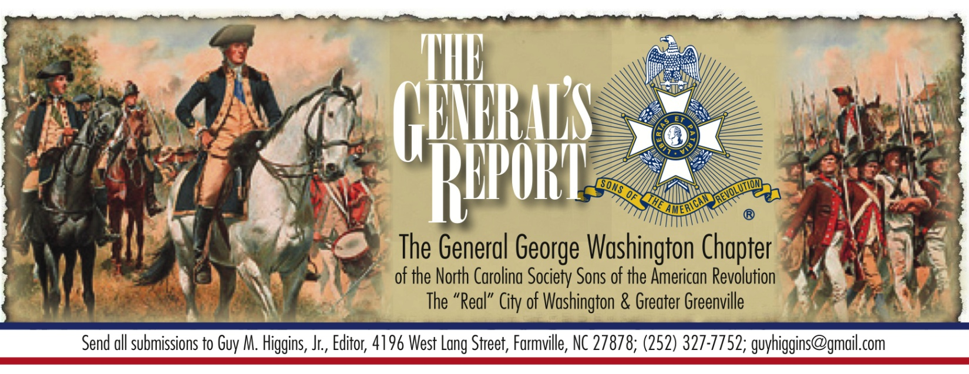 Volume 13, Issue 1 ncssargeorgewashington.org
January 2025

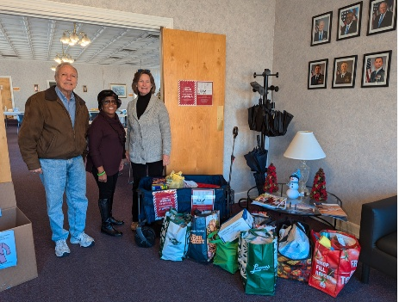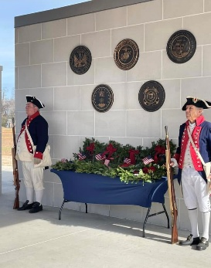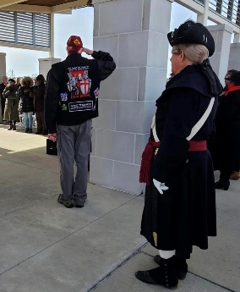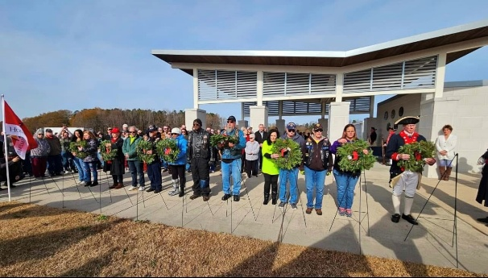
SJAFB Stocking Stuffer Delivery Wreaths Across America Honor Guard and wreath presentation.
Activity Report
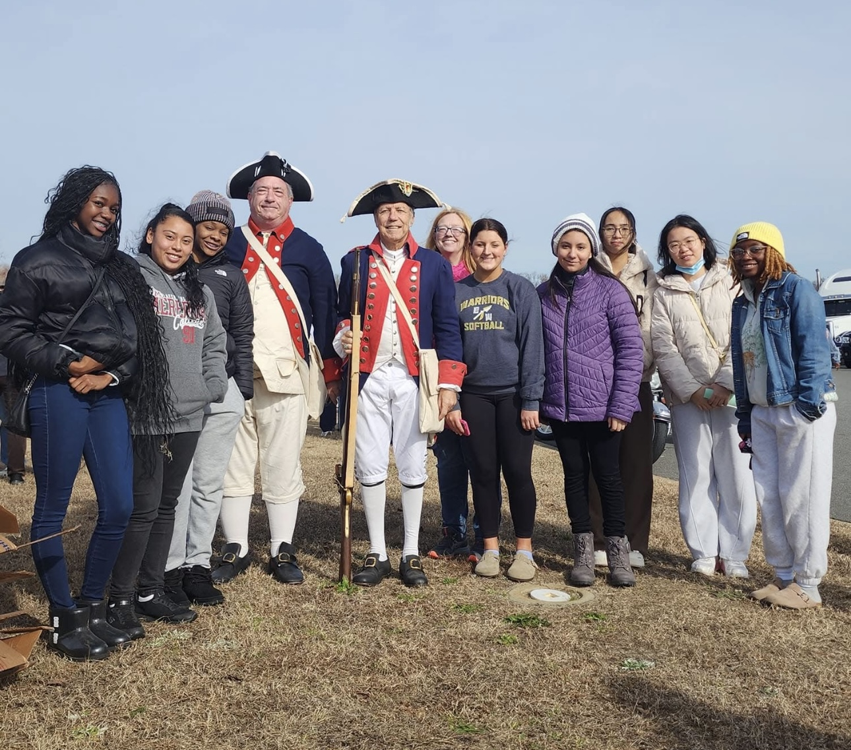
Eastern Wayne High School National Honor Society students

December is a month that is not very busy with two exceptions. For the second year I helped Valerie Howell of the Mosely-Bright Chapter, DAR deliver Stocking Stuffer Donations for the Airmen on Symour Johnson AFB. At mid month, we participate in the Wreaths Across America event at the Eastern Carolina State Veterans Cemetery. This year Broughton and I stood Honor Guard duty while Lynn and Gary presented the Merchant Marine wreath and led the other wreath presenters to ther spots. Following the ceremony we placed wreaths on about 20 graves. While fininshing up the wreath laying, Broughton and I were asked to pose with the Eastern Wayne High School National Honor Society students that had participated. In return I gave them a short lesson on SAR activities as they relate to students.

We still have members who have not paid their dues for 2025 and will continue to receive checks or money orders for those who would like to remain active members and continue to honor and celebrate the sacrifices that were made for our country. It is especially important as we approach this milestone year of 2026 and the many commemorations and activities that will be available to participate in. Dues is $50 (National), $20 (State), and $20 (Chapter) for a total of $90. Youth dues is still $5 (Younger than 18 - National only). Please make your check out to “GGWC NCSAR” and mail them to Kenny Smith, 146 Slaney Loop, Winterville, NC 28590.

Our next meeting will be on Thursday, the 16th of January, at Greenville Church of God, 3105 S Memorial Dr., Greenville, NC,
at 7 PM, and on Zoom. A Zoom link was sent this morning, for those unable to attend in person. I look forward to seeing
everyone there,

George

Meeting Agenda – January 16, 2025

Call to Order: George Strunk

Invocation: George Strunk
Pledge of Allegiance: Don Bonham
SAR Pledge: Jerry Wilcox
Program: TBD
Possible Inductions of new members
Presentation of Awards
Treasurer Report: Kenny Smith ($1,352.27)
Business: Upcoming events and any other concerns for the group.
SAR Recessional: Stephen Elliott
Benediction: George Strunk

Last Meeting Minutes - 21 November 2024
The Chapter met on November 21st and the following were present: George Strunk, Steve Craig, Ron Jones, Doug Williams, Gerald Wilcox, Dave Hance, Michael Halley, Kenny Smith, Broughton Goodson, and Stephen Elliott. Guest: Chadwick Stokes. George opened the meeting, gave the Invocation and the pledges were recited. Kenny reported that our Bank Balance was $ 2134.27. With no nominations from the floor, the Chapter elected George Strunk to be President, Lynn Bull to be Vice President, Kenny Smith as Treasurer, Broughton Goodson as Color Guard Commander and Jerry Wilcox as Registrar. Kenny Smith was presented his 10 Year Membership Certificate. We discussed the success of the Caswell ceremony held on the 16th as well as other upcoming events. The SAR Recessional and Benediction ended the meeting.
Upcoming SAR events that might be of interest

Jan 16 General George Washington Chapter Meeting – 7 PM - 3105 S Memorial Dr., Greenville, NC
Feb 1 244th Battle of Cowans Ford – 9:00 AM - 10500 Beattie’s Ford Rd., Huntersville, NC
NC SAR Winter BOM – 11:30
Feb 7 Heroes of the Hornet’s Nest – Washington, Georgia
Feb 8 Battle of Kettle Creek – Washington, Georgia
Feb 20 General George Washington Chapter Meeting – 7PM –– 3105 S Memorial Dr., Greenville, NC
Feb 15 Crossing of the Dan- 10AM – 700 Bruce St., South Boston, VA
Feb 22 247th Anniversary of the Battle of Moore’s Creek – 10AM – Currie, NC
Feb 27-Mar 1 NSSAR Spring Leadership – Louisville, KY
Mar 14 245th Anniversary of the Battle of Guilford Courthouse – Greensboro, NC
Mar 20 General George Washington Chapter Meeting, Greenville 7 PM – 3105 S Memorial Dr., Greenville, NC
Apr 4-5 NC State Annual Meeting - TBD, Greensboro, NC
Apr 12 Halifax Resolves – Halifax, NC
Apr 17 General George Washington Chapter Meeting – 7 PM 3105 S Memorial Dr., Greenville, NC
May 15 General George Washington Chapter Meeting – 7 PM 3105 S Memorial Dr., Greenville, NC

May 17 Patriots Day in Alamance County – Alamance Battleground, Burlington, NC
May 20 246th Anniversary of the Mecklenburg Declaration – Charlotte, NC

May 26 Memorial Day
Jun 14 Flag Day
Jun 14 Liberty Point Resolves – Fayetteville, NC
Jun 19 General George Washington Chapter Meeting– 7 PM 3105 S Memorial Dr., Greenville, NC
Jun 21 244th Anniversary of the Battle of Ramsour’s Mill – Lincolnton, NC
Jun 22 Liberty Point Resolves – Fayetteville, NC
July 4th Independence Day
Jul 11-18th SAR National Congress – Uncasville, CT
Jul 24 General George Washington Chapter Meeting – 7 PM 3105 S Memorial Dr., Greenville, NC
Jul 26 Battle of Colson’s Mill – Norwood, NC
Aug 2 Battle of Rockfish – Wallace, NC
Aug 9 Battle of House in the Horseshoe – Sanford, NC
Aug 9 Battle of Blue Licks Memorial Ceremony – Carlisle, KY
Aug 16 NC SAR Summer BOM – UNC Club, 4200 Hillsborough St., Raleigh, NC
Aug 21 General George Washington Chapter Meeting– 7 PM 3105 S Memorial Dr., Greenville, NC
Aug 23 New Bern Resolves, Christ Episcopal Church, New Bern 10 AM
Aug 27 Battle of Elizabethtown –
Sep 20 Washington’s Tomb Vigil – Mt. Vernon, VA
Sep 18 General George Washington Chapter Meeting– 7 PM 3105 S Memorial Dr., Greenville, NC
Oct 2 Fall Leadership – Louisville, KY
Oct 4 Anniversary of the Crossing of the Catawba River – Greenlee Ford, NC
Oct 7 244th Anniversary of the Battle of Kings Mountain – Gafney, SC
Oct 7 2-4 PM South Atlantic District Meeting – Gafney, SC
Oct 11 245th Anniversary of the Battle of Shallow Ford – Huntsville, NC
Oct 16 General George Washington Chapter Meeting– 7 PM 3105 S Memorial Dr., Greenville, NC
Oct 17 Victory at Yorktown – Yorktown, VA
Nov 11 Veterans Day – Goldsboro Veterans Memorial Park, Goldsbooro, NC 11:00 AM
Nov 15 Caswell Commemoration – Kinston, NC 11:00 AM
Nov 21 General George Washington Annual Meeting – 6 PM 3105 S Memorial Dr., Greenville, NC
Dec 14 Wreaths Across America 11 AM – Eastern Carolina State Veterans Cemetery, 164 Longs Plant Farm Road., Goldsboro.
Jan 18 Battle of Cowpens – 12:30 – 4001 Chesnee Hwy, Gaffney, SC

