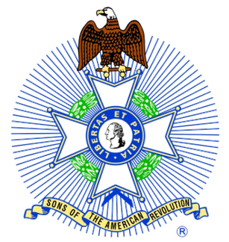
BLUE RIDGE CHAPTER NCSSAR MEMBERSHIP MEETING
SATURDAY 08 JUNE 2024 @ 11:00 AM (10:30 FOR LUNCH)
J & S CAFETERIA, 800 FAIRVIEW ROAD, ASHEVILLE, NC 28803
AGENDA
CALL TO ORDER: PRESIDENT STEVE GREENE
INVOCATION: CHAPLAIN TOM RIGHTMYER
PLEDGE TO AMERICAN FLAG: CRAIG ISAACISON
SAR PLEDGE: RON HILLABRAND
INTRO OF GUEST BY STEVE GREENE/ABOUT THE AUTHOR: ROBERT BROWN, JR.
Over the years he has been fortunate to be published in the history and education fields. “KINGS MOUNTAIN AND COWPENS: OUR VICTORY WAS COMPLETE” has been in print with History Press since 2009. “CLASSROOM HISTORIANS: BUILDING STUDENT UNDERSTANDING OF THE PAST” was published in 2011 by the American Institute for History Education. In addition, He has authored chapters on “NORTH CAROLINA IN THE COLONIAL ERA AND IN THE CIVIL WAR AND RECONSTRUCTION” for McGraw-Hill’s The American Journey.
He is a local historian from Hickory, history education specialist, and former high school history teacher. Robert graduated with a degree in History from UNC-Charlotte and received his National Board for Professional Teaching Standards certification. He has been involved in education since 1994 as a teacher, administrator, college instructor, and coach. This past spring he was the interim principal at Hickory High School. He has twice been named a Time-Warner Cable Star Teacher, and as the Daughters of the American Revolution, History Teacher of the Year for North Carolina in 2001. Robert has written three successful Teaching American History grants for Cleveland County Schools in Shelby, North Carolina, and has consulted with more than thirty school districts around the country on their applications. He has also taught as an adjunct instructor for Cleveland Community College and Gardner-Webb University. For three years he was the Professional Development Coordinator for the American Institute for History Education in New Jersey and am a National Board-Certified teacher in social studies/history. He has two Masters of Arts degrees — one in history from the University of Nebraska at Kearney and the other in school administration from Gardner-Webb University.
YOU WILL NOT WANT TO MISS THIS HISTORIC PRESENTATION!!

- MINUTES OF 08 MAY2024 MEMBERSHIP MEETING---PAUL GRASS
- TREASURERS REPORT…TREASURER RON HILLABRAND
- REGISTRAR UPDATE…MIKE BURKHART
- MEMBERSHIP COMMITTEE CHAIRMAN…VACANT
- COLOR GUARD UPDATE…COMMANDER GARRY LINTON
- GRAVE MARKING…CRAIG ISAACSON
- AMERICANISM/FLAG COMMITTEE…CHAIRMAN CLARENCE ROGERS,
- EDUCATION COMMITTEE…CHAIRMAN GARRY LINTON/RON CHAPMAN
- JROTC COMMITTEE…CHAIRMAN LARRY CHAPMAN
- AWARDS COMMITTEE…CHAIRMAN LANCE DICKINSON
- CHAPTER HISTORIAN…KEN WEGLARZ
- CHAPTER GENEALOGIST…JOHN ROPER
OLD BUSINESS: OPEN DISCUSSION
- Need for Chapter Treasurer
- Need for Membership Committee Chairman
- Need for Assistants/Back-ups to various officers and committee chairmen.
- Update on outreach trifold brochure with information about our chapter.
NEW BUSINESS: OPEN FOR DISCUSSION
- Aug 10 chapter membership meeting- need a committee to plan, organize, make necessary arrangements…for a casual social BBQ event & covered dish (with no other or very few agenda items otherwise) at the Mills River Park pavilion to strengthen our connections…family fun and fellowship!
- 29 chapters/1334 members... recruit, retain, reinstate.

UPCOMING EVENTS:
- June 4: Madison County Genealogical Society Rev War Presentation by Garry Linton & Craig Isaacson (Location Mars Hill Public Library @ 6:00 pm)
- July 4: Henderson County Historical Society 4th of July Parade and dedication of Historical Marker, Hendersonville
- July 10: Executive Board Meeting (Location to be announced)
- September 17: Constitution Day, Hendersonville (in cooperation with DAR)
- September 20: Naturalization, Asheville Federal Courthouse. Color Guard muster time - 10:15 AM for an event start time of 11:00 AM
- Dec14 “Official Color Guard" for the Wreaths Across America event in Hendersonville, NC on Saturday.
- July, 2026: North Carolina Hosts the NSSAR Congress

EXECUTIVE BOARD MEETING WILL BE 10 JULY 2024 (LOCATION TO BE ANNOUNCED)
RECESSIONAL: KEN WEGLARZ
BENEDICTION: CHAPLAIN TOM RIGHTMYER
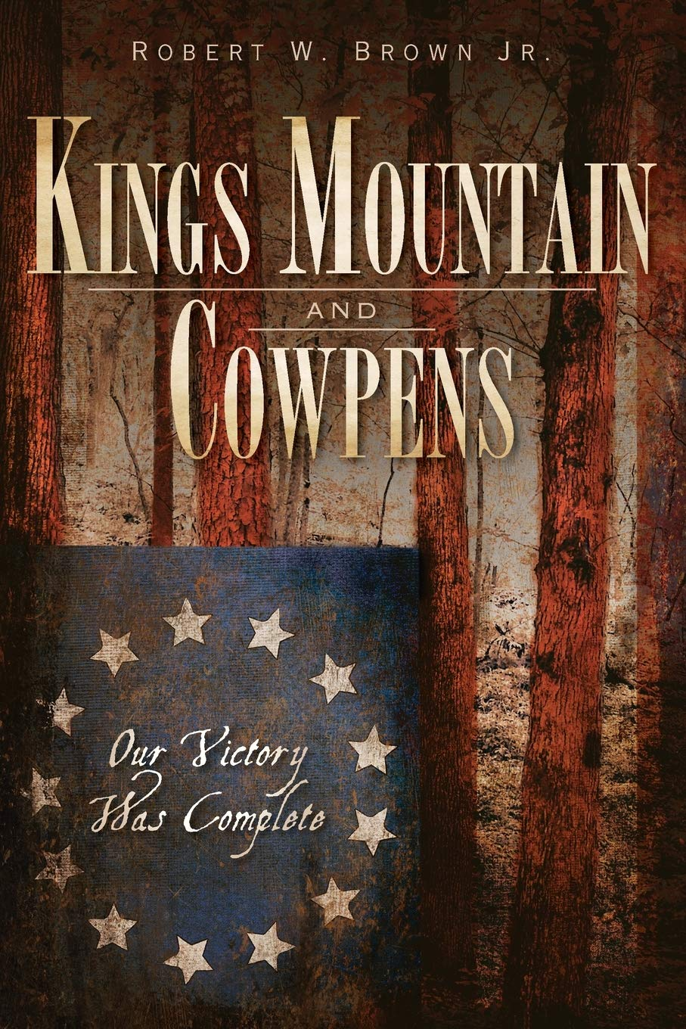
From the rocky slopes of Kings Mountain to the plains of Hannah s Cowpens, the Carolina backcountry hosted two of the Revolutionary War s most critical battles. On October 7, 1780, the Battle of Kings Mountain utilized guerilla techniques American Over Mountain Men wearing buckskin and hunting shirts and armed with hunting rifles attacked Loyalist troops from behind trees, resulting in an overwhelming Patriot victory. In January of the next year, the Battle of Cowpens saw a different strategy but a similar outcome: with brilliant military precision, Continental Regulars, dragoons, and Patriot militia executed the war s only successful double envelopment maneuver to defeat the British. Using firsthand accounts and careful analysis of the best classic and modern scholarship on the subject, historian Robert Brown demonstrates how the combination of both battles facilitated the downfall of General Charles Cornwallis and led to the Patriot victory in America."

