You are cordially invited to Celebrate
the Raleigh Chapter’s 96th Anniversary Banquet
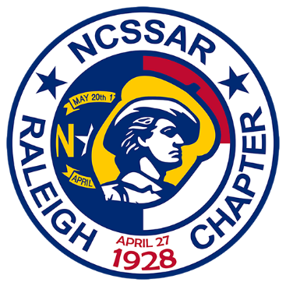
Saturday, April 27th, 2024
Reception 5:30PM-6:30PM
Dinner at 6:30PM
Winston’s Grille, 6401 Falls of Neuse Road, Raleigh, NC 27615
Cost: $75 per attendee
Dress: Business Casual, Suit, or Colonial Period Attire
Keynote Speaker: David Snyder and his first-person portrayal of Governor William Tryon
All patriotic organizations are invited!

Menu Choices: (each choice includes a salad, main course, desert, and non-alcoholic beverage
- London Broil: 7oz Marinated, flank steak, topped with mushroom demiglace, served with homemade mashed potatoes and sauteed vegetables.
- Rotisserie Chicken: herb seasoned, ½ rotisserie chicken, served with homemade mashed potatoes and collards.
- Shrimp & Grits: shrimp sauteed with tomatoes, shallots, shiitake mushrooms, basil, and applewood smoked bacon, served on a bed of creamy grits.
- Grilled Salmon: fresh grilled salmon, topped with a sherry tomato cream sauce, served on a bed of rice pilaf and sauteed vegetables.
- Triple Crown: beef tenderloin, shrimp, chicken, mushrooms, broccoli, peppers, and onions sauteed in a ginger teriyaki stir fry sauce over rice.
Please RSVP by April 7th, 2024
Name ________________________Chapter/Organization_______________________Title_____________________
Guest(s) ________________________________________________________________________________________
Meal Choice: (please circle your choice) 1. London Broil 2. Rotisserie Chicken 3. Shrimp & Grits 4. Grilled Salmon 5. Triple Crown
SAR____ DAR____ CAR ____ Other Organization _______________________________________________________
Amount enclosed ($75 per attendee): ______________________
(Make check payable to “Raleigh Chapter NCSSAR”)
Please mail RSVP with check to: Gary Spencer
5701 Timber Ridge Drive
Raleigh, NC 27609-4141
Or you can pay via PayPal, using the “Friends & Family” feature to Robert_Sigmon@yahoo.com
If you have any questions, please call Gary at: 919-749-7967 or email communications@sarraleigh.org

