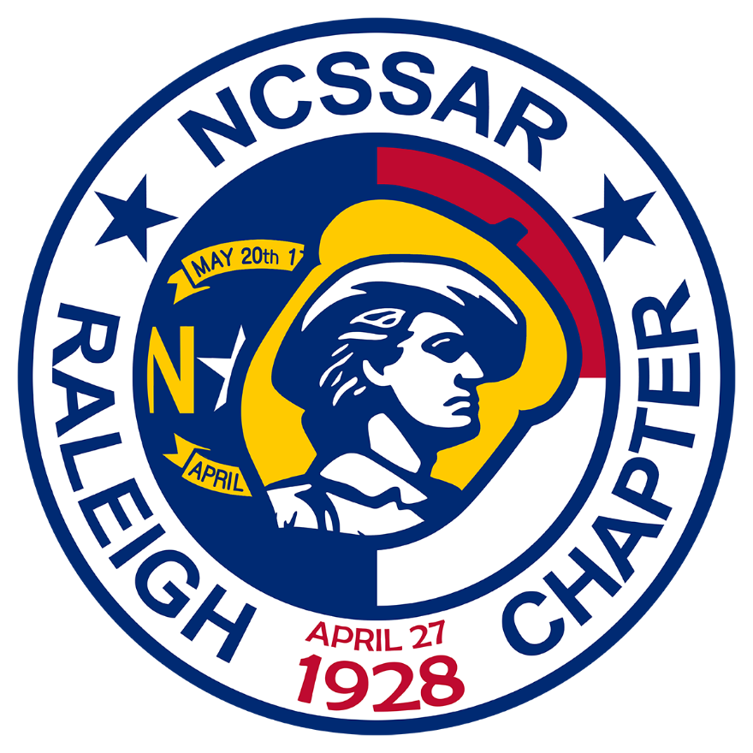
The Raleigh Chapter, Sons of the American Revolution
is inviting you to attend our Annual Picnic Gala!
This year, the picnic will be held on June 15th, at Lake Crabtree, 1400 Aviation Parkway, Morrisville, NC 27560, at high noon. This will be rain or shine, as this is a sheltered picnic area. There’s also a horseshoe pit beside it! We will be catered by the locally famous Sam Jones BBQ. Our Keynote speaker will be the renowned Chris Grimes, as he delves into medical practices of the Revolutionary Period, with his extensive collection of equipment. All members of Patriotic Societies are encouraged to participate, as well as any guests you wish to bring. Dress is casual.
Please RSVP by June 7th, 2024
Name ________________________Chapter/Organization_______________________Title_____________________
Guest(s) ________________________________________________________________________________________
SAR____ DAR____ CAR ____ Other Organization _______________________________________________________
Amount enclosed ($25 per attendee): ______________________
(Make check payable to “Raleigh Chapter NCSSAR”)
Please mail RSVP with check to: Gary Spencer
5701 Timber Ridge Drive
Raleigh, NC 27609-4141
Or you can pay via PayPal, using the “Friends & Family” feature to Robert_Sigmon@yahoo.com
If you have any questions, please call Gary at: 919-749-7967 or email communications@sarraleigh.org

