Jack Castleberry, BSA Troop # 7, Awarded the SAR Eagle Scout Medal and Certificate
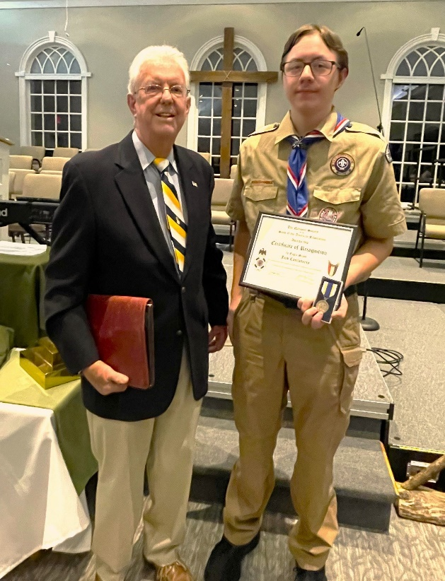
(L-R) Sandhills SAR Compatriot Steve Lawrence, Eagle Scout Jack Castleberry
On January 23rd, Sandhills SAR Chapter, BSA Eagle Scout Committee Chairman, Steve Lawrence,
attended the Troop# 7 Honor Court in Pinehurst, NC to present Jack Castleberry of Pinehurst
with the Sons of the American Revolution Eagle Scout Medal and Certificate for his
outstanding achievement of completing his path to the Eagle Scout. Only 2 to 8% of the youth entering
the Scouting Program will complete the path to Eagle Scout.
Jack’s Eagle Scout project included planning, fundraising, and constructing an amphitheater near the Weymouth Woods Visitors Center for the purpose of holding outdoor nature classes at the Sandhills Nature Preserve.
Jack is currently attending the Sandhills Community College and is the son of Cal and Melisa Castleberry of Pinehurst, NC.

