Sandhills SAR Chapter Recognizes Two Eagle Scouts with Medals and Certificates

Sandhills Chapter Compatriots, Bruce Fensley – President and Eagle Scout Committee Chairman- Steve Lawrence attended two Boy Scout Honor Courts to present the Sons of the American Revolution Eagle Scout Medals and Certificates to recognize the Outstanding achievement of two Moore County Boy Scouts.

Both Eagle Scout Projects involved Community Service improvements to both their neighborhoods.

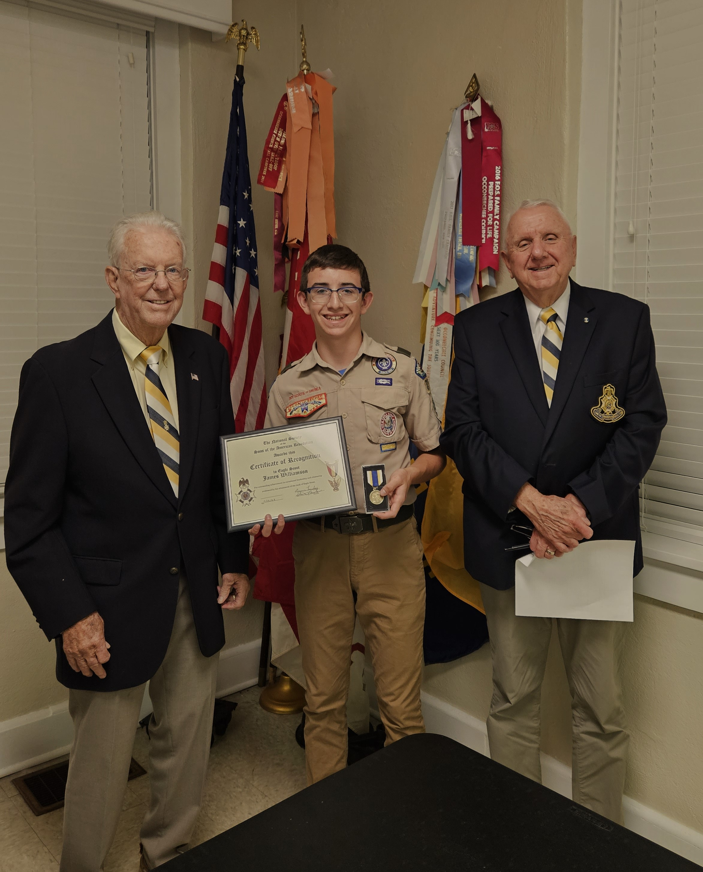
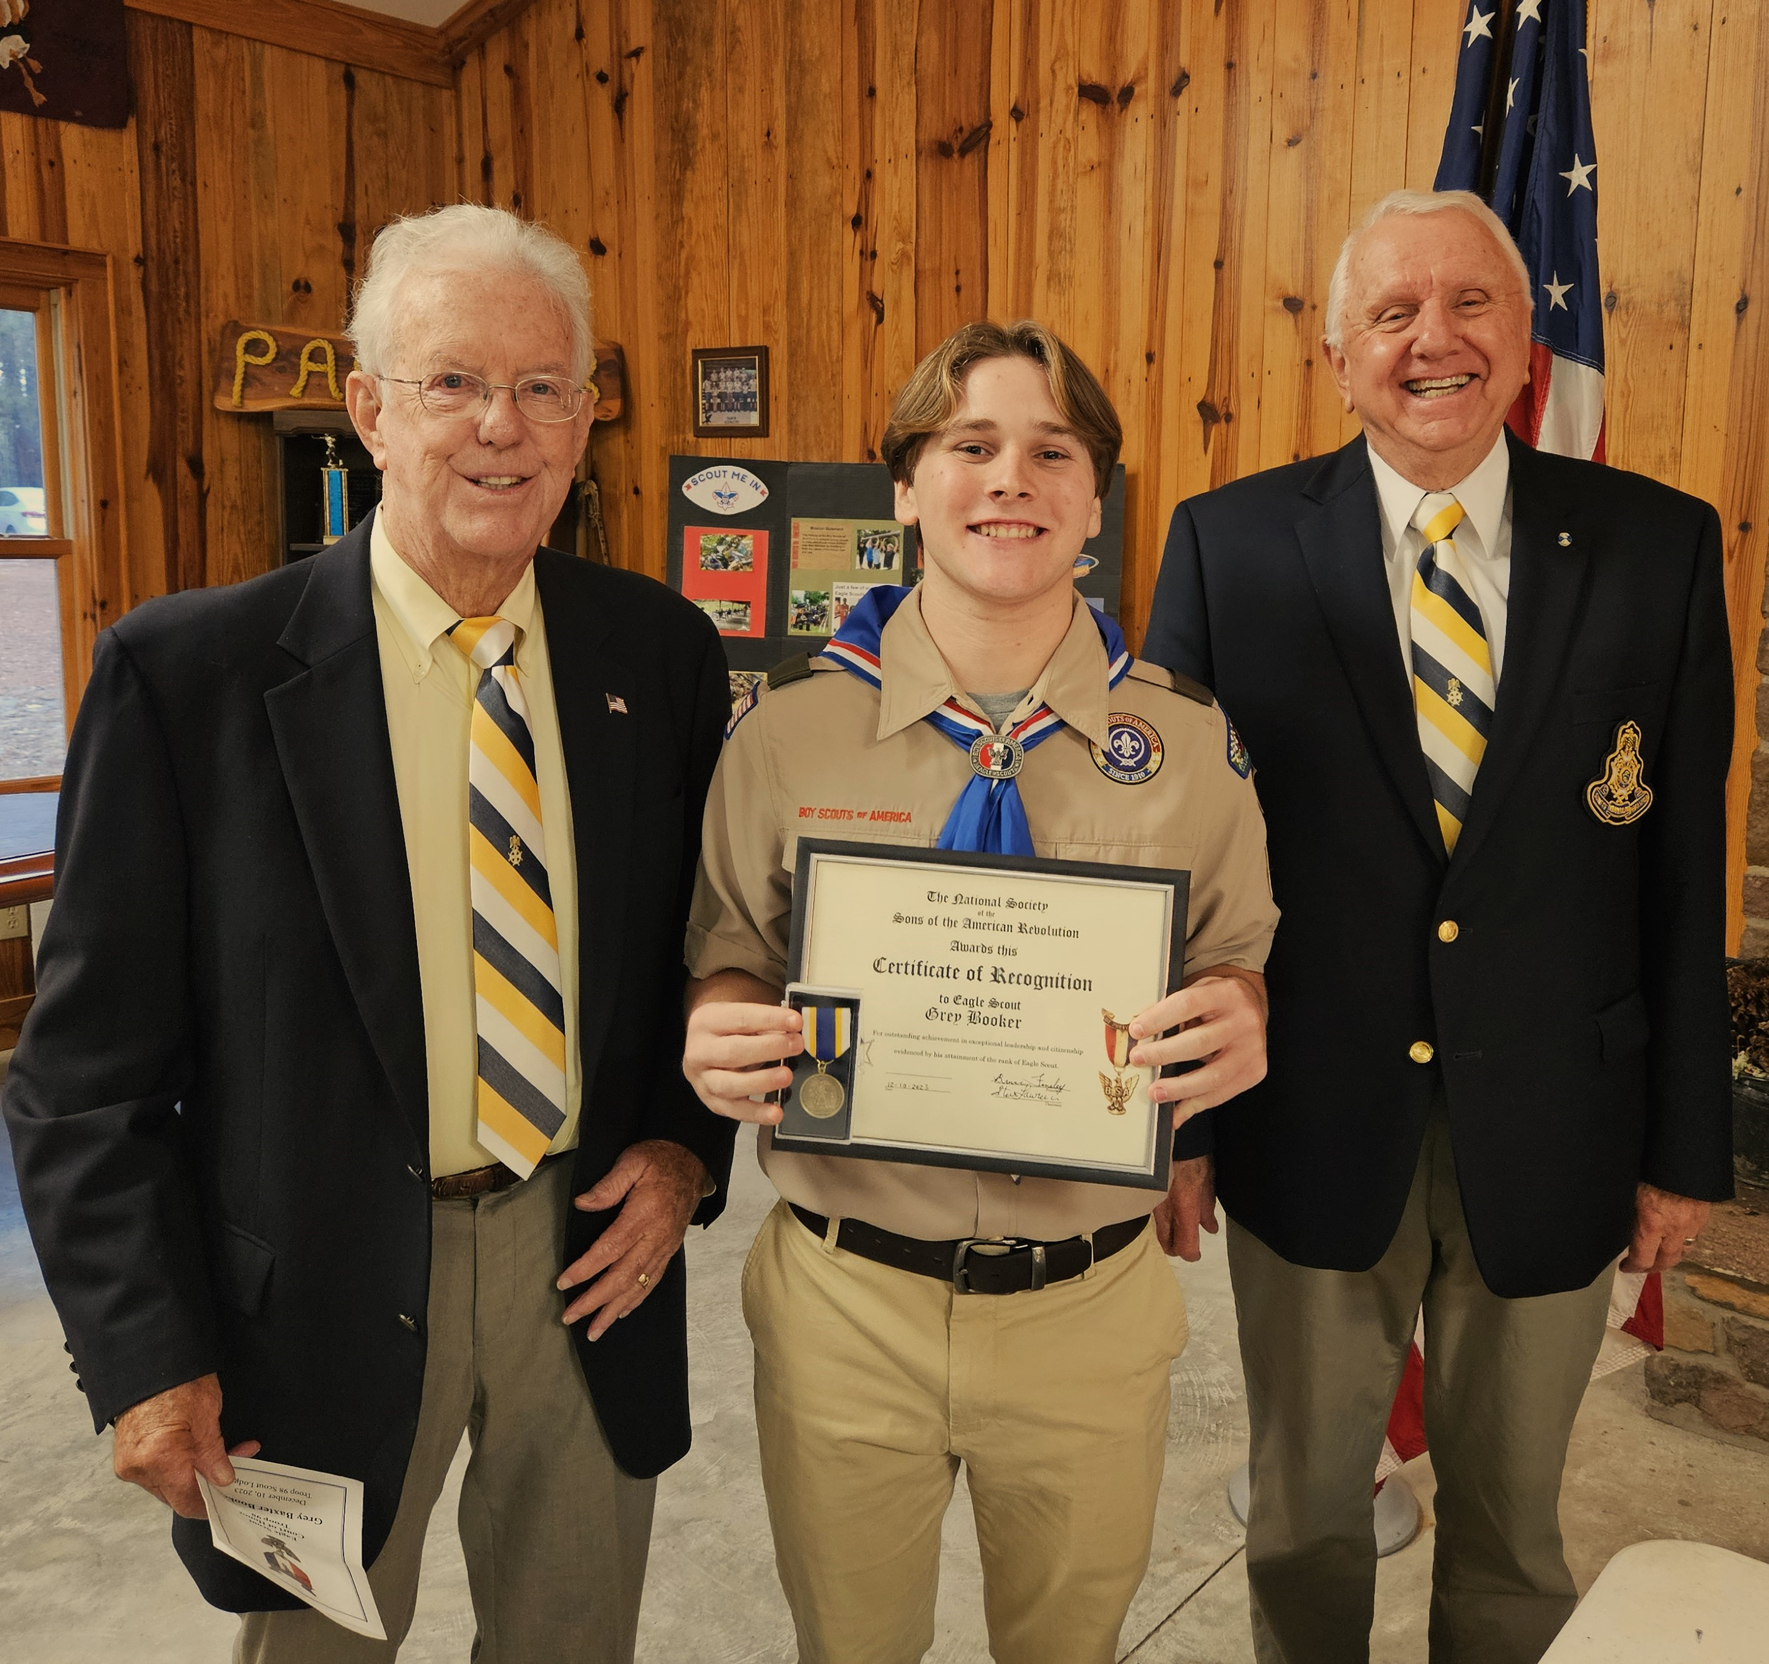

Left - Right- SAR Compatriot Steve Lawrence Left - Right – SAR Compatriot Steve Lawrence,
Eagle Scout –James Williamson of Troop 880 Eagle Scout – Grey Booker – Troop 98 - West
Aberdeen, SAR Compatriot Bruce Fensley End, SAR Compatriot Bruce Fensley

