Memorial Day Observance Service Pinehurst Village Chapel

Members of the Sandhills Chapter MOAA and the SAR Chapter joined together on Monday May 29, 2023 to conduct the 2023 Memorial Day Observance Service at the Pinehurst Village Chapel. MOAA President, Army COL (Ret) Don Goss led the Patriotic Program that included; Bagpiper Peter McArthur, 82nd ABN Brass Quintet, Sandhills SAR Color Guard Presentation, and "God Bless America '' sung by the Golf Capital Chorus. Rev. Trey Majure delivered the Invocation and the Benediction.

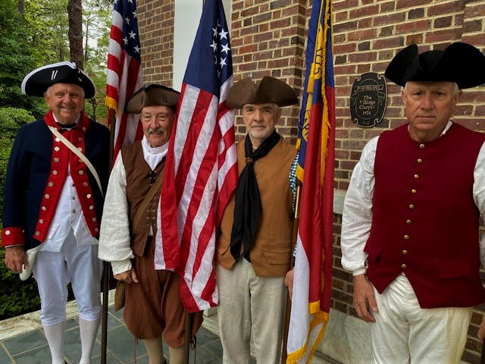
(L to R) Sandhills Chapter Color Guard Compatriots, Bruce Fensley, Bill Loeser, Ramsey Blanks,
and Steve Gent served as the Color Guard.

Army Major Gen.(Ret) Hugh Van Roosen, of Whispering Pines, was the Keynote Speaker and emphasized keeping alive the Memory and Honoring The veterans that have served Our Country for nearly 250 years.
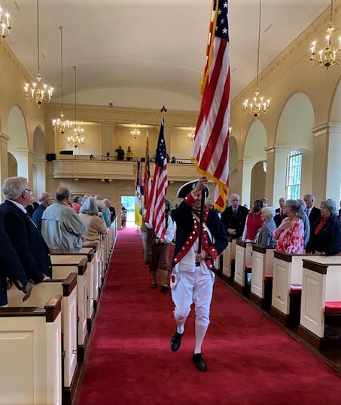

See the link below to the Pilot Newspaper article for more details and pictures.
https://www.thepilot.com/gallery/moaa-memorial-day-celebration/collection_b8e5ecb2-fece-11ed-b04f-3357483c6f18.html

