Sandhills Chapter SAR Public Service Award - Southern Pines Law Enforcement

On March 15, 2023- Sandhills Chapter Vice President and Public Service Committee Co-Chairman Mike Saulnier and Compatriot Rod Herbig attended a Law Enforcement Awards Ceremony at the Southern Pines Police Station. Patrolman Wessman was presented with the SAR Law Enforcement Medal and Certificate.

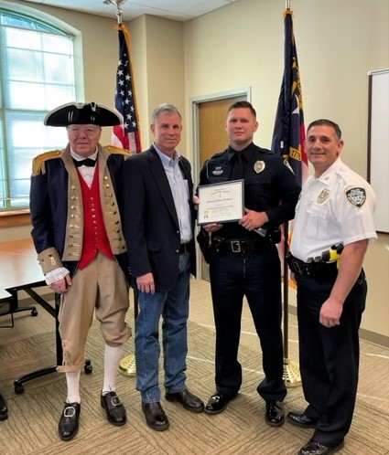

(L-R) Rod Herbig, Mike Saulnier, Officer Steven Wessman, Southern Pines Police Chief, Nicholas Poidori

Officer Wessman is being recognized for being a proactive officer, who has been awarded the Employee of the Quarter Award in the First Quarter of 2021 and the Second Quarter of 2022. In each award description, his supervisor recognized the impact of Officer Wessman’s work on the drug enforcement activities. Officer Wessman has a strong desire to be involved in community policing activities and to stay motivated with proactive policing efforts. Officer Wessman was also awarded with the Southern Pines Police Department Life Saving Medal in April of 2021, for helping save the life of a person who was experiencing a drug overdose.

