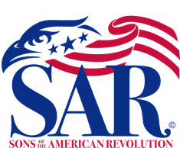

Sandhills Chapter Monthly Meeting at the Pinehurst Village Chapel in Pinehurst, NC.

The March 21, 2023 meeting speaker was Union Pines JROTC Program – Naval Cadet LCDR McKylee Wilkerson

Cadet Wilkerson gave an excellent PowerPoint presentation to inform our Compatriots about the Union Pines JROTC Program; Objectives, Goals, Awards, and unit accomplishments. Cadet Wilkerson has received an appointment to West Point, for the fall of 2023. Sandhills Chapter Vice President, COL (Retired) Mike Saulnier, presented Cadet Wilkerson with a SAR Certificate of Appreciation. LTC USN (Retired) Timothy Winn, Union Pines JROTC Branch Commander accompanied Cadet Wilkerson at our meeting.
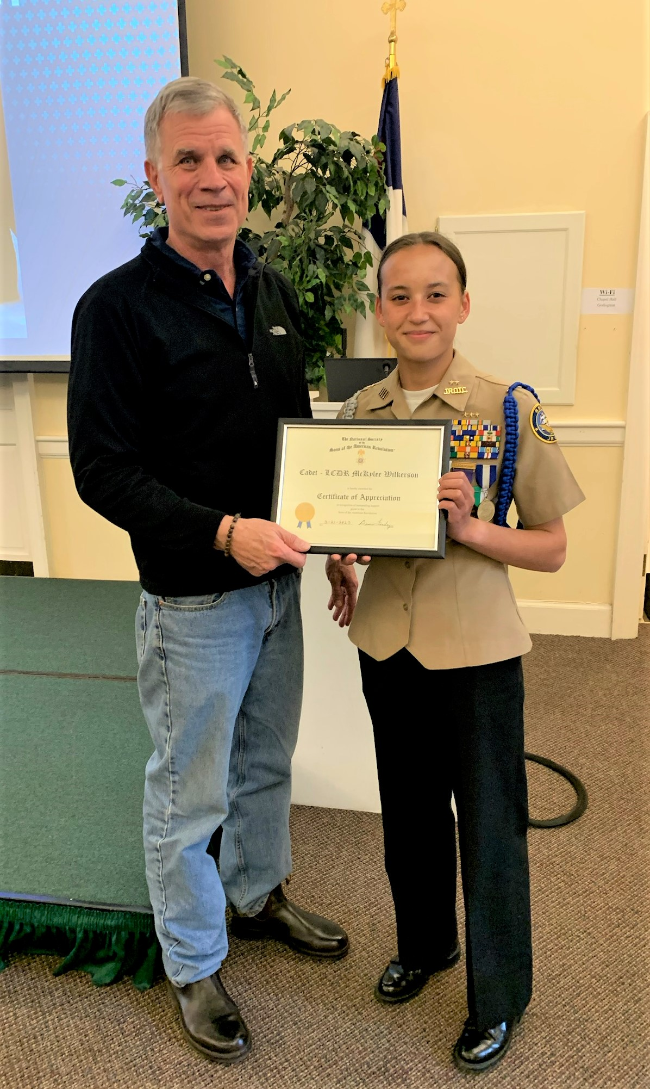

Sandhills Chapter Vice President, Mike Saulnier and Union Pines JROTC Cadet McKaylee Wilkserson

