Sandhills Chapter SAR Public Service Awards – Pinehurst Fire Department

On March 28, 2023, Sandhills Compatriots; Mark Townsend and Mike Saulnier (Public Service Committee Chairmen), Rod Herbig, and Bruce Fensley were invited to the Pinehurst Village Council Meeting, by Pinehurst Fire Chief – Carlton Cole, to present the SAR Public Service Awards to outstanding Pinehurst Fire Department employees.
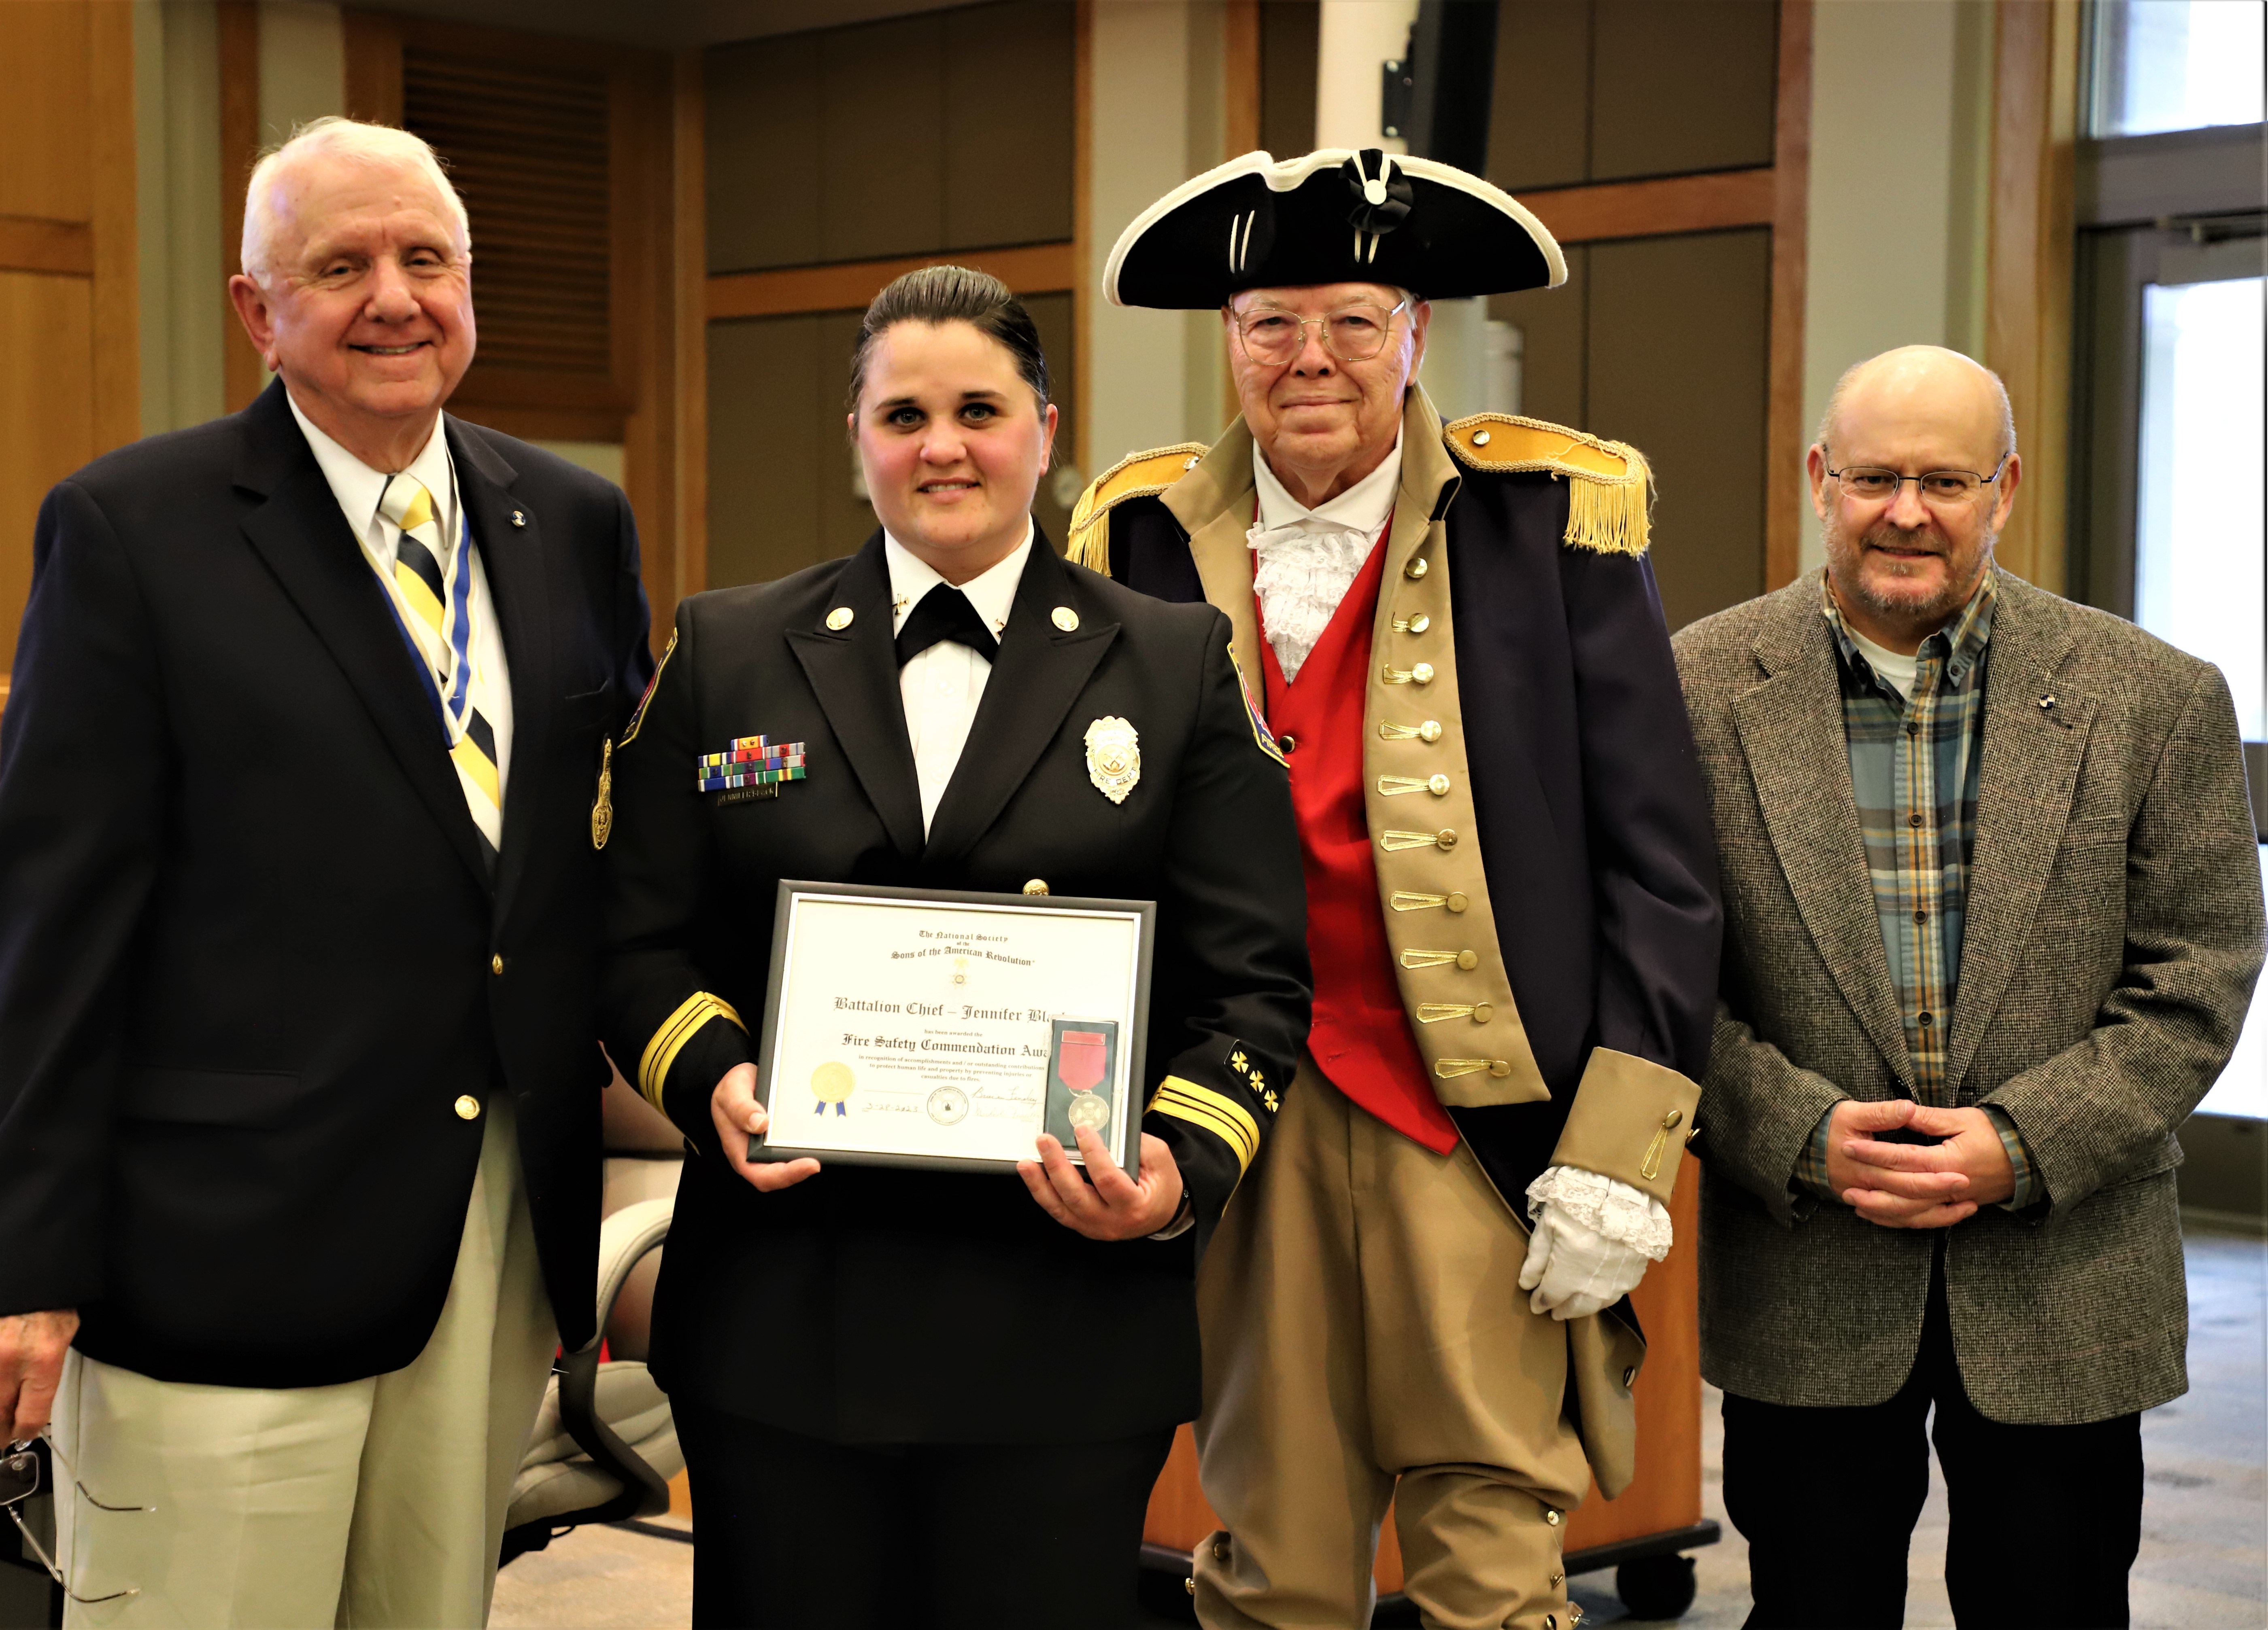

(L to R) Bruce Fensley, Battalion Chief Jennifer Black – SAR Fire Prevention Medal, Rod Herbig, Mark Townsend

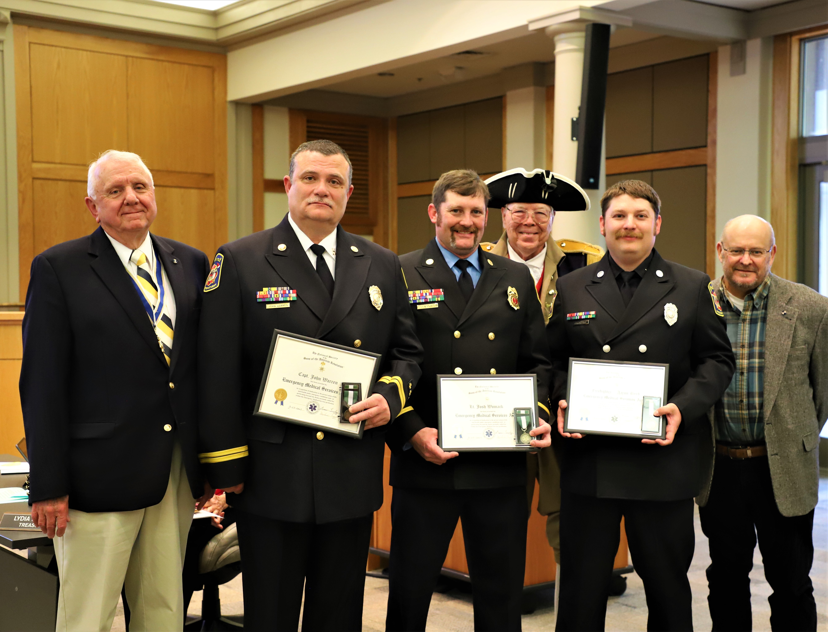

(L to R) Bruce Fensley, CPT. John Warren, LT. Josh Womack, Fireman Aaron Byrd – All SAR Emergency Medical Services Medal recipients, Rod Herbig, and Mark Townsend. Mike Saulnier – Not Pictured

