250th Birthday Celebration held at The Alston House (House In The Horseshoe)

On March 25, 2023, The Sandhills SAR Chapter Color Guard joined with the Daughters of the Alfred Moore DAR Chapter and members of the Alston House Association to participate in the 250th Birthday Celebration held at The Alston House (House In The Horseshoe) in Sandford, NC.

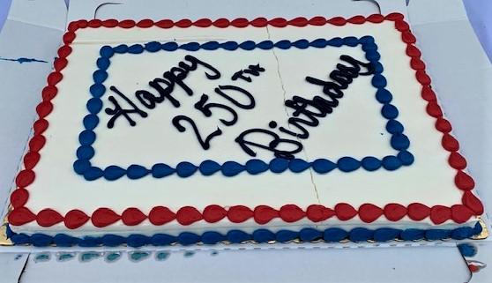

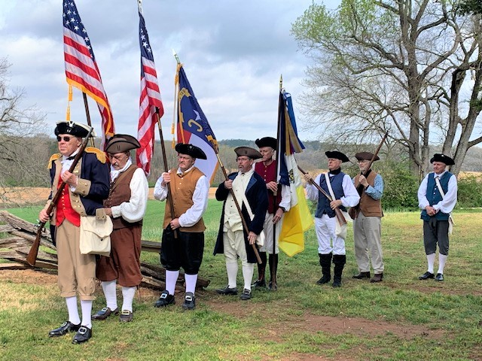

Color Guard Members (L to R). Rod Herbig, Bill Loeser, Mark Townsend, Victor Burns,
Steve Gent, Jack Laflin, Ramsey Blanks, Bruce Fensley.
