The 241st Anniversary of the Guilford Courthouse Battle (National Event)

On 3/15/23 Sandhills Chapter Compatriots; Victor Burns, Bruce Fensley, Steve Gent, Jack Laflin, and Bill Loeser attended the 241st Anniversary Ceremony of the Guilford Courthouse Battle in Greensboro, NC to present a Memorial Wreath and participate in the National Color Guard Unit.
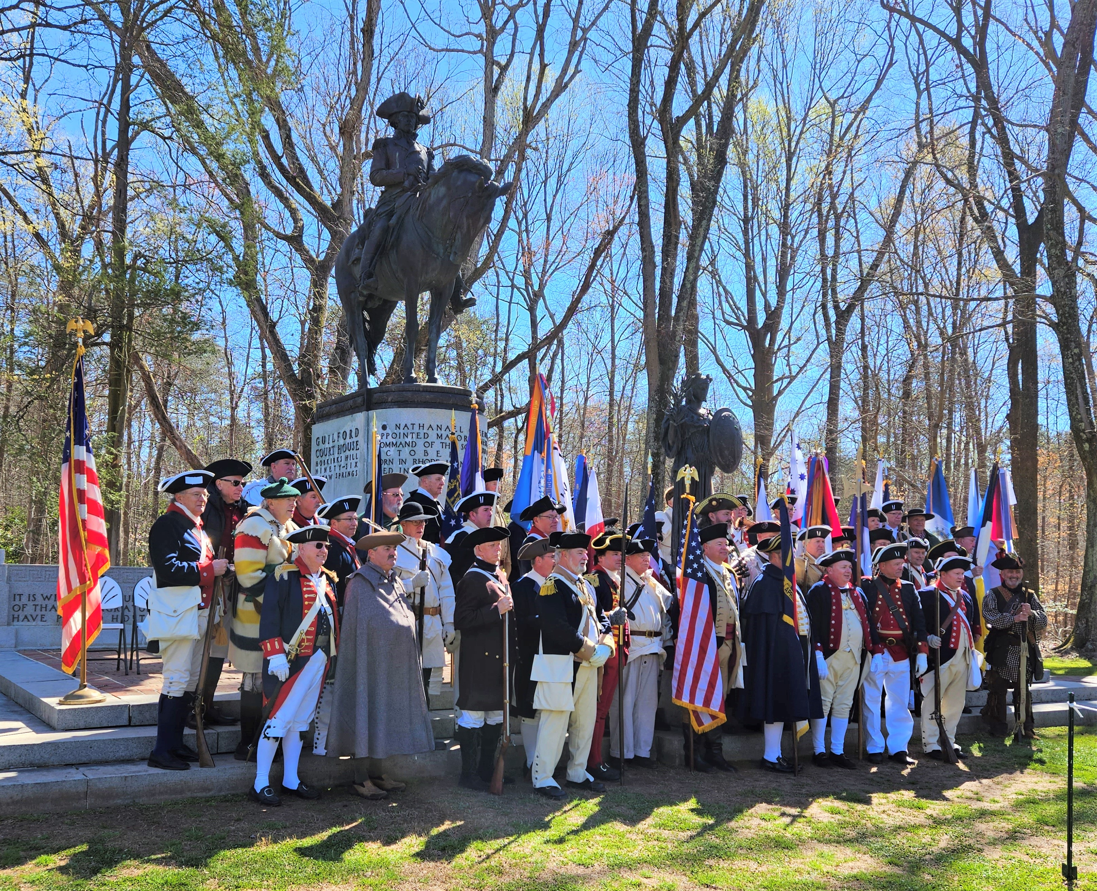

The Members of the NSSAR National Color Guard Unit
