Sandhills SAR Chapter – 2-21-23
George Washington’s Birthday Dinner Meeting
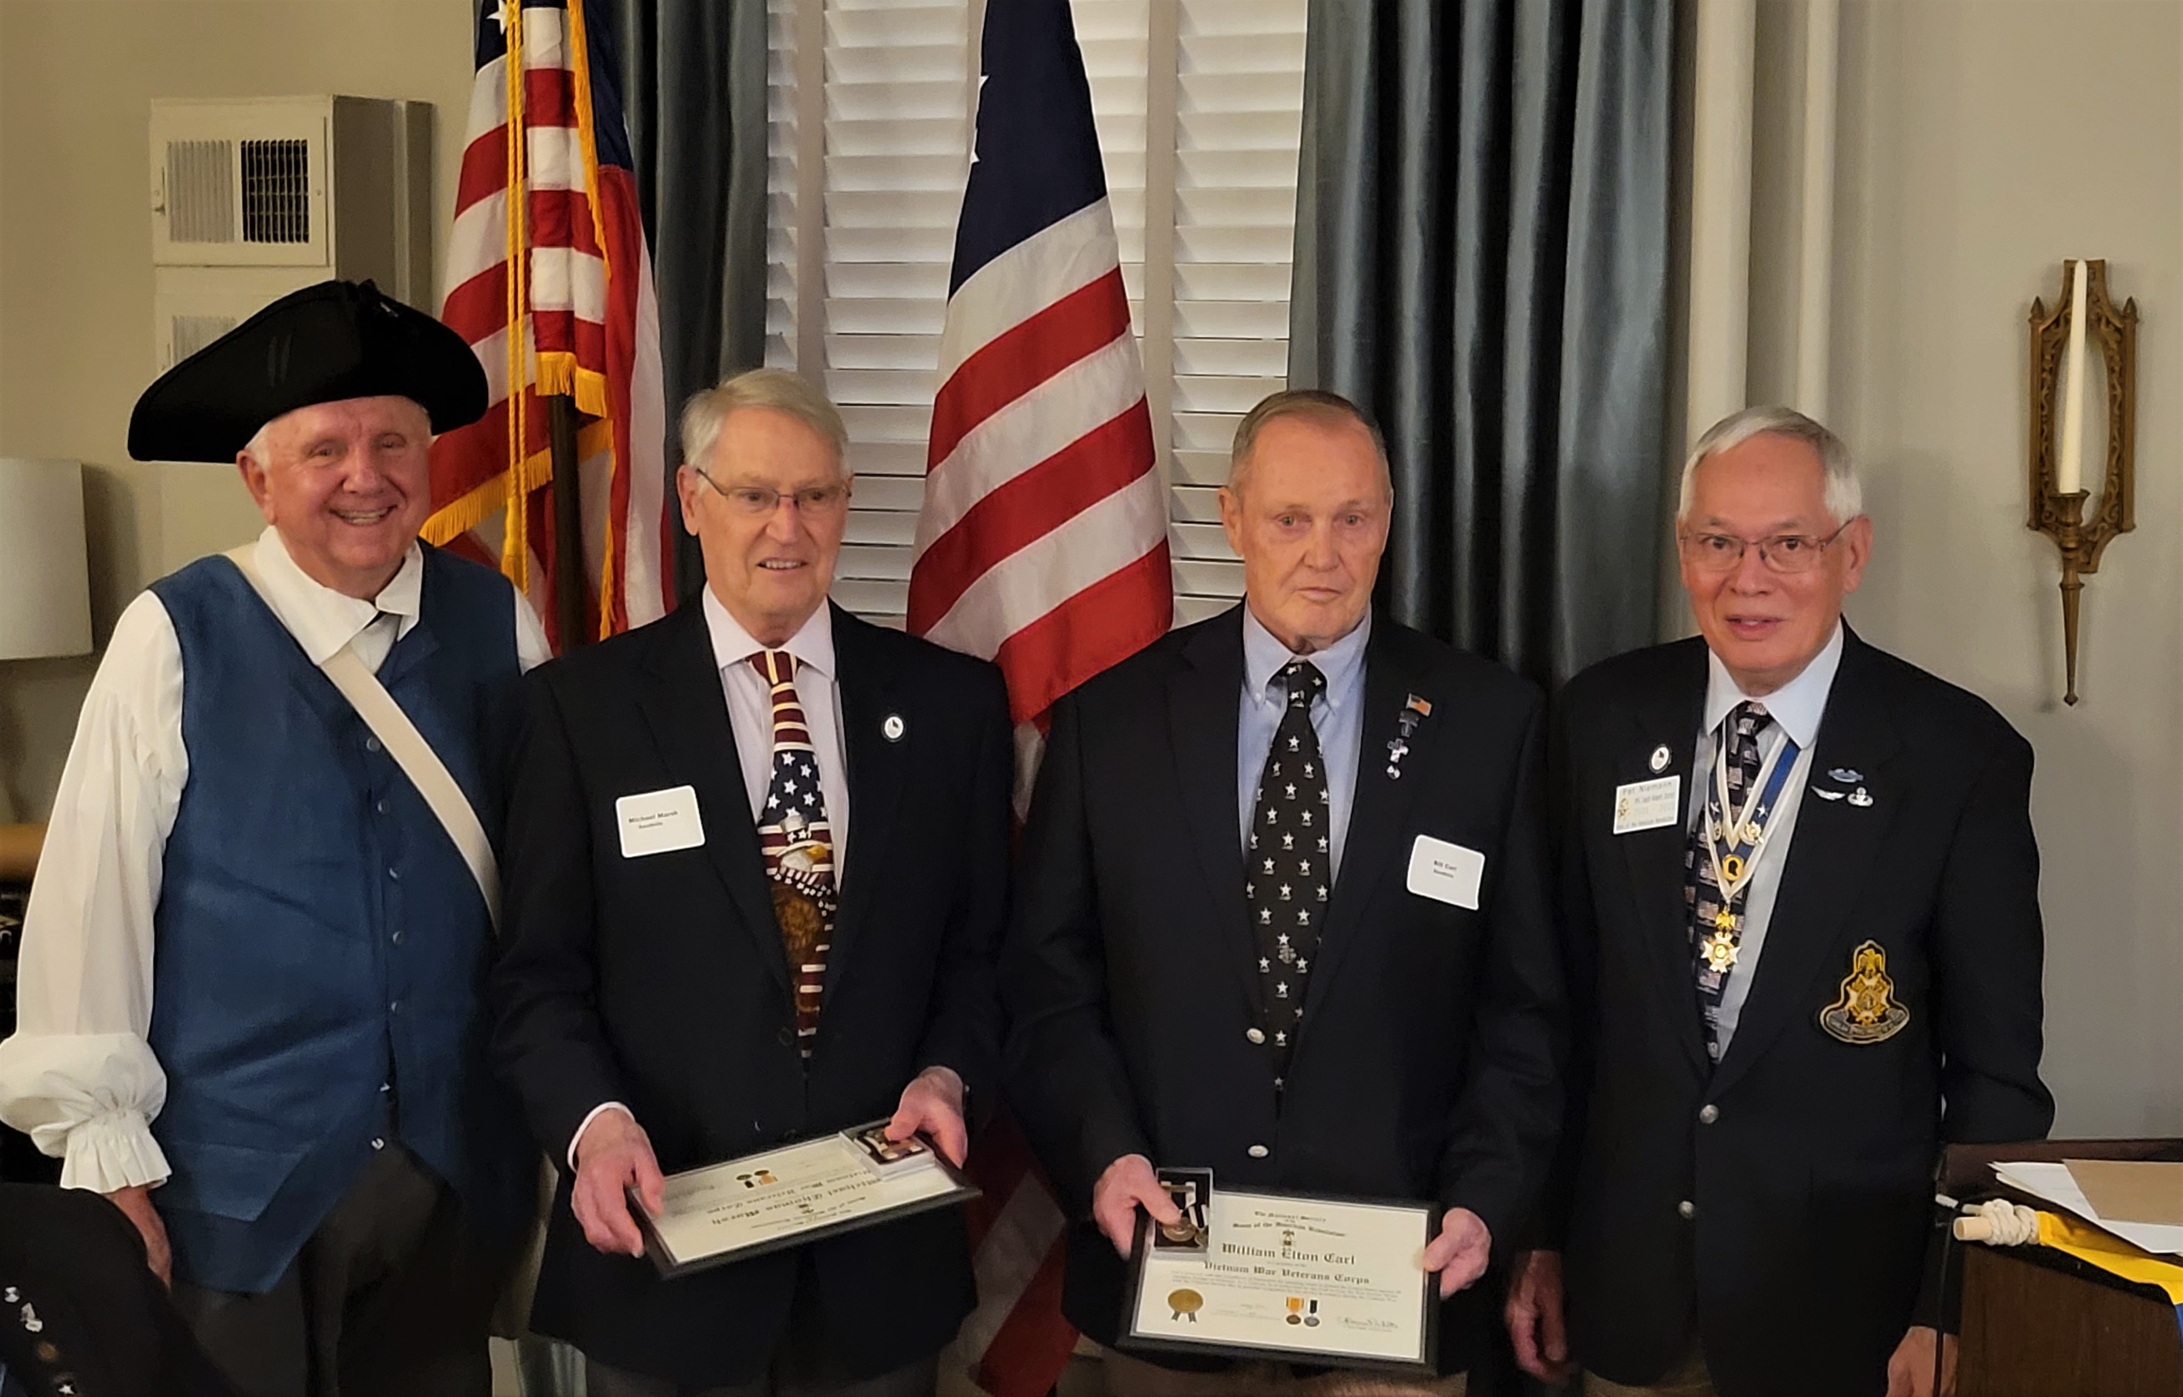

(Pictured L to R) : Compatriots Bruce Fensley, Dr. Michael Marsh, LTC William Carl, and COL. Pat Niemann)

Sandhills Chapter Compatriot and SAR Veterans Recognition Committee Chairman, Pat Niemann, presented the SAR War Service Medal and Certificate to Compatriots Dr. Michael Marsh and LTC – William Carl for their National Service during the Vietnam War.

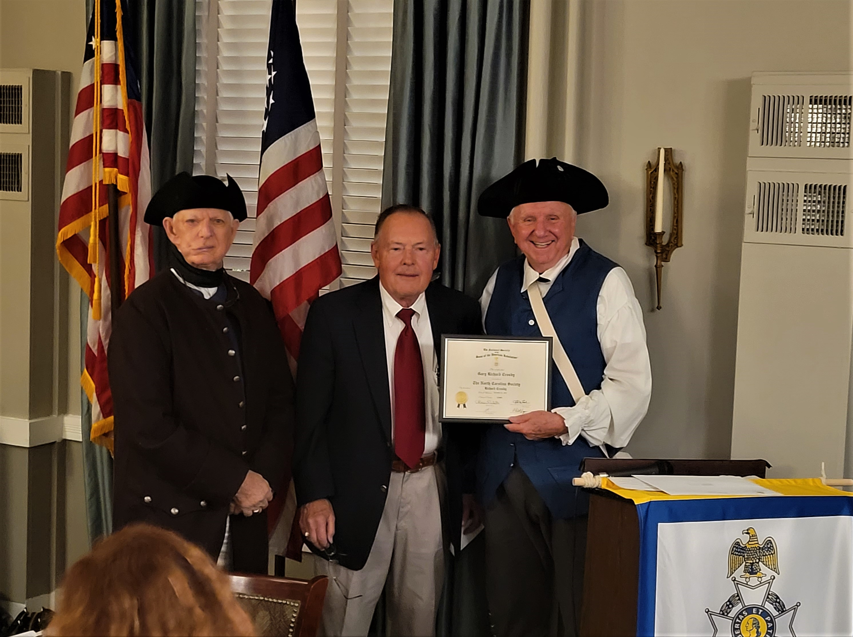

(Pictured L-R Sandhills Chapter Registrar – Jack Laflin, Gary Crosby, Bruce Fensley

Sandhills Registrar – Jack Laflin and President Bruce Fensley conducted a SAR Membership Induction Ceremony for New SAR Compatriot, Gary Crosby of Pinehurst, NC. Gary’s family Patriot is Richard Crosby, who signed his Oath on June 1, 1778 and who served as a Pvt. during 1780 – 1781 in Capt. William Smith’s Co. of the 6th Battalion commanded by Col. Caleb Davis in the Pennsylvania Militia. Congratulations Gary and Welcome into the Sons of the American Revolution.

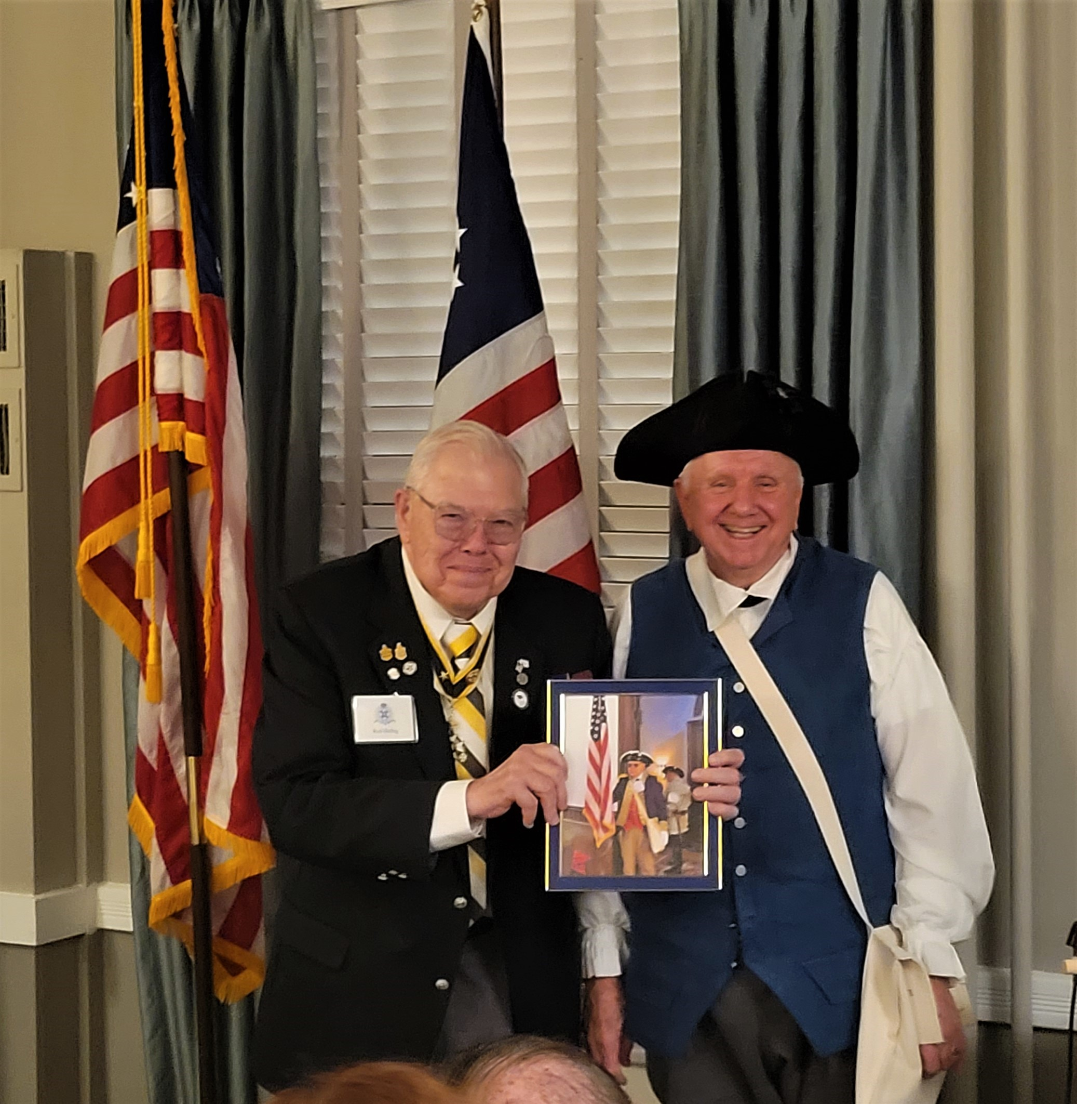

(Pictured L – R, Compatriot Rod Herbig and President Bruce Fensley)

Rod Herbig “The General”, Sandhills Compatriot and Charter Founding member of Pinehurst, NC received a special birthday picture of him serving in the Color Guard Unit by presenting the US Flag at the Patriot Graving Marking ceremony for Nathan Stedman in Pittsboro, NC.

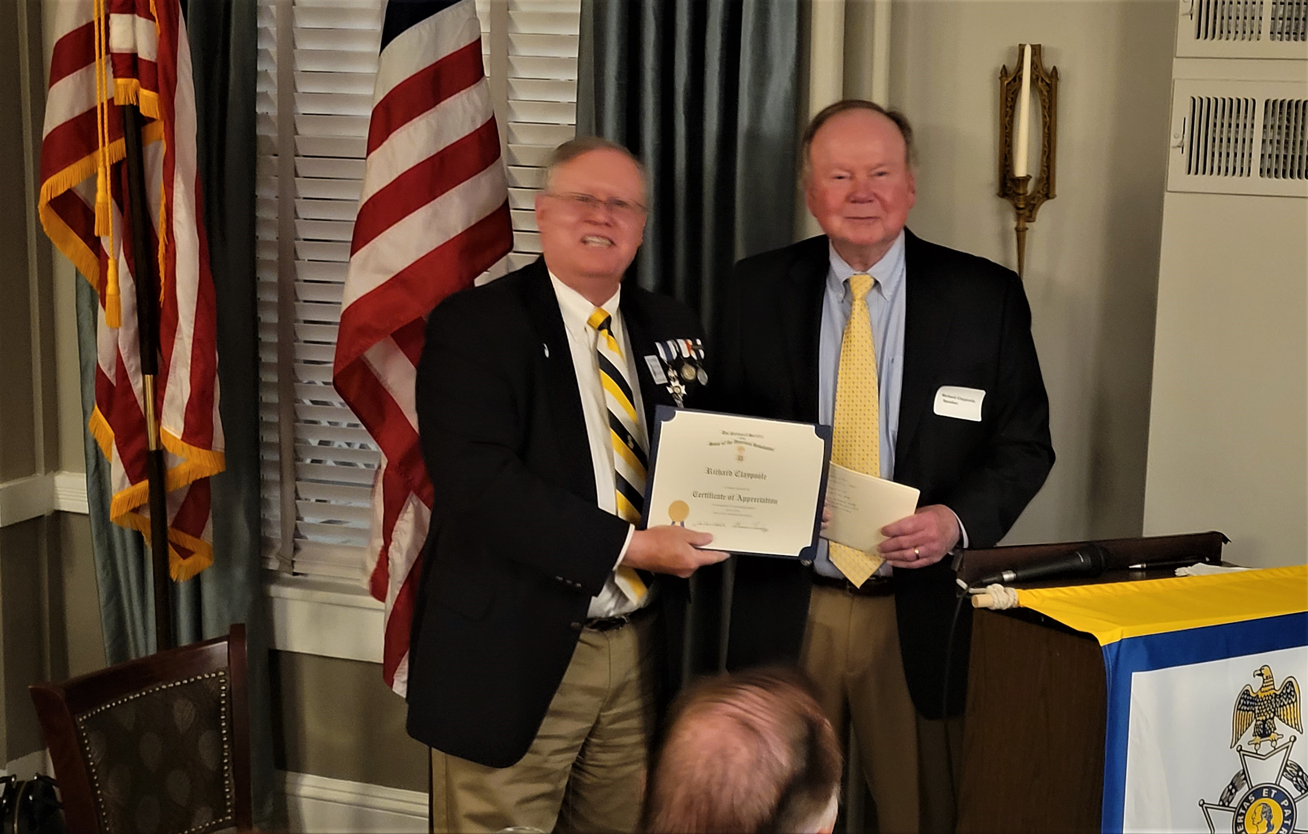

(Pictured L to R, Sandhills Secretary – Mike Fusselbaugh and Richard Claypoole)

Sandhills Chapter Secretary - Mike Fusselbaugh, presents a SAR Certificate of Appreciation to Richard Claypoole for his excellent presentation of “ Our Veterans, Our Presidents”. Richard lives in Lewes, Delaware and retired as the Assistant Archivist of the US Presidential Libraries & Museum. Richard also authored the “Documents of America”. Richard is a US Army Veteran who served in the Vietnam War during 1969 to1971.

