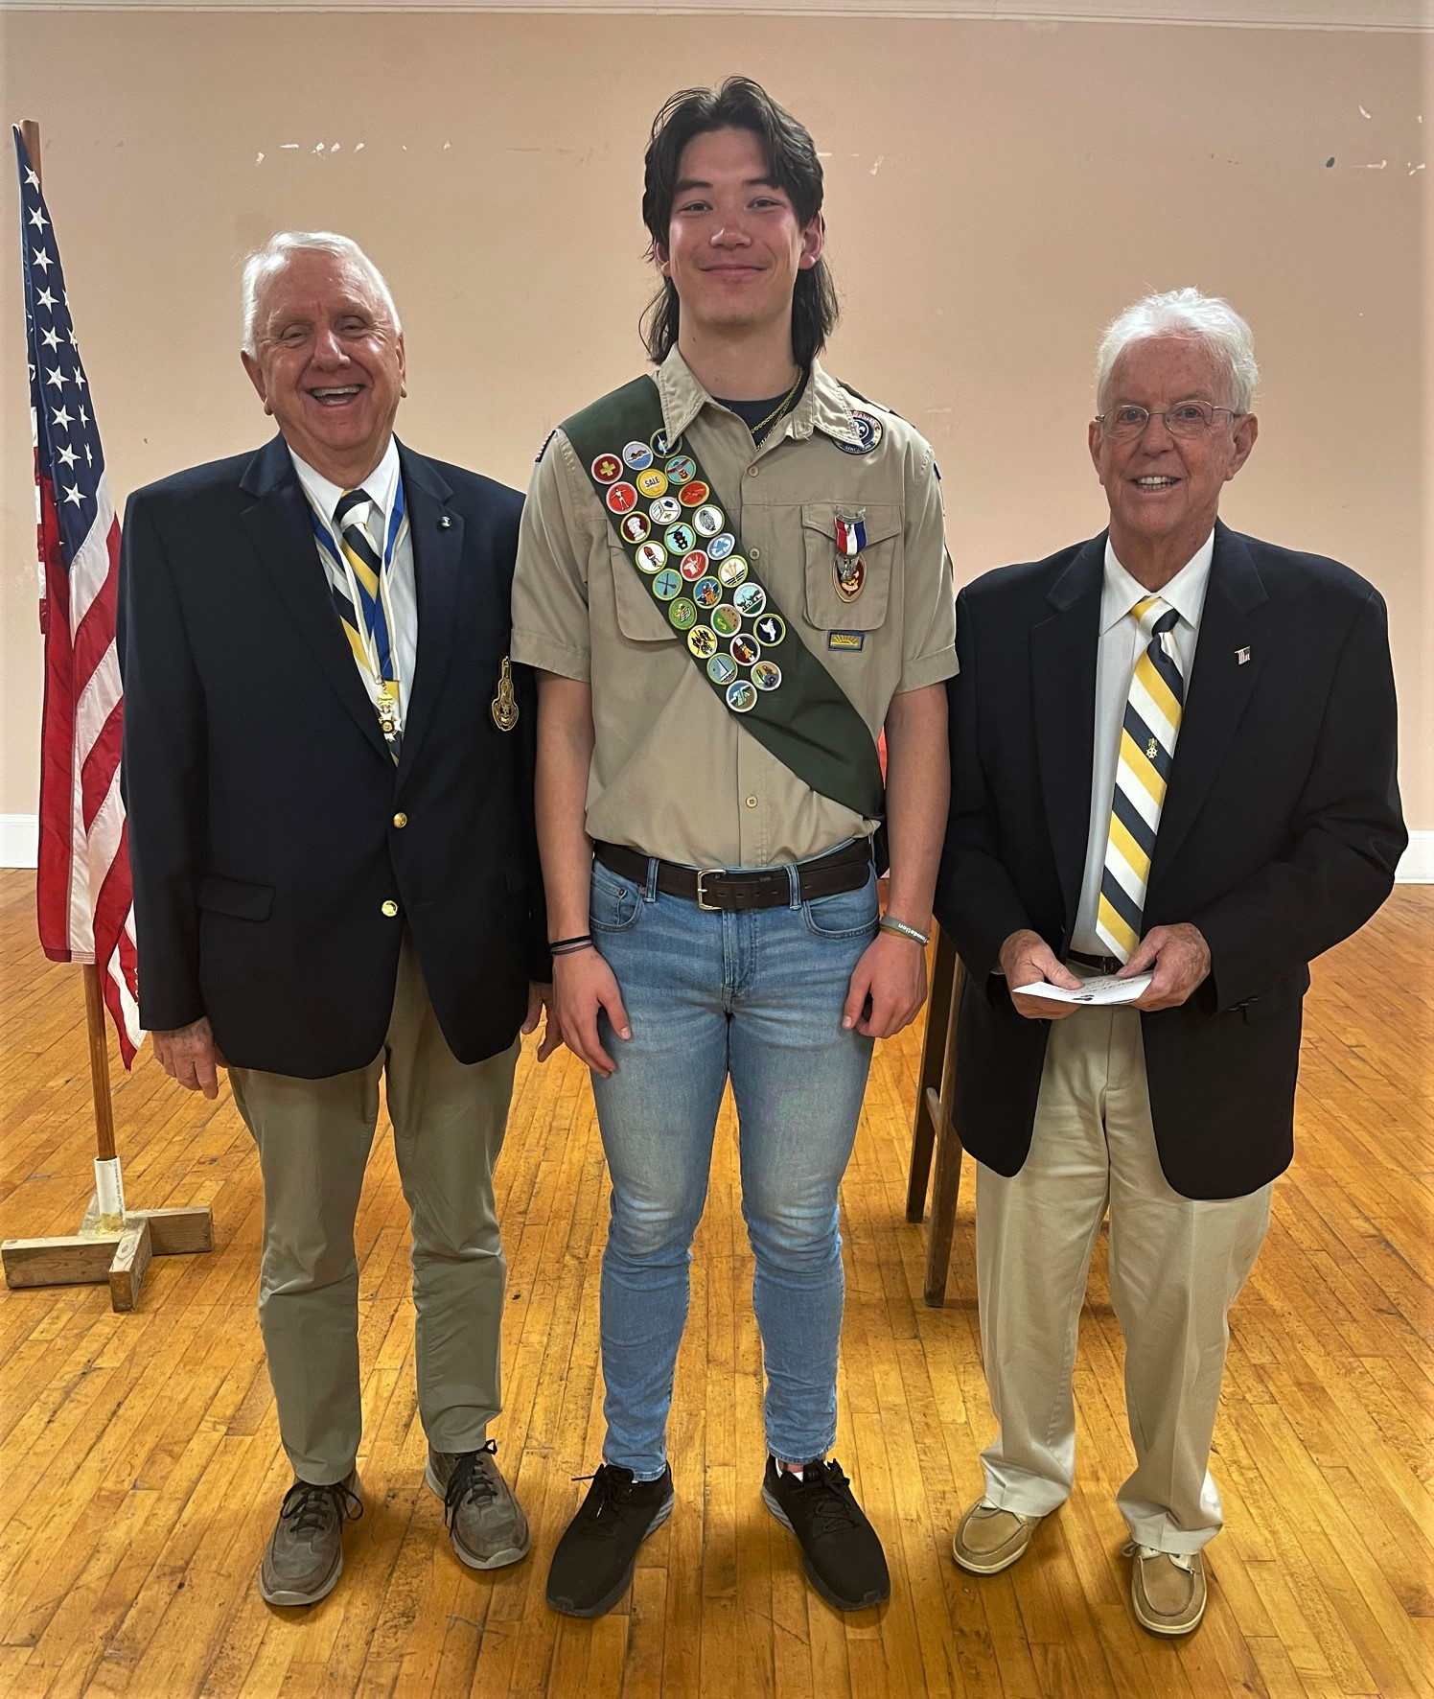
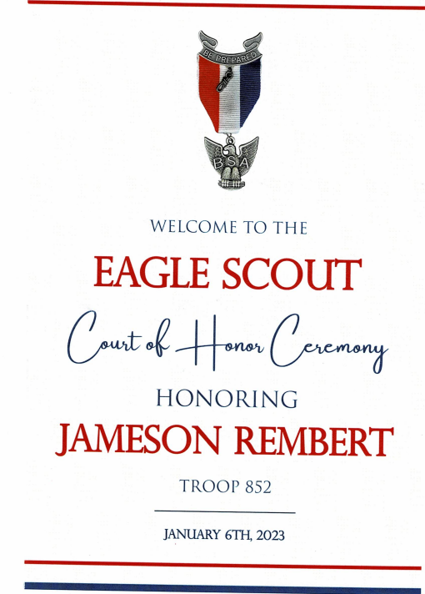

Boy Scout Troop 852 (Carthage, NC)
Eagle Scout Court Of Honor

On January 6, 2023, Sandhills SAR Chapter, Eagle Scout Committee Chairman, Steve Lawrence (R) and Chapter President Bruce Fensley (L) attended an Eagle Scout Honor Court at Boy Scout Troop 852 in Carthage, NC to present Jameson Rembert with the Sons of the American Revolution Eagle Scout Medal and Award Certificate.
Jameson is the son of Retired US Air Force Veteran Bart Rembert of Carthage, NC. His Mother, Erin, is the owner of Eliza Quinn Gift shop in Carthage, NC. Troop 852 Boy Scouts and troop leaders, family members, and friends attended this outstanding achievement ceremony. Jameson is a 2022 graduate of Union Pines High School and is currently a freshman college student in Colorado.
Jameson’s Eagle Project restored an abandoned JROTC obstacle course at Union Pines High School, which was overgrown with bushes and small trees. His project cleaned up the entire obstacle course area, removed trees and bushes, rehabilitated and upgraded the area to be used by “special needs” students for exercise and recreation.

