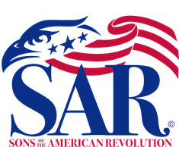

The West End Elementary School
History Teacher - Mrs. Wolfe’s, 5^{th –} Grade, American History Classes

On November 21, 2022, Mrs. Debbie McMurry – The Alfred Moore DAR Chapter – Registrar, Mrs. Harriet Riley – Past Regent of the Alfred Moore DAR Chapter, and Bruce Fensley – Sandhills SAR Chapter – President, collaborated to develop a North Carolina American Revolutionary War Program for 72 fifth grade students organized into three classes.

The goal of these classes were to inform and interest Moore County students about some of North Carolina’s ordinary citizens that took “extraordinary” actions that helped to obtain American Independence and Freedom from Britain’s Rule.

DAR Daughter, Debbie McMurry, told the class about one of her family’s Patriots, 17 year old, James Harris of North Carolina who joined Continental Army and marched off to South Carolina to fight in the fierce Kings Mountain Battle of British Loyalist against American Patriots. The British effort to secure Loyalist support in the South was a failure. Thomas Jefferson called the results of this battle, “The turn of the Tide of success.
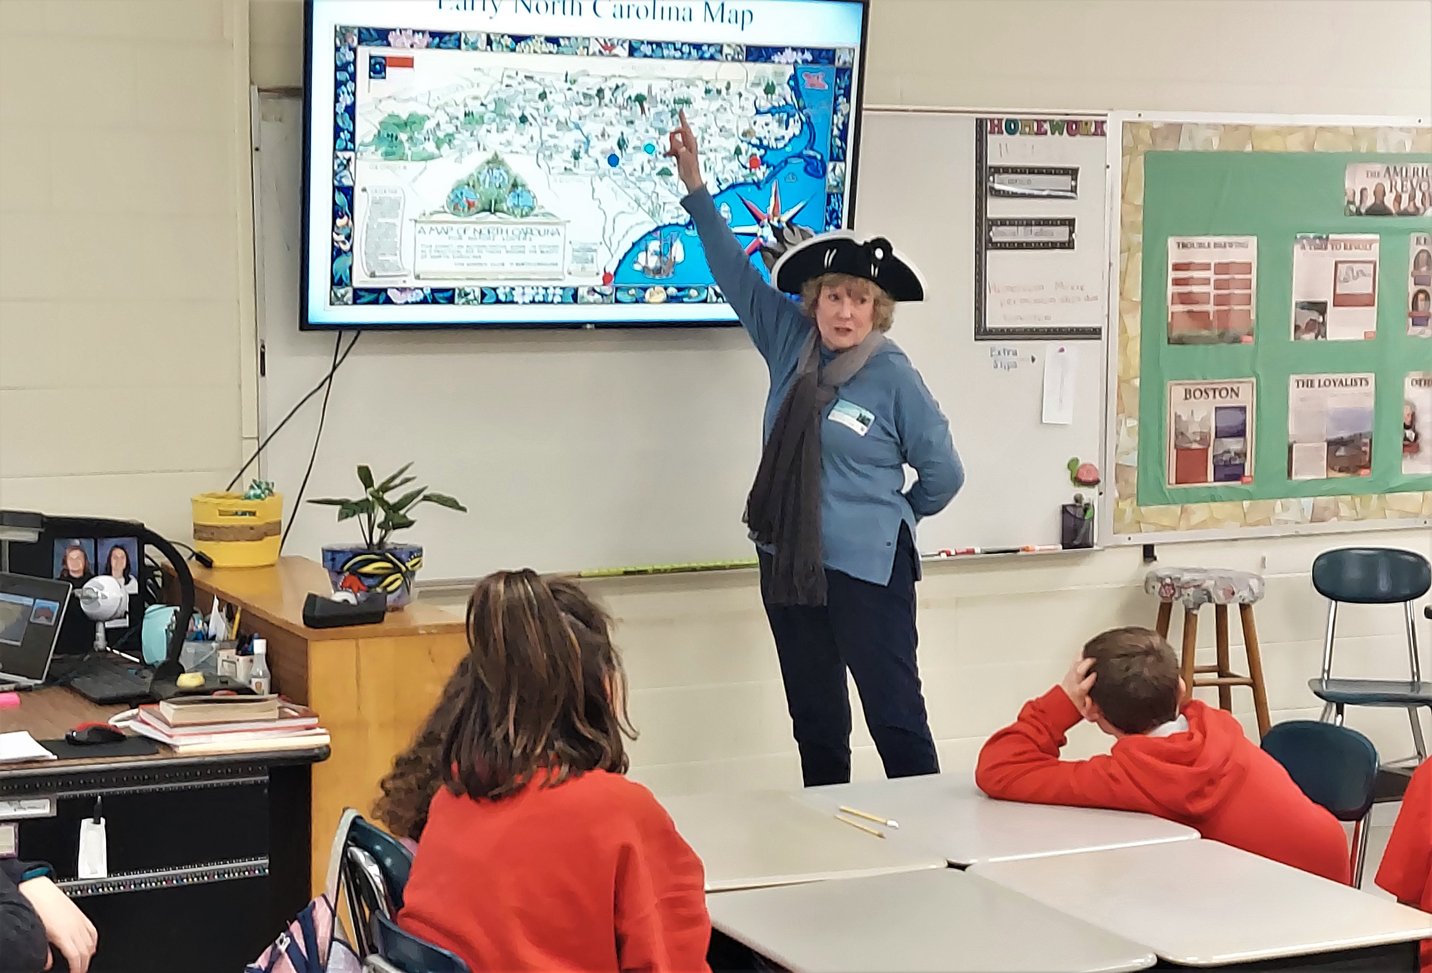

Debbie McMurry - Alfred Moore DAR Daughter –
--------------------------------------------------------------------------------------------

Sandhills Compatriot, Bruce Fensley, told the story of 10 teenagers that formed “The Cabarrus Black Boys” in May 6, 1771. These Piedmont Region boys developed a plan to attack a British wagon train, ordered by Governor Tryon from Charlestown, SC to deliver military supplies to the British military stronghold in Hillsboro, NC. These supplies were intended to be used to put down the Alamance Regulators. Before the attack, the boys all pledged a solemn oath not to disclose anything and anyone involved in the act. The boys blackened their faces with soot and dressed as Indians, so that they could not be recognized. During the evening of May 6, 1771, The Cabarrus Black boys attacked the wagon train that was camped near a huge rock on Phifers Hill, West of what is now Concord. They quickly overwhelmed the guards and teamsters and bound them up. They quickly piled all the military supplies, gun powder, flints and kegs of supplies and set fire to the pile, which caused a huge explosion. The British set out to identify and punish the people who destroyed these military supplies. The boys fled North Carolina and avoided British capture with the help of the settlers in the frontier of Georgia. They all returned to North Carolina in 1775 when the Patriots of North Carolina rose up to oppose the Loyalist and British forces. They fought in many of the important battles with General Charles Cornwallis.
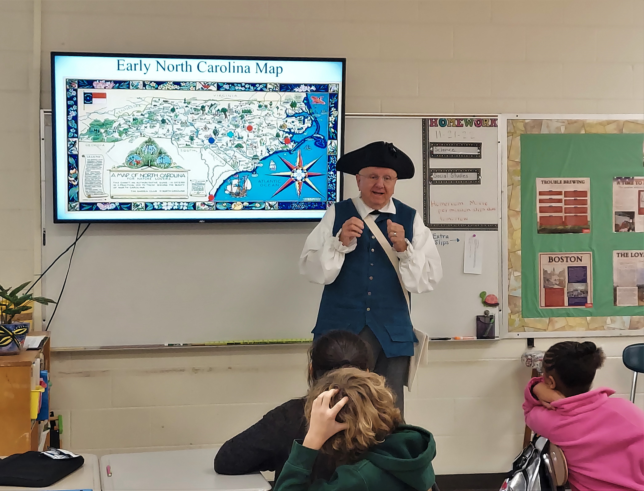

Bruce Fensley – Sandhills Chapter President
-----------------------------------------------------------------------------------------------

DAR daughter, Harriet Riley, shared the story about her family’s Patriot, Dr. George Glasscock of Carthage, NC. Dr. Glasscock was a medical doctor in Virginia. Their family moved to North Carolina in 1773 and led a quiet life caring for the settlers of what is now Moore County. When the Revolutionary War broke out in North Carolina, Dr Glasscock served as a surgeon in the American Army at the Battle of Guilford Courthouse. Dr. Glasscock died on October 18, 1787 and is buried in the family Cemetery in Cross Hills area outside Carthage, NC.

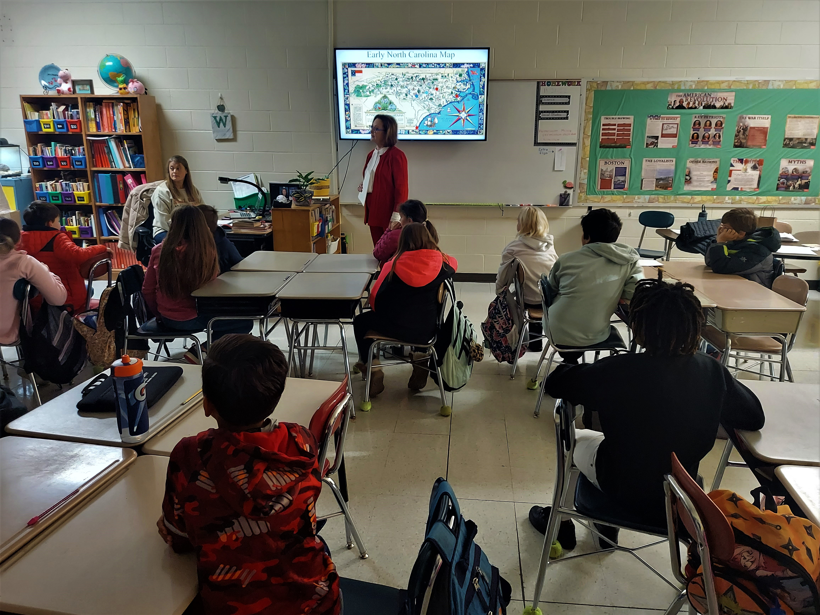

Harriet Riley – Past Regent – Alfred Moore DAR Chapter

