SAR Nursing Home Christmas Visit

On 12-20-22, my wife (Christine – Sandhills Ladies WOSAR) and I visited US Military Veterans currently residing at the Tara Plantation Nursing Home, in Carthage, NC.

We had 4 extra Poinsettia Plants from our Chapter Dinner on the 13th and thought they would make a nice Christmas gift for our Elderly Veterans in a nursing home.

We also put together Christmas Gift bags containing; a New Warm Fleece Blanket/Throw, a bottle of Shower Wash, Skin Moisturizer, Chocolate and Christmas Candy, and some Christmas Cookies for each Veteran.

This is Tom K., who is a Vietnam/Cambodia Era Army Veteran who just returned from a medical procedure at First Health. He loved the chocolate candy and really appreciated his new warm blanket.
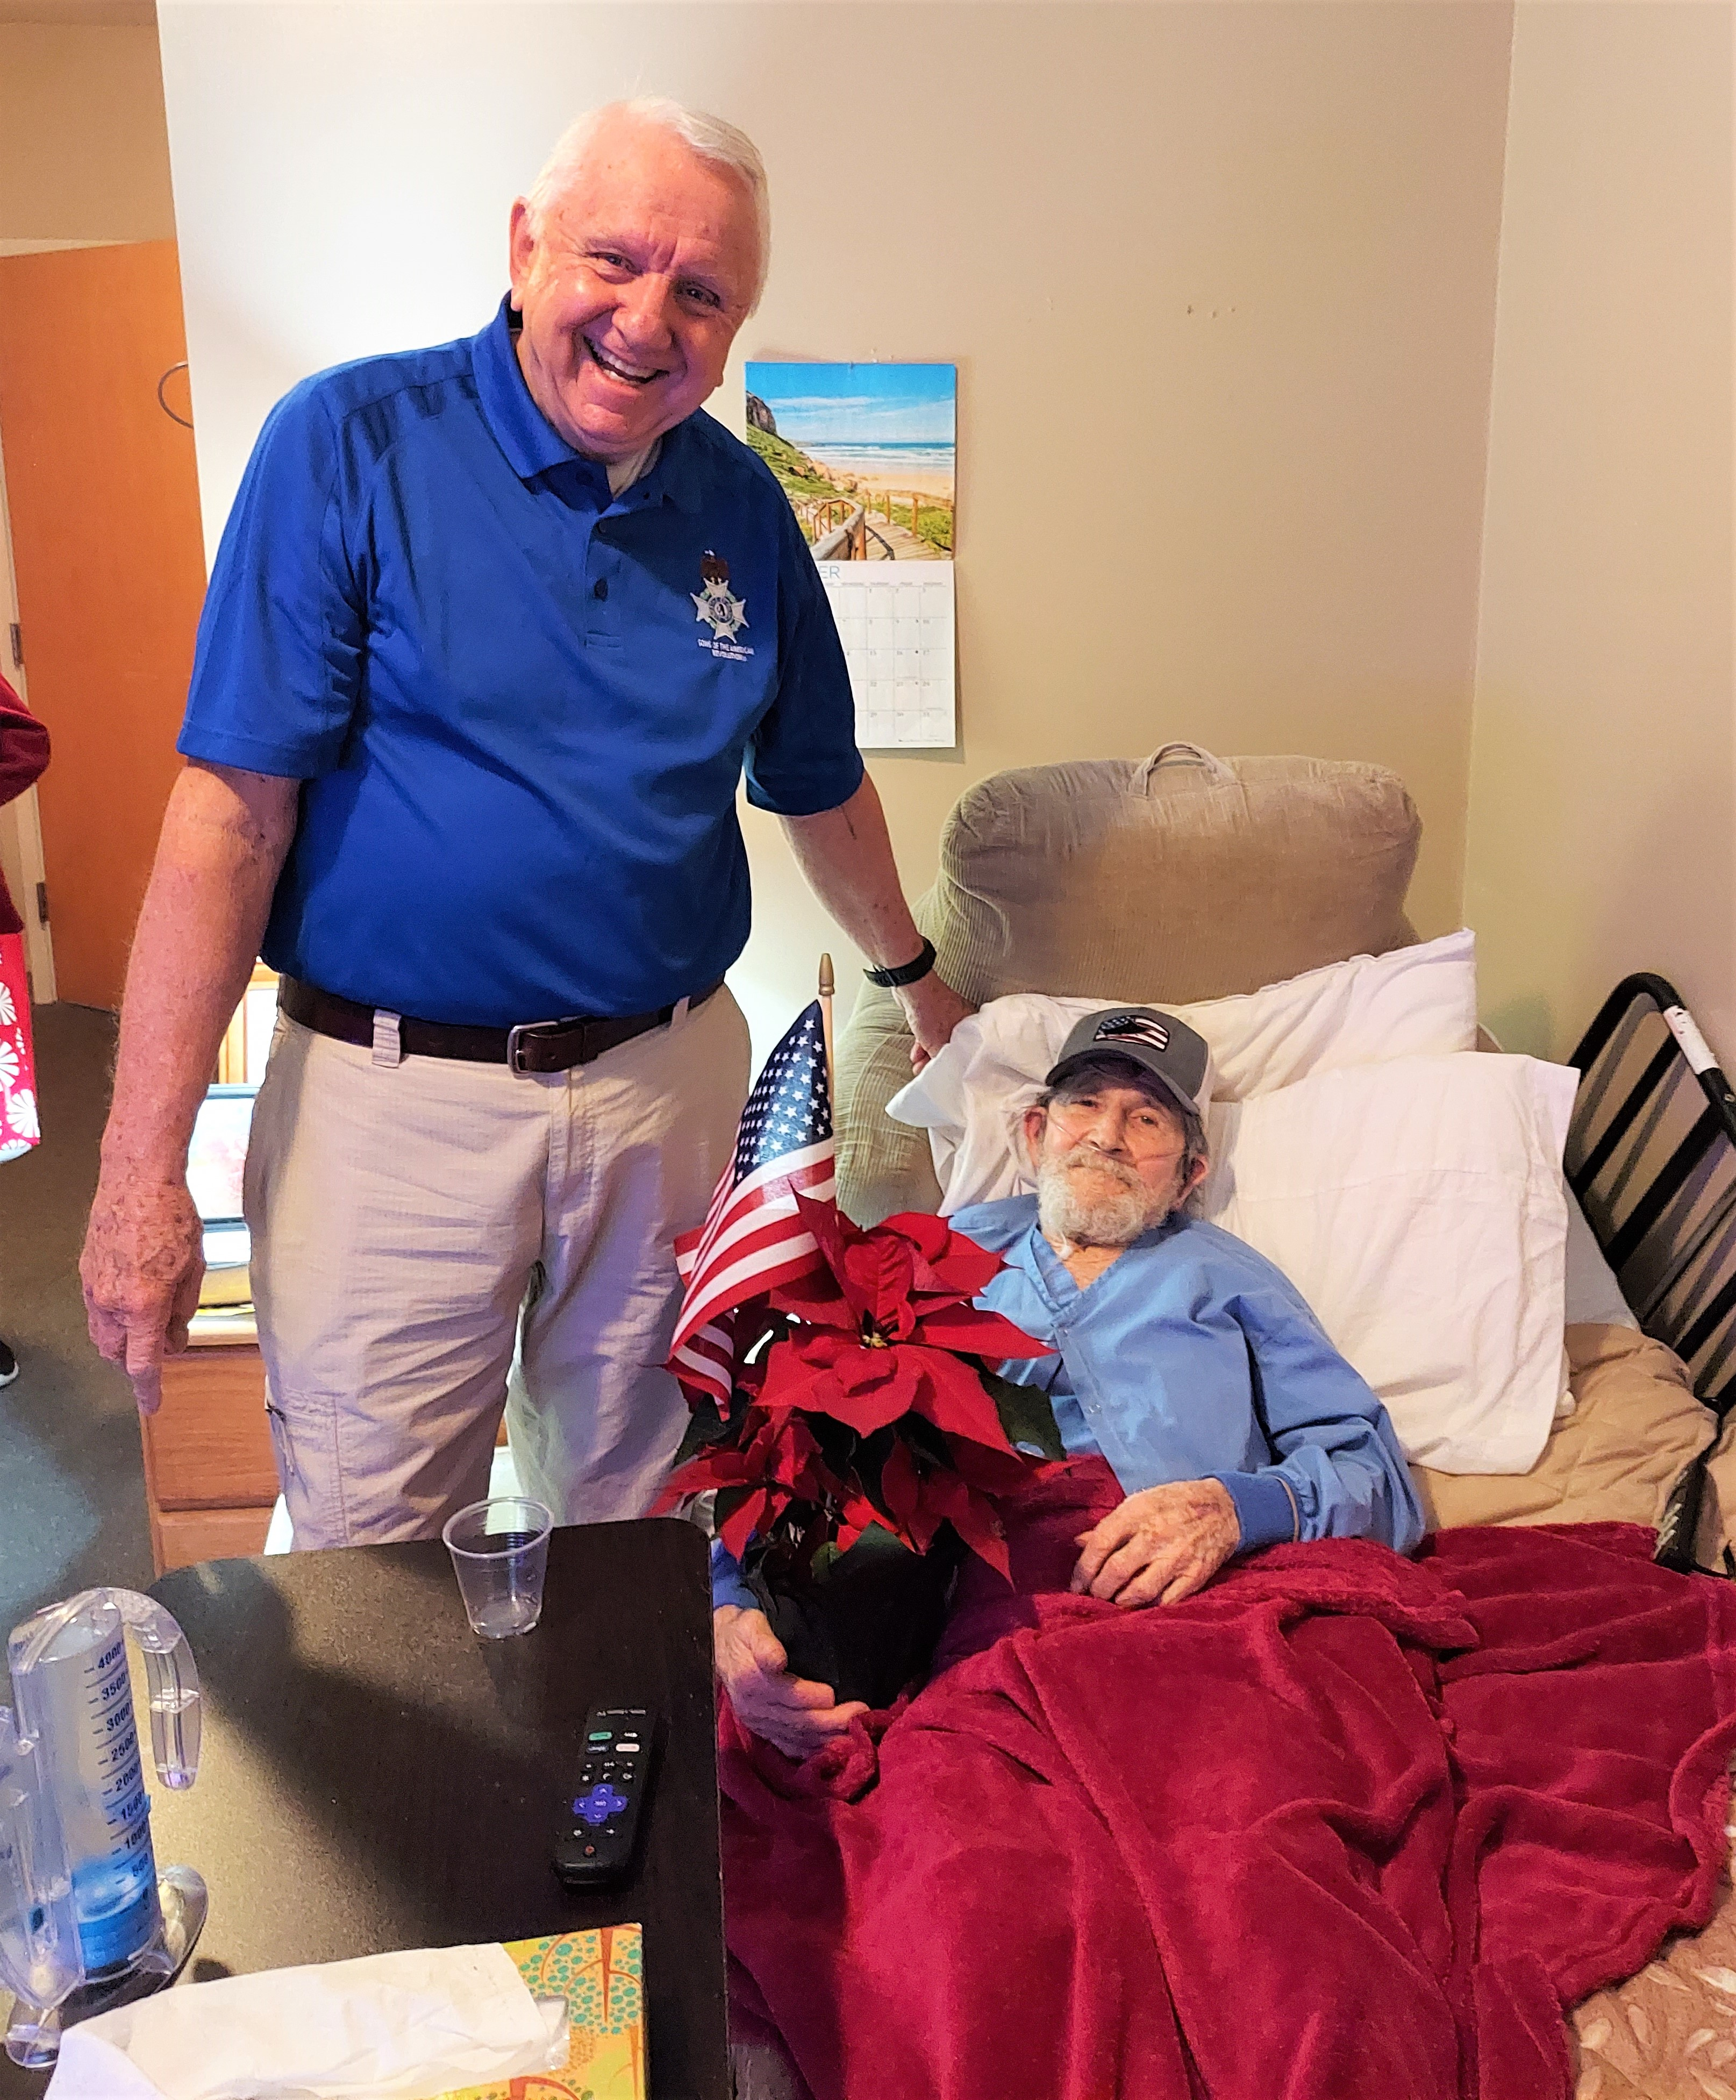

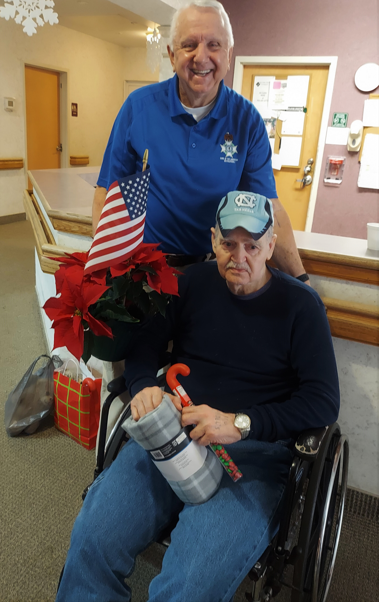

This is Merchant Marine Veteran, Joe B. who really appreciated his Poinsettia with The Flag and packages of M&Ms. Joe is experiencing significant hearing loss. But we were able to have a very nice visit.

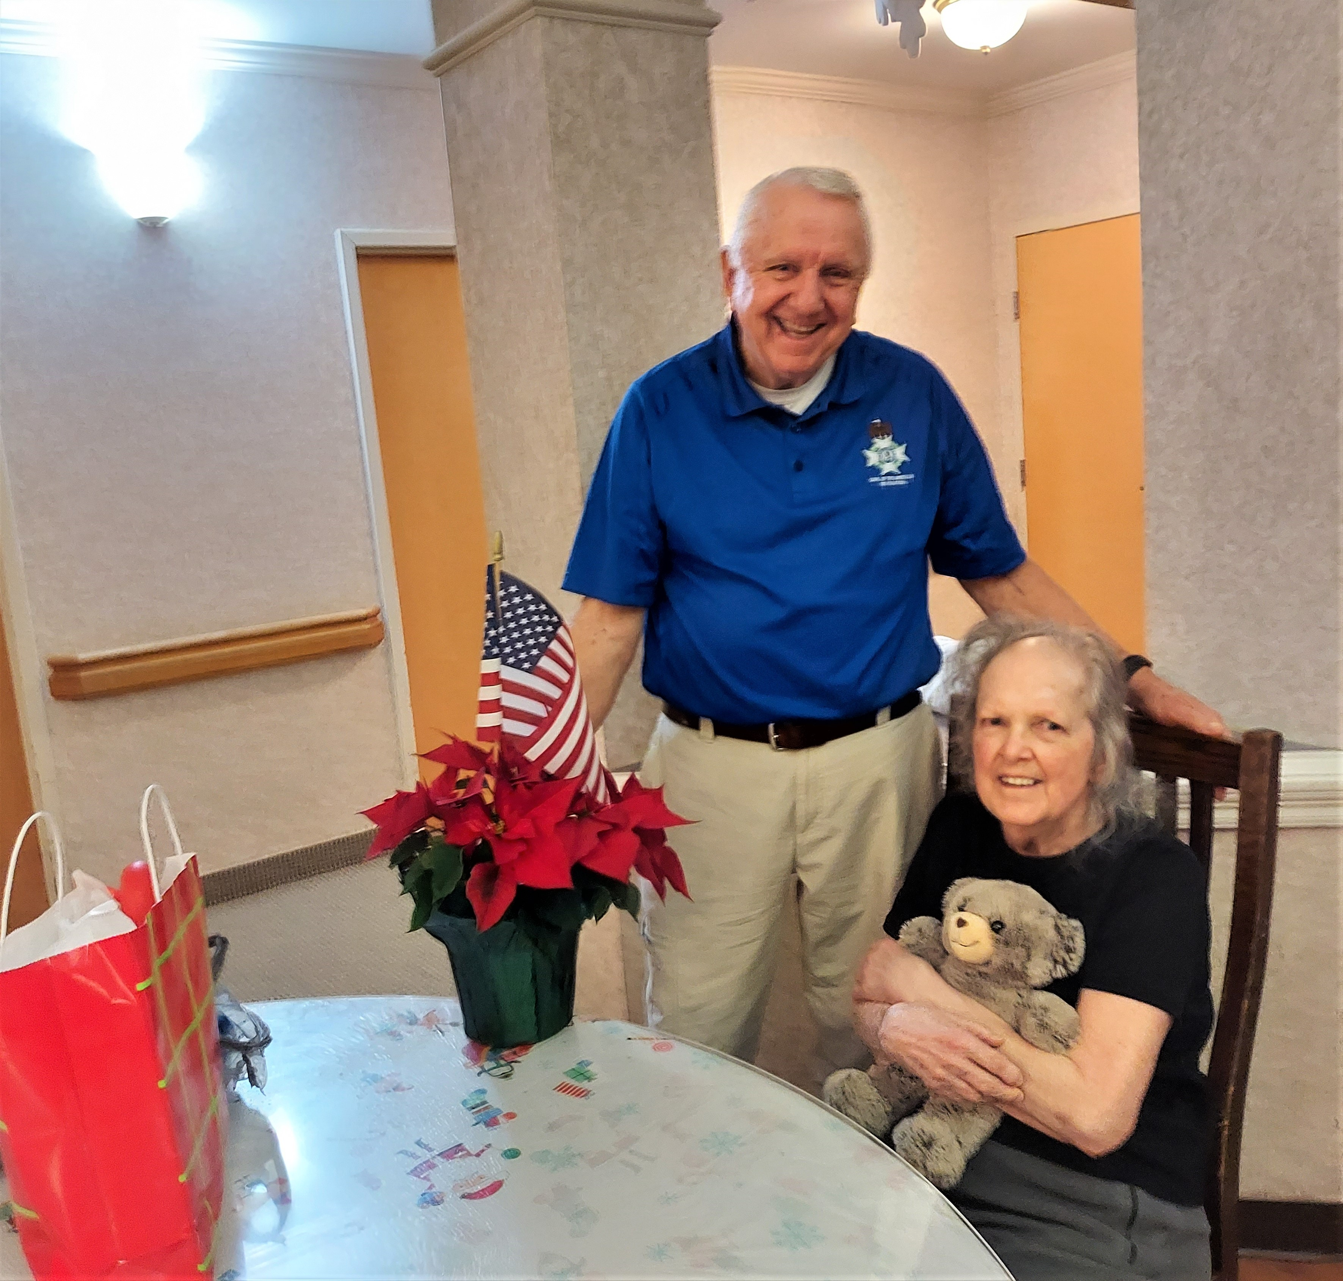

This is Air Force Veteran, Marjorie "D". Marjorie immediately fell in love with her New Teddy Bear Companion and dug right into the Twix Cookies.

We thoroughly enjoyed our visits with these American Heroes who Served and Protected our Country in their earlier years. We need to let them know that the Sons of the American Revolution appreciates and Thanks them for their Service.

We try to do so much to Recognize and Honor our Military Veterans who have passed. I think we also need to try to do more for those living Veterans who are now elderly and struggling with medical challenges.

This would be a great opportunity for a new Sandhills Chapter Committee in 2023 and another way that we can honor our Veterans and serve our communities. If anyone would be interested in joining in please let me know.

Fraternally Yours, Bruce Fensley- Sandhills Chapter-President

