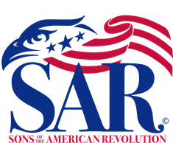

Sandhills Chapter of the Sons of the American Revolution

SAR Patriot Grave Marking Ceremony
Nathan Stedman III
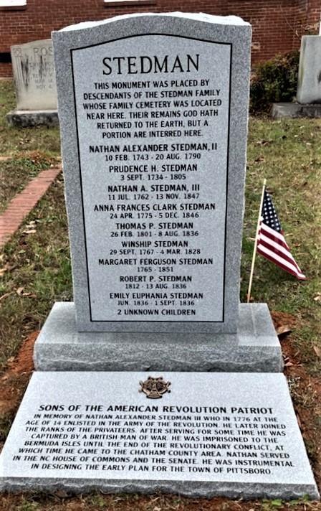

On November 19, 2022, Compatriots of the Sandhills SAR Chapter, were joined by family descendants of the American Revolutionary War Patriot Nathan Stedman III, SAR Compatriot Bob Sigmon and Gary Spencer of the NCSSAR Color Guard Adjutant, Compatriots and President Richard Pena of the Raleigh SAR Chapter, the Regent and Daughters of the Alfred Moore DAR Chapter of Southern Pines and Daughters of The Deep River DAR Chapter in Pittsboro, and public guest gathered at the Pittsboro United Methodists Church to dedicate the Grave Marking and the SAR Medallion to honor the Revolutionary War Service of Patriot Nathan Stedman III.

Sandhills SAR Chapter President – Bruce Fensley led the Ceremony, with Sandhills Chapter Compatriot and family descendant of Nathan Stedman III, Victor Burns (Carthage, NC), provided a life chronology and service record of Patriot Nathan Stedman’s Service to the American Revolutionary War. NCSSAR Piedmont Region VP, Steve Van Pelt led the Pledge of Allegiance and singing of the National Anthem. COL. Michael Saulnier led the SAR Pledge. Sandhills Chapter Compatriot and NC Senator- Tom McInnis, offered the Benediction and the Invocation prayer.

