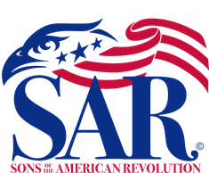

Boy Scout Troop 98, US Federal Flag Code Class
11- 14-2022

The Boy Scouts of the Troop 98 Lodge in West End, NC attended a US Federal Flag Code Class presented by Sandhills SAR Chapter Compatriot Rod Herbig. Mr. Herbig is an Eagle Scout and past Boy Scout Leader for many years in Illinois.

Compatriot Herbig included a review of the details of The US Federal Flag Code (Public Law 94-344, Adopted June 15, 1954 – President Eisenhower). The Flag Code defines the details of the design of the American Flag, the times, holidays, and occasions for displaying the flag, the positions and manner for properly displaying the Flag, Respecting the Flag, and Hosting, Lowering, Retirement, Folding/Storage of the Flag and Respectful Flag Retirement. The Sons of the American Revolution has always encouraged education outreach programs to support youth education about the US Flag.

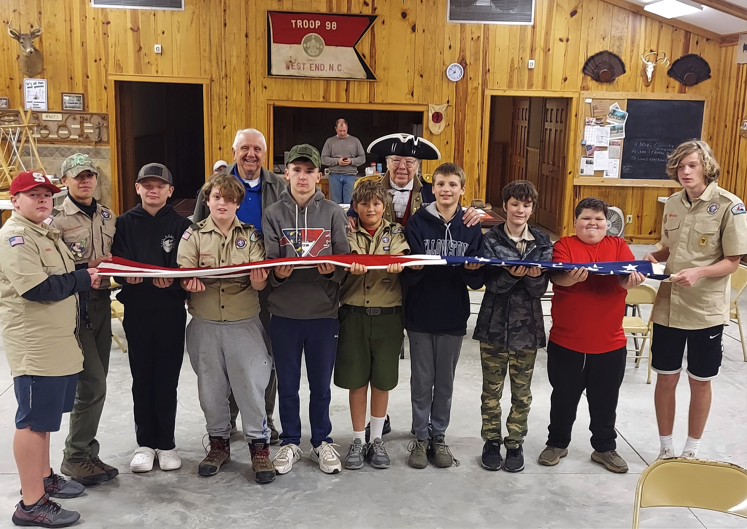
The boy scouts attending this meeting, were also instructed on the proper Folding and Storage of the Flag when not in use.

