Sandhills Chapter Presents Two SAR Eagle Scout Awards

A BSA Honor Court was held at Troop 98 Boy Scout Lodge in West End, NC to recognize Charles Hill and Samuel Wicker of Moore County for achieving their Eagle Scout.

Sandhills SAR Chapter Compatriots, Stephen Lawrence - Eagle Scout Committee - Chairman and Chapter President Bruce Fensley were pleased to present the SAR Eagle Scout Medal and Certificates to these outstanding young men.
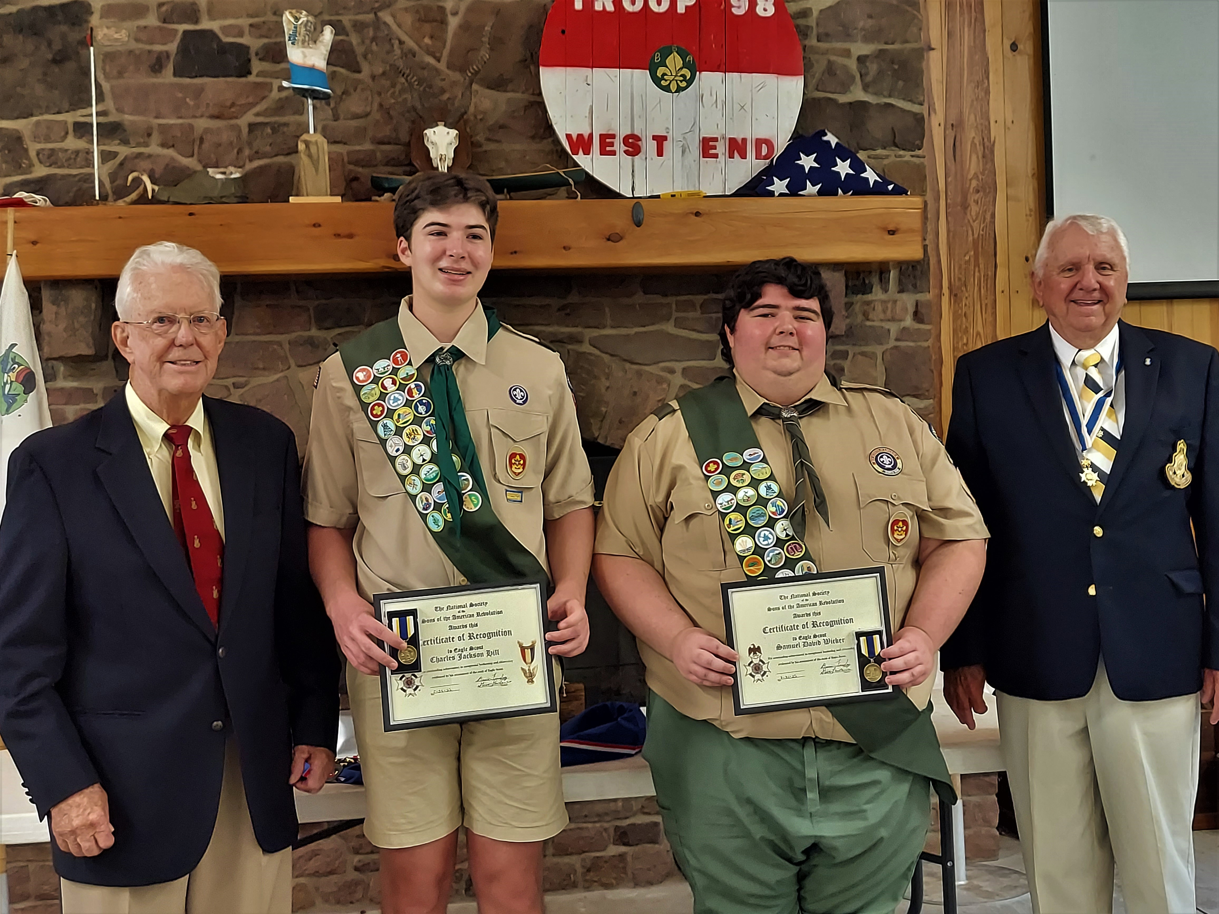
(Pictured L – R- Stephen Lawrence, Charles Hill, Samuel Wicker, Bruce Fensley)

Charles Hill’s Eagle Scout Project conducted a graveyard clean-up and demarcation placement at the Old Faith Presbyterian Church Cemetery in Aberdeen, NC. Old Faith Presbyterian Church is believed to be the oldest African-American church in Moore County.

With a passion for animal welfare, Samuel Wicker’s Eagle Scout Project provided needed shelter and shade provisions at the “Caring Hearts For Canines” Animal Rescue Shelter in Aberdeen, NC. Sam also was successful with soliciting sufficient donations to fund the materials for his project.

