The 241stAnniversary of the Attack at the House In the Horseshoe (August 6^{th)}
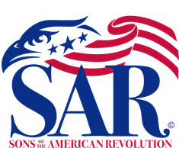

All Welcome
The Sandhills Chapter of the Sons of the American Revolution (SAR) invites all to join us for a day of living history and a patriotic ceremony to honor the 241st Anniversary of the attack at The Historic Alston House or “The House in the Horseshoe”. The Alston House is located at 288 Alston House Rd in Sanford, NC 27330. The Patriotic ceremony starts at 10:00 AM with members of the Sandhills SAR Chapter, the North Carolina State SAR Society, four Daughters of the American Revolution (DAR) chapters, and participation from other patriotic associations.

The event will include many scheduled displays and demonstrations of 18th Century life, historical displays, living Revolutionary War Era encampment, extensive 18thCentury firearms and weapons display, period medical treatments, as well as many other interesting displays throughout the day. Food Trucks and refreshments will be available.
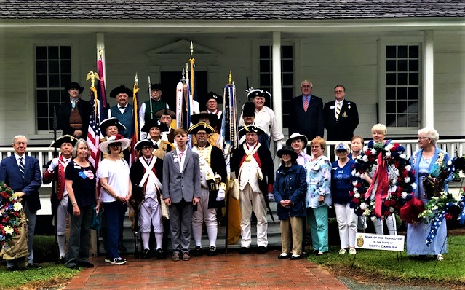

The 1781 Battle Reenactment will take place 2:00 PM
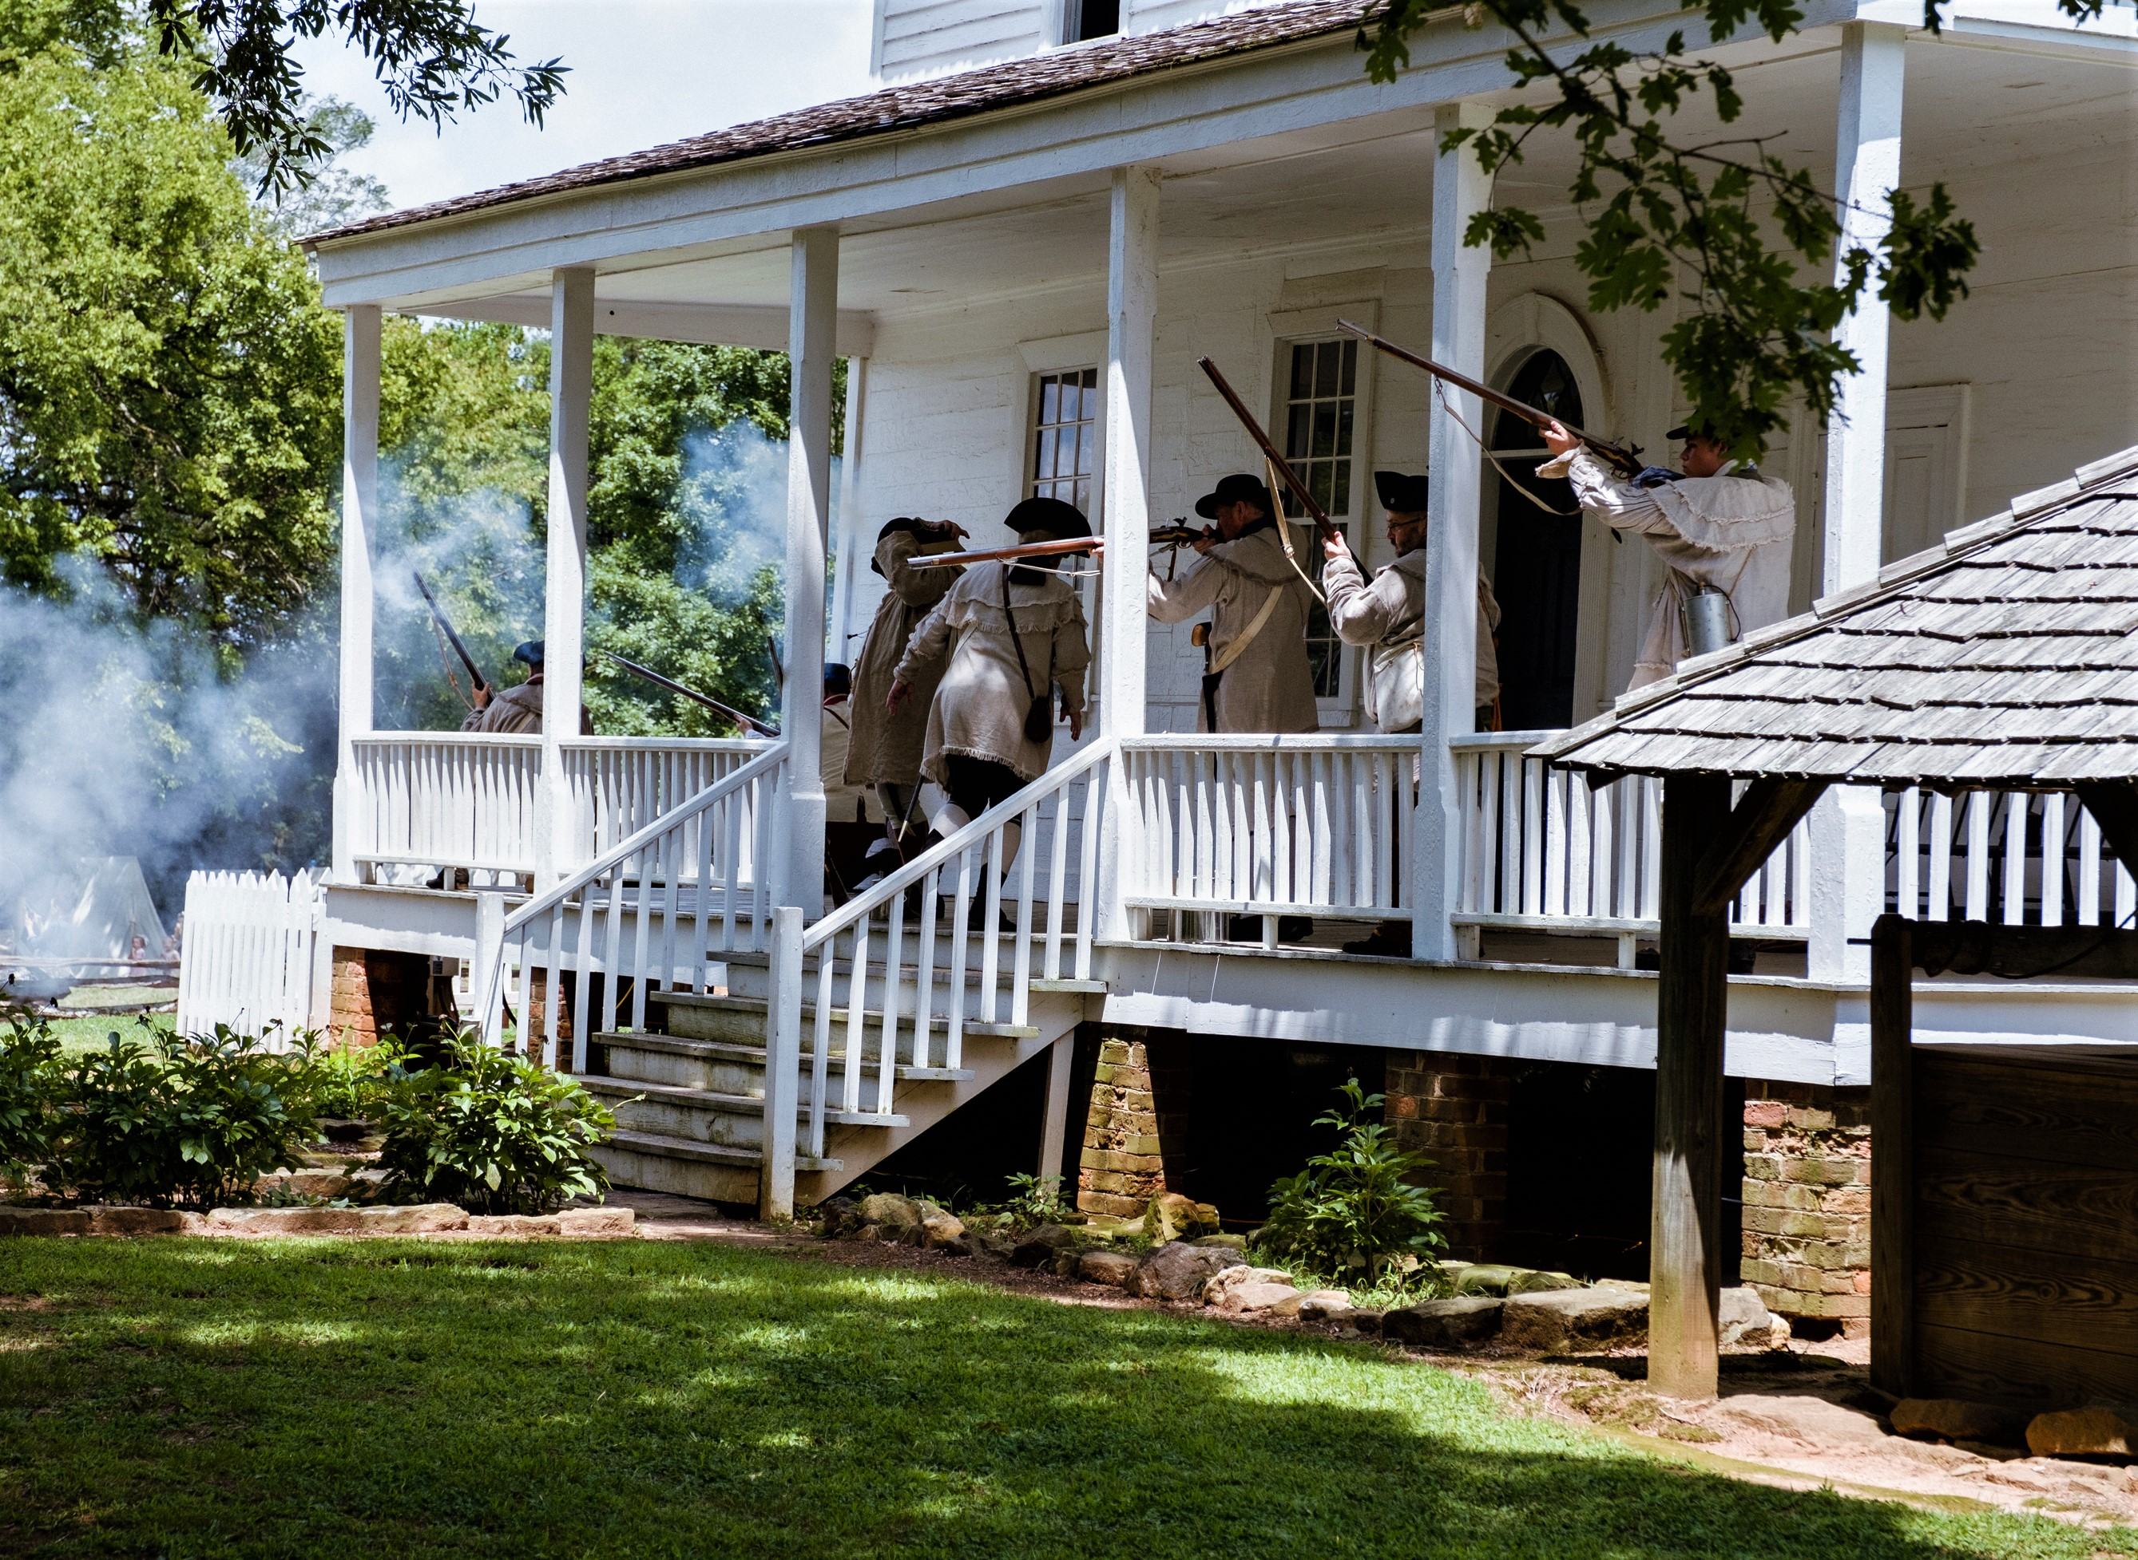

The Reenactment Battle highlights the struggles and events between the Tory and Whig families in the back country as the Revolutionary War engulfed North Carolina. For more information, please visit; www.sandhillssar.org, www.ncssar.org/calendar and www.historicsites.nc.org, also please contact Mike Fusselbaugh at fusselmrf@gmail.com.

