Sandhills SAR Presents Southern Pines Public Service Awards for Fire Prevention and Law Enforcement

On May 19, 2022, The Sandhills SAR Chapter attended a Southern Pines Public Service Awards Ceremony at the Southern Pines Firehouse #2.

Kenneth Skipper, Southern Pines Asst. Fire Marshall, received The Sons of the American Revolution (SAR) Fire Safety Medal and Award Certificate in recognition of his outstanding accomplishments and contributions to protect human life and property by preventing injuries and casualties due to fires in the Town of Southern Pines.

Jason Perry, Southern Pines Police Sergeant, received Sons of the American Revolution (SAR) Law Enforcement Commendation Medal and Award Certificate in recognition for his Outstanding Achievements and Dedication to the Maintenance of Law and Order in the Town of Southern Pines.

The recipients of these SAR Public Service Medals and Certificates are only eligible to receive these awards once in a lifetime.

The Sons of the American Revolution recognizes that our communities are Served and Protected by these dedicated Public Servants 24 hours a day and 7 days a week. This dedication to Public Service, Safety, and professionalism should not go unnoticed by the citizens of our communities. While we sleep tonight, community public servants are working to ensure that we are; safe, awaiting our calls for help, and striving to make our communities a better place to live. We owe them our Sincere Thanks.

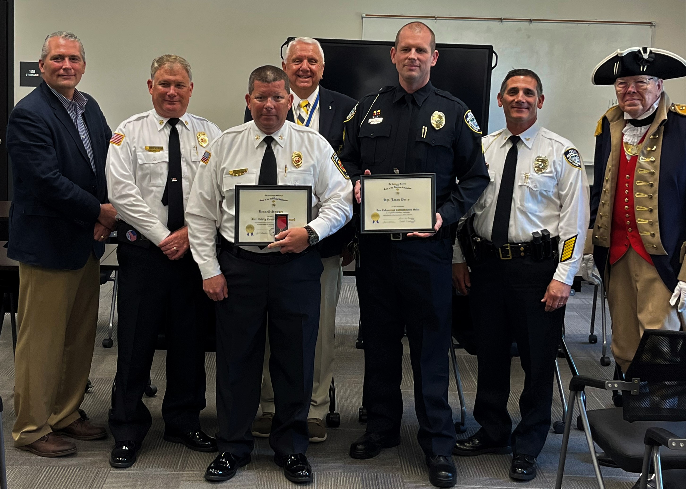

Pictured (L to R): Southern Pines Town Manager - Reagan Parsons, Fire Chief - Michael Cameron, Asst. Fire Marshall- Kenneth
Skipper, Sandhills SAR Chapter President- Bruce Fensley, Police Sgt. Jason Perry, Chief of Police – Nicholas Polidori, Rod
Herbig – Sandhills SAR Compatriot). Not Pictured are Sandhills SAR Compatriots, Mark Townsend - Public Service Committee
Chairman and Michael Saulnier - Awards Ceremony MC.

