Sandhills Chapter Honor Three Eagle Scouts of Troop 98 in West End, NC.

On Sunday June 5, 2022, Compatriots of The Sandhills SAR Chapter joined a Boy Scout Court of Honor with the Scouts of Troop 98, their families, friends, scout leaders, and representatives of other patriotic organizations to present Three Outstanding young men with the Sons of the American Revolution, Eagle Scout Medals and Certificates. Their Eagle Scout projects included Community Service projects collaborating with the Fire Department and designing and establishing environmentally sound small fish habitats in local waterways.

Our Compatriots congratulated them for their hard work, leadership skills, and encouraged them to apply the important lessons that they learned in the Boy Scouts throughout their adult lives.
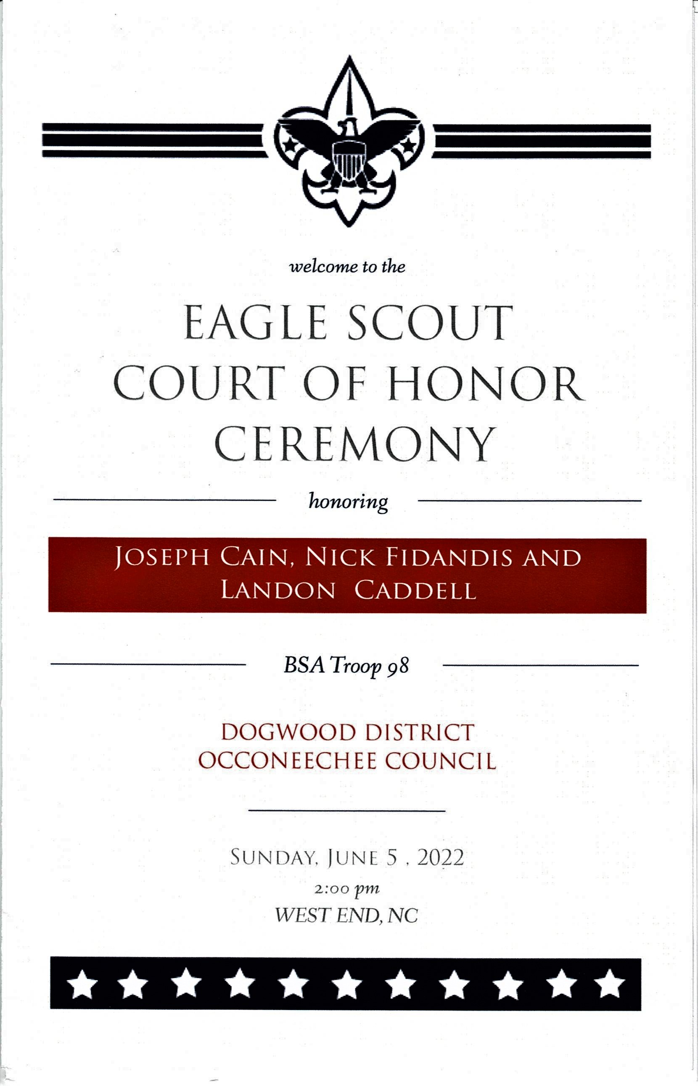

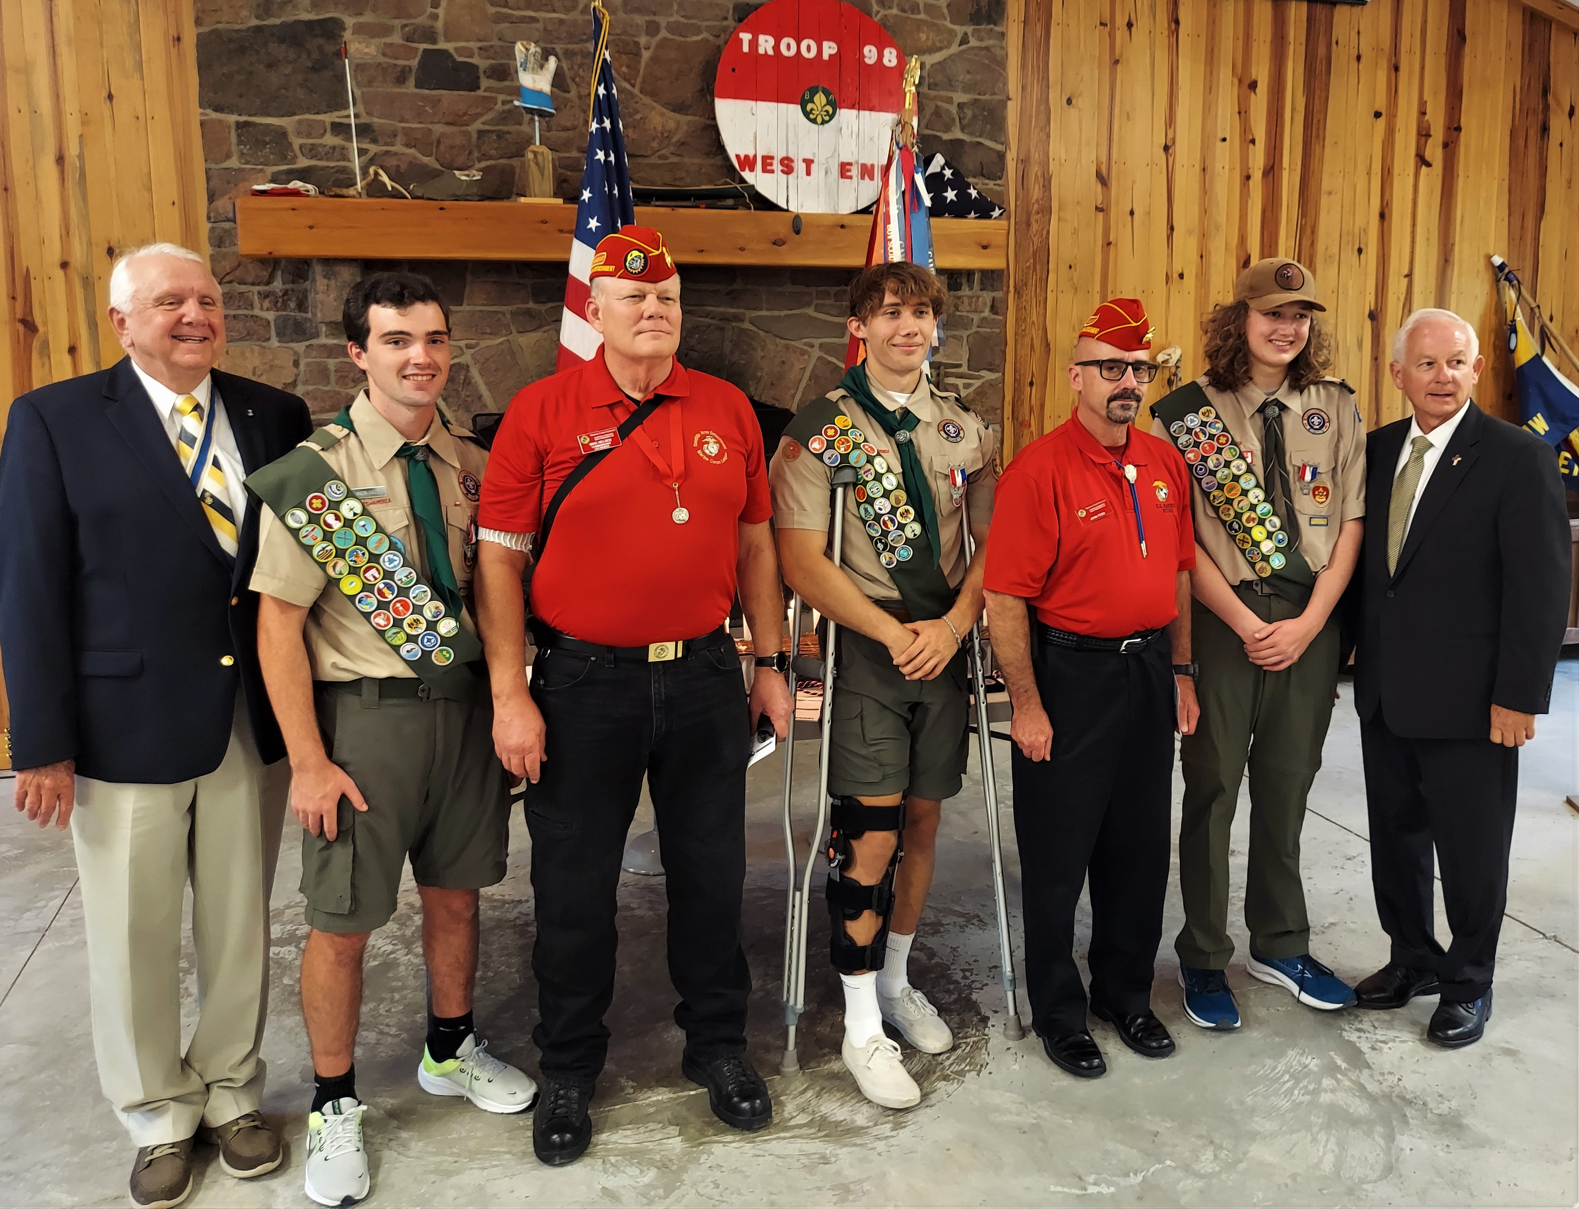

Pictured L to R, Bruce Fensley-Sandhills SAR Chapter President, Landon Caddell - Eagle Scout, Mike Nelsen – Marine Corps League, Nick Fidandis - Eagle Scout , John Fesq – Marine Corps League, Joseph Cain – Eagle Scout, Jamie Boles, Moore County - NC House Representative. (Not Pictured – Stephen Lawrence – Sandhills SAR Chapter Eagle Scout Committee- Chairman)

