Pinehurst WW II Veteran, Dr. Jack Duaner, Receives The French Legion of Honor Award.

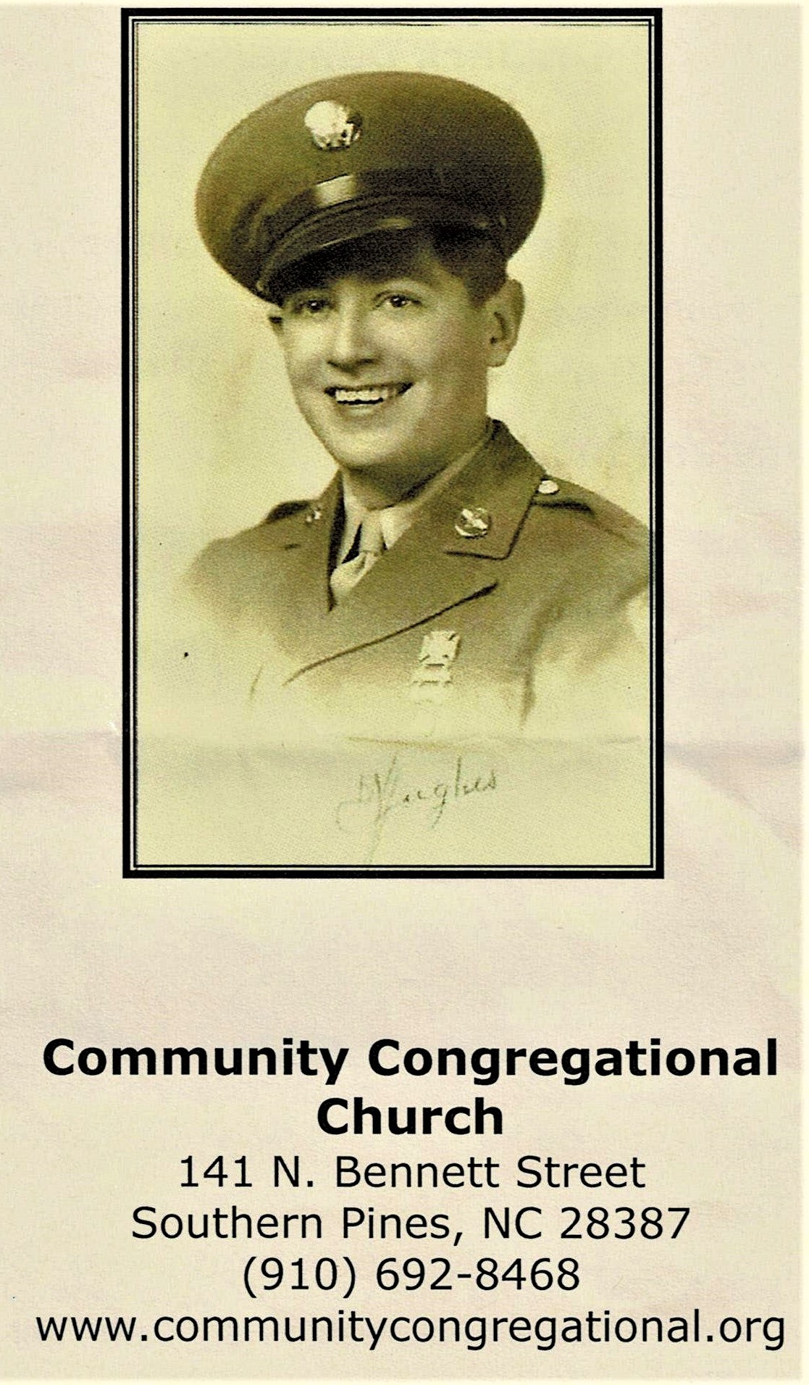

On June 1st 2022, Compatriots from the Sandhills SAR Chapter attended the Presentation Ceremony of the French Legion of Honor Award, by the Consul General of France, Mr. Vincent Hommeril, to US World War II Army Veteran, Dr. Jack Duaner (Pinehurst, NC).

Jack Duaner entered US military service in 1943, landed in Normandy in 1944 and served with the 60th Infantry, 9th Division in the prolonged Battle of the Hurtgen Forest that claimed more than 44,000 Allied causalities in just a 3-month period.

Jack was discharged in 1946, returned home to Iowa, attended the University of Iowa, earned a PHD Degree, and continued on to a very successful career in Marketing a Sales. Jack, age 98, is an active member and a "Treasure" in the parish of the Community Congregational Church in Southern Pines, NC.

Jack is truly a "Member of The Greatest Generation".
Congratulations and Thank You for Your Service to our Country from the Sandhills Chapter Compatriots and The Sons of the American Revolution.

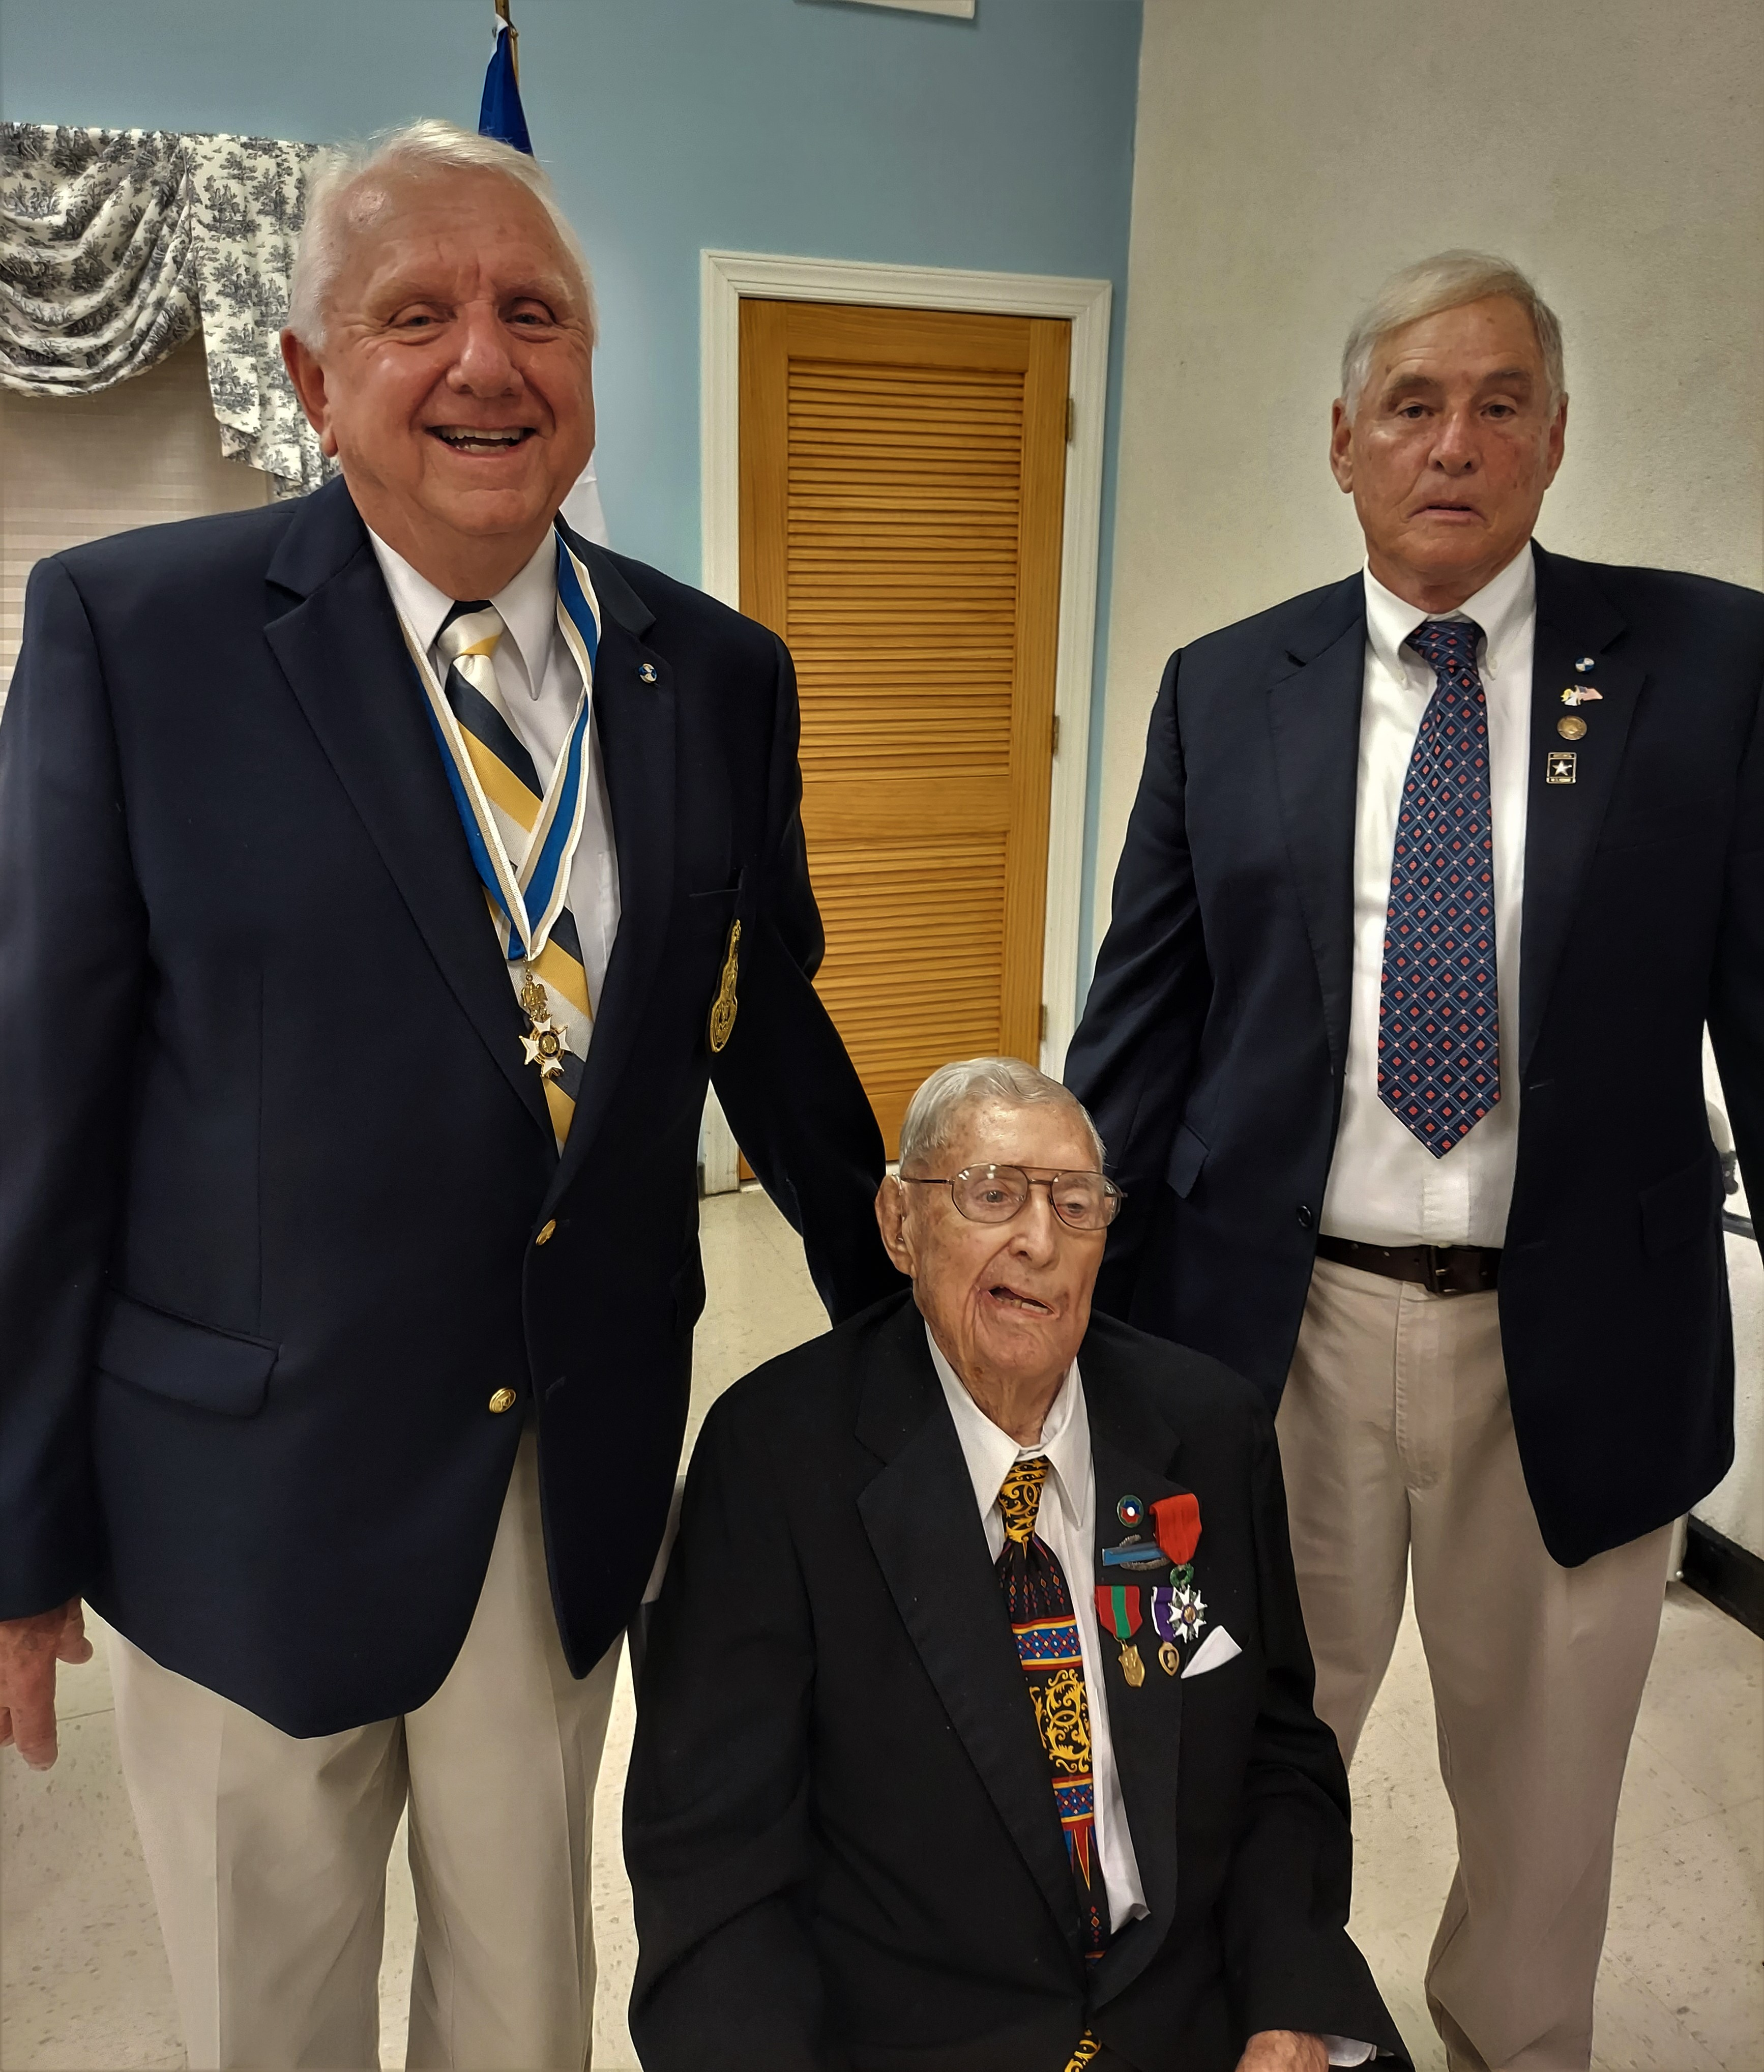
(Lft to Rt) Sandhills President Bruce Fensley, Dr. Jack Duaner, and Compatriot MAJ (Ret) Chuck Spelman)

