Sandhills Chapter Compatriot Rod Herbig Receives DAR National Award

Sandhills Chapter Charter Compatriot, Rod Herbig of Pinehurst received a surprise DAR National Award Medal and Certificate for Excellence in Community Service from Regent Jacqueline Wade of The Temperance Smith Alston DAR Chapter, at their annual Awards and Recognition Meeting at the Pinehurst Country Club May 21st. Rod has received many SAR Medals and Awards throughout his long service to the SAR. This was Rod’s first DAR National Award and Recognition. Rod also received a framed 8”x10” photo of Rod conducting a Public Class on the US Flag Laws from the Compatriots of the Sandhills Chapter.
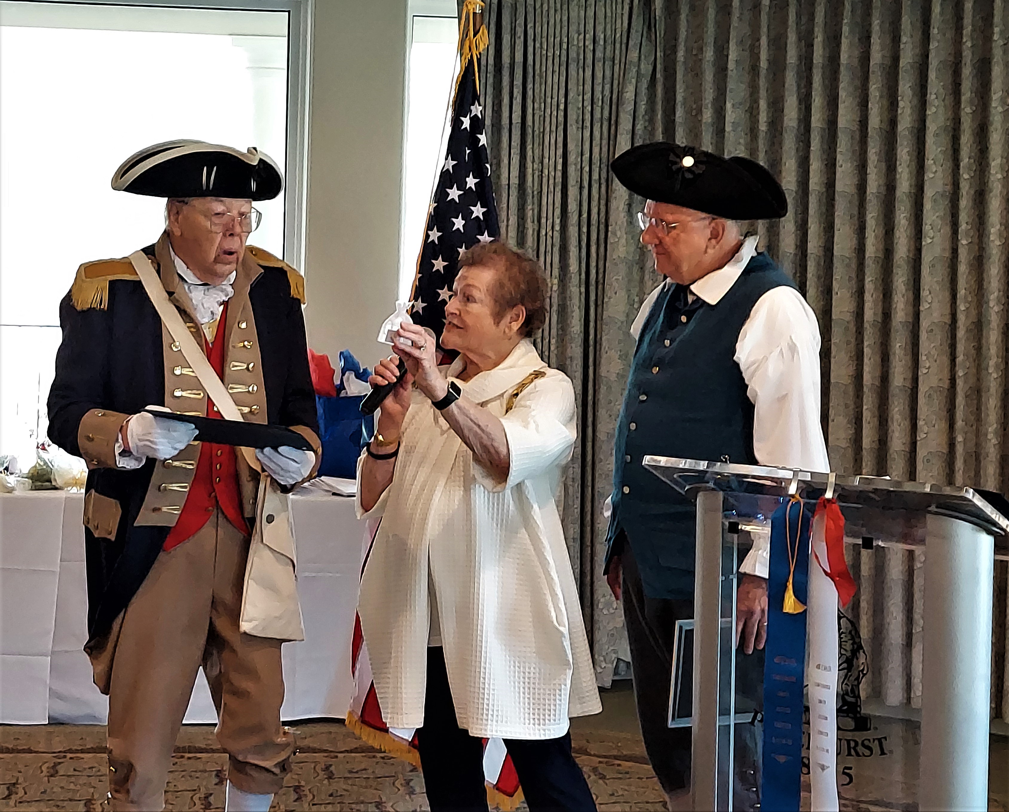

(L-R) Compatriot Rod Herbig, TSA Regent Jacqueline Wade, and Sandhills Chapter President- Bruce Fensley

