Revolutionary War – Spy Craft – Sandhills Compatriot – Dr. Mike Marsh

The Guest Speaker at the May 17th Sandhills SAR Chapter Meeting was Sandhills Compatriot, Dr. Michael Marsh. Topic- “Revolutionary War Spy Craft”. How Washington created and benefited from a network of Spies and Methods that was used to communicate, monitor British plans, and assess British strengths and weaknesses. One of Washington’s most effective methods during the Revolutionary War was to use false information “planting” and the use of deceptive actions/information about the Continental Army movements to keep the British “Wrong Footed”. This very interesting presentation included a discussion of Spy Craft methods such as; Ciphers, Coding/Decoding Techniques, Deceptions, methods used to hide & “drop” messages. Also a brief background on Continental Army’s “Chief Expert in Coding & Ciphering”, James Lovell. Mike called him “America’s One Man NSA & CIA”. Mike Marsh received a Certificate of Appreciation for his very interesting presentation.

Members from the Alfred Moore DAR Chapter attended this meeting and presentation.
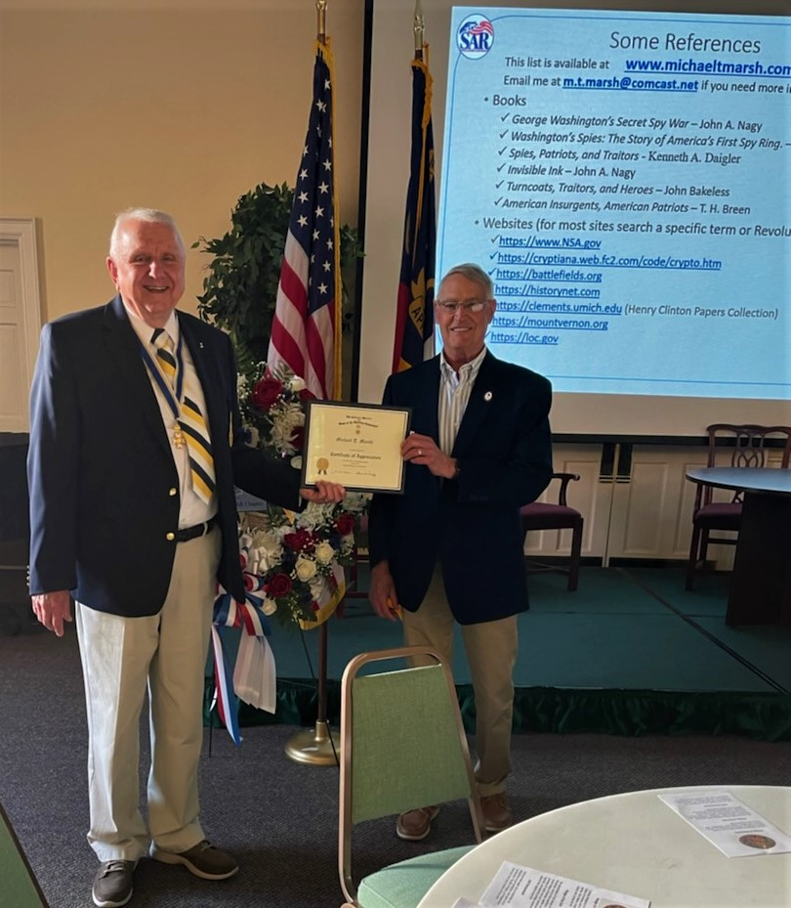

Dr. Michael Marsh Receiving a SAR Certificate of Appreciation
(L – R) Sandhills President – Bruce Fensley and Compatriot Michael Marsh.

