The Sandhills Color Guard - Alfred Moore DAR Patriot Recognition Ceremony

Compatriots of the Sandhills SAR Chapter and Color Guard attended the NCSDAR Patriots Recognition Ceremony for the Alfred Moore DAR Chapter (Southern Pines) on May 14th, at the Pinehurst Country Club. The Sandhills Color Guard Unit presented the Colors during the opening ceremony.

Regent Harriet Riley presented a very interesting Patriot Profile about Dr. George Glasscock, who served at the Battle of Guilford Court House. Dr. Glasscock is Harriet Riley’s family Patriot.

This meeting also included the installation of a new Board of Officers (2022 – 2024) and honored the outgoing Regent, Harriet Riley for her outstanding service. DAR Daughters, Jean Smyth was elected Regent and Grace Hamilton - Vice Regent. We look forward to supporting and collaborating with the new Alfred Moore Board

Bruce Fensley, Sandhills Chapter President presented SAR Greetings and thanked Harriet Riley for her strong support and cooperation with the Sandhills SAR Chapter.

The Sandhills Chapter Color Guard received a DAR Certificate of Appreciation for their support of the Alfred Moore DAR Chapter throughout the year.
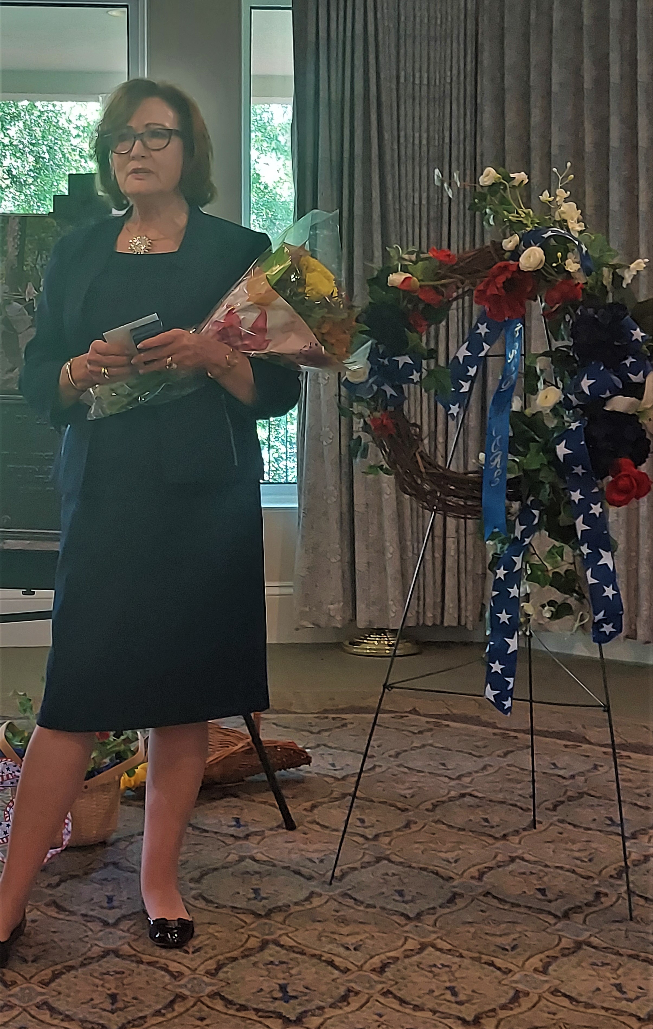
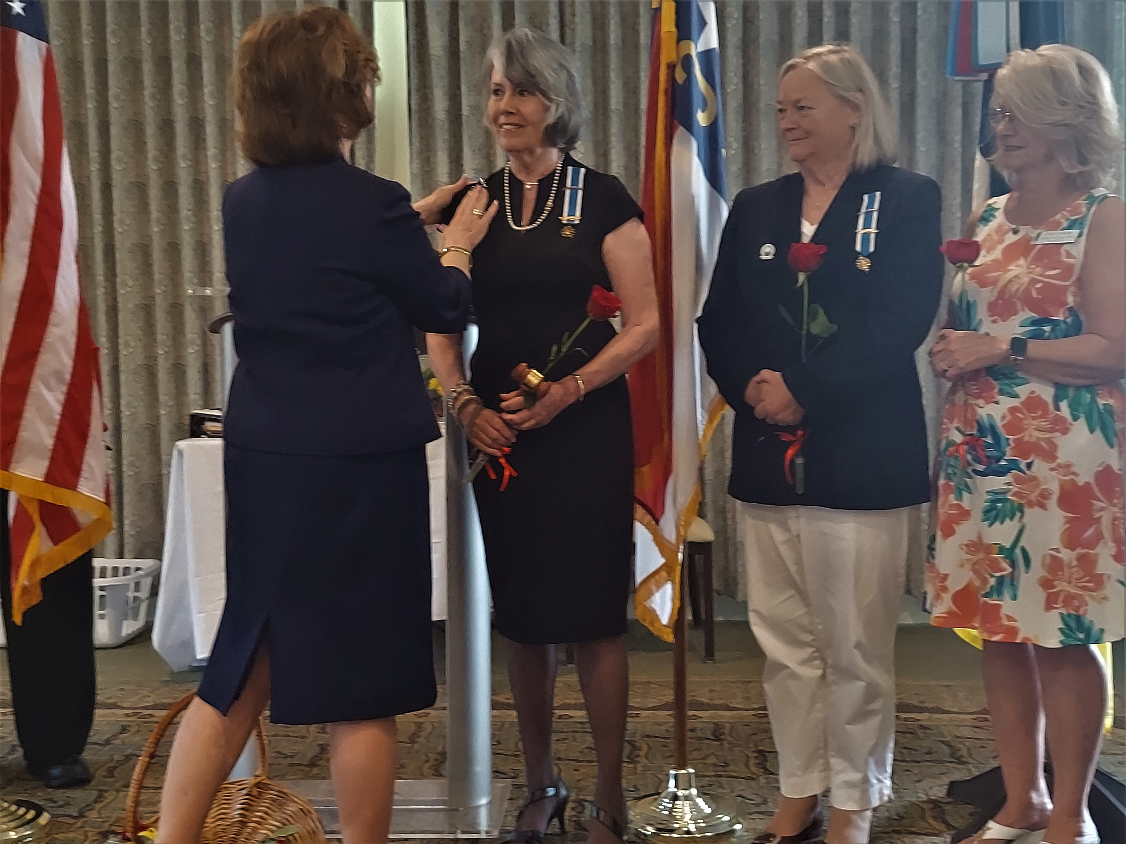

Harriet Riley – Alfred Moore DAR Regent Installation of New Regent - Jean Smyth and Grace Hamilton – Vice Regent
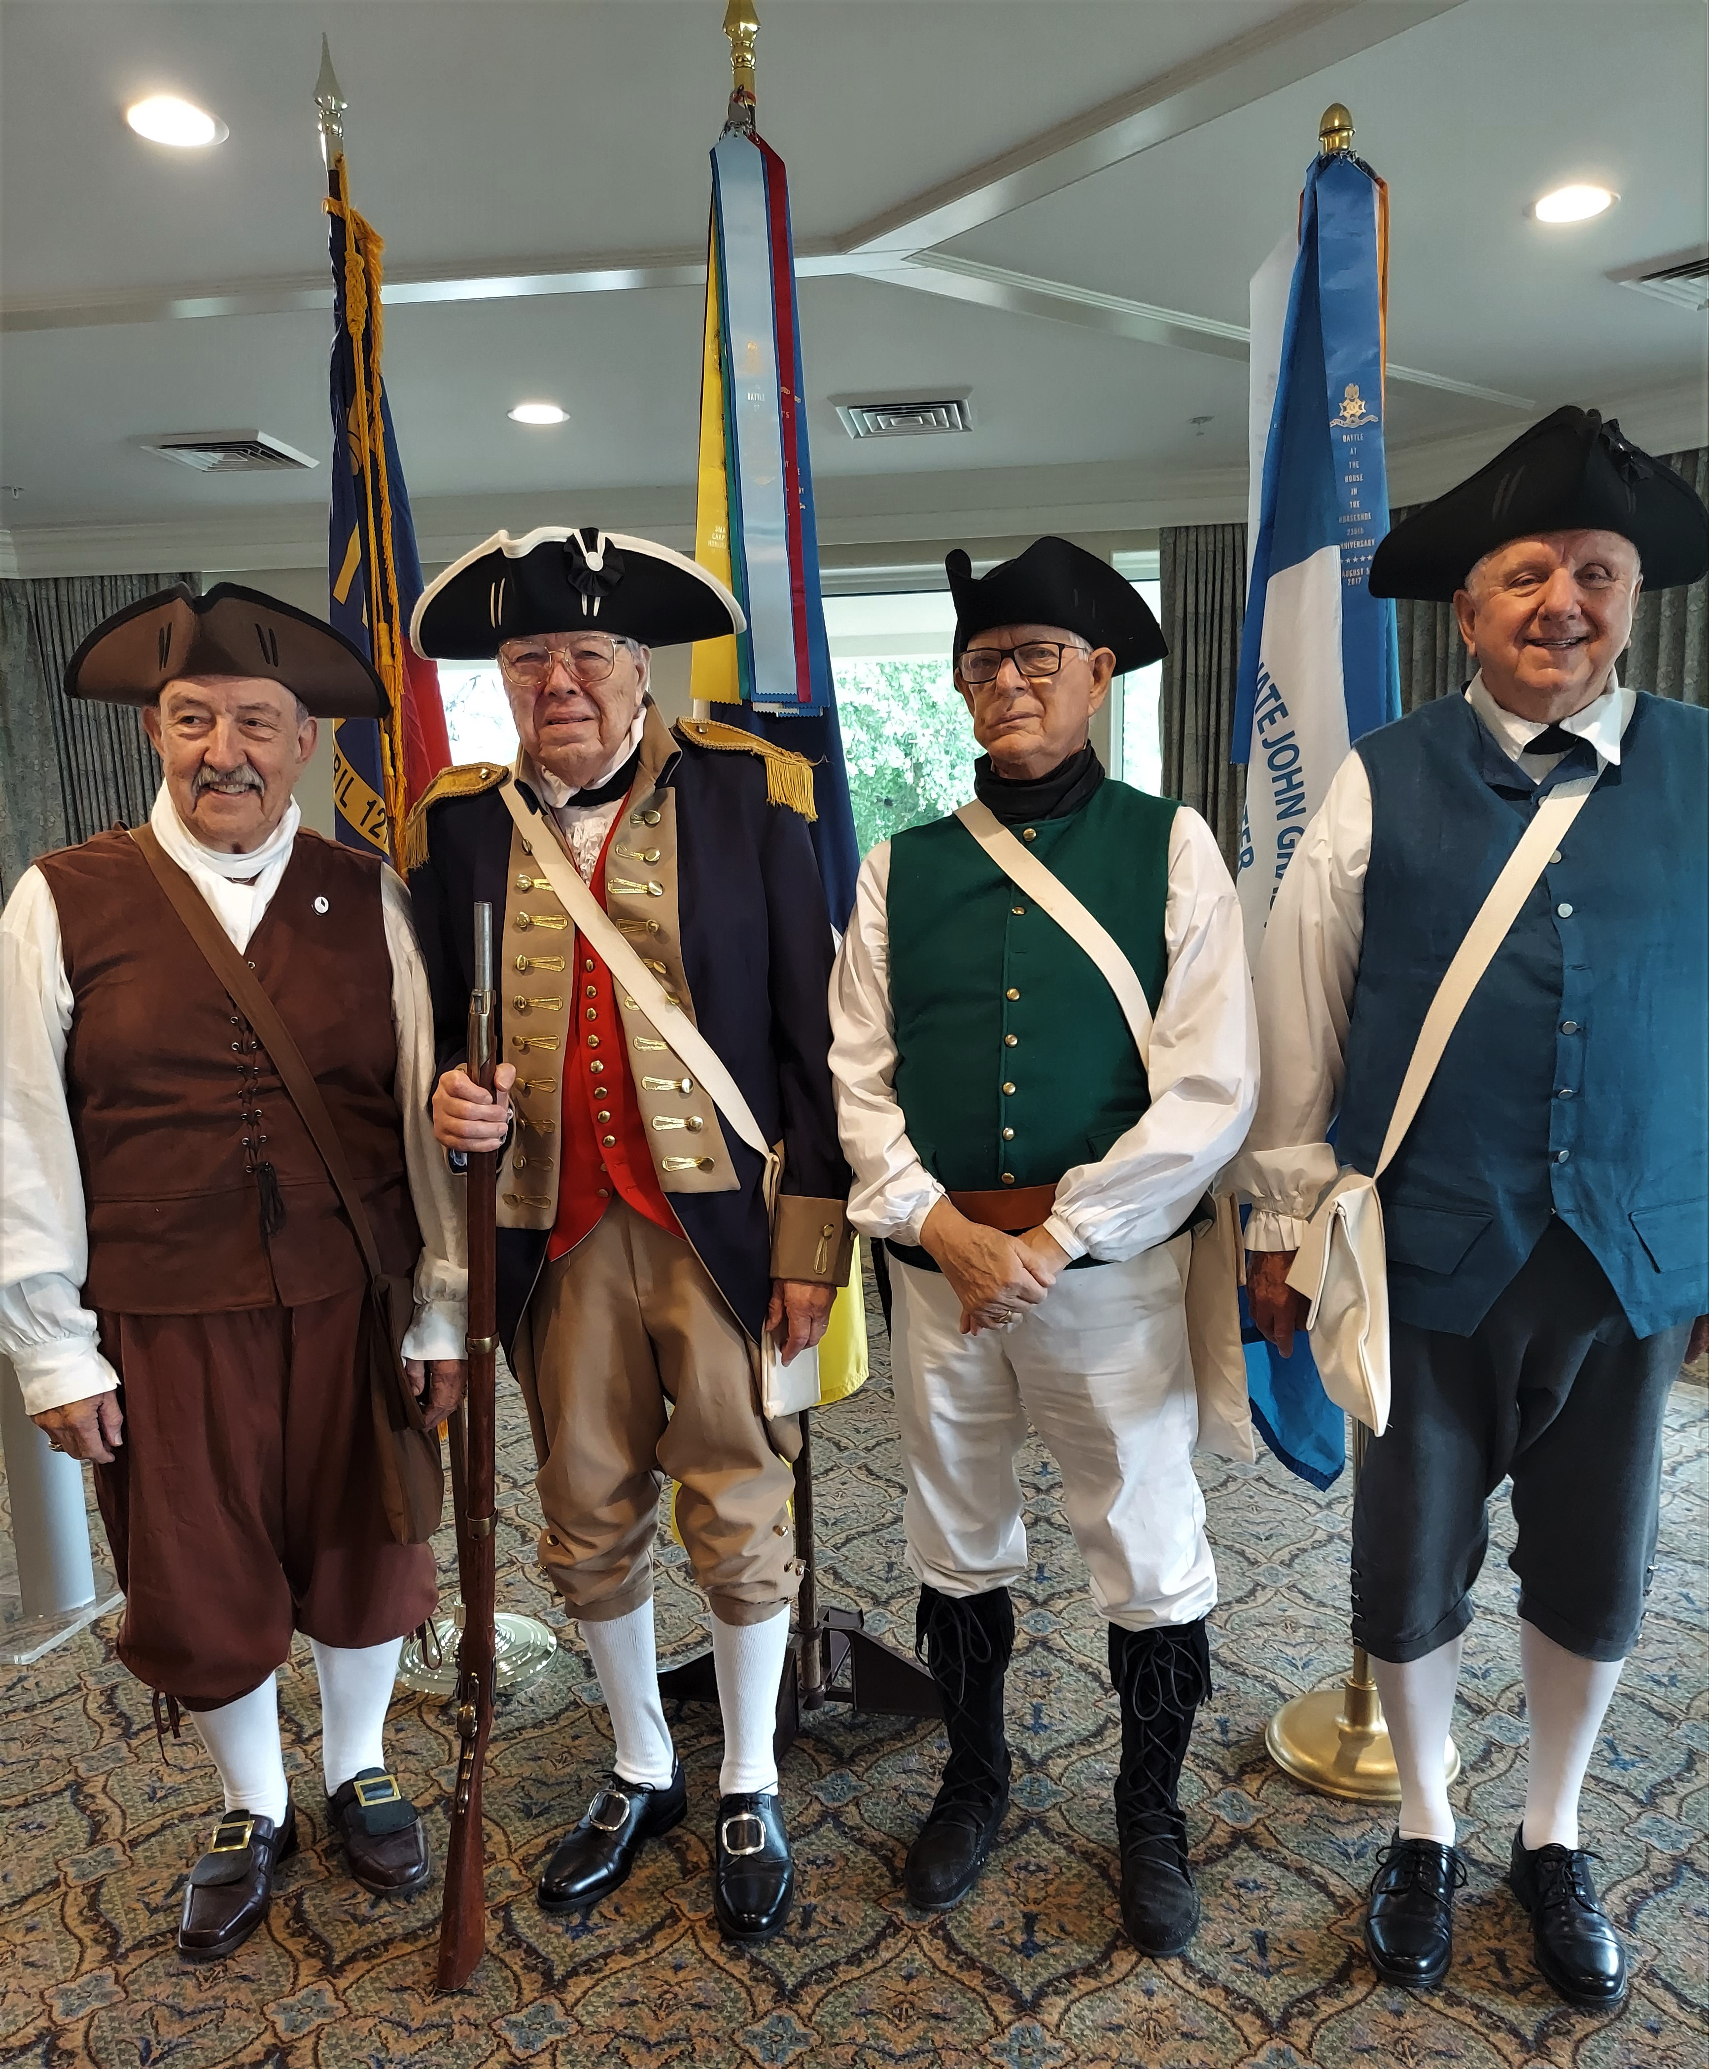

Sandhills Chapter Compatriots
(L to R) Bill Loeser, Rod Herbig, Jack
Laflin and Bruce Fensley

