The Old Scotch Cemetery Clean-Up

On Saturday March 19th, Sandhills Chapter Compatriots, joined with Members of the Moore County Historical Association to continue the cemetery clean-up at the Old Scotch Cemetery in Carthage. This old and historic cemetery contains many graves from the 18th and 19th Century. We are hoping to locate the grave sites of more Revolutionary War Patriots to be marked and honored in the future.
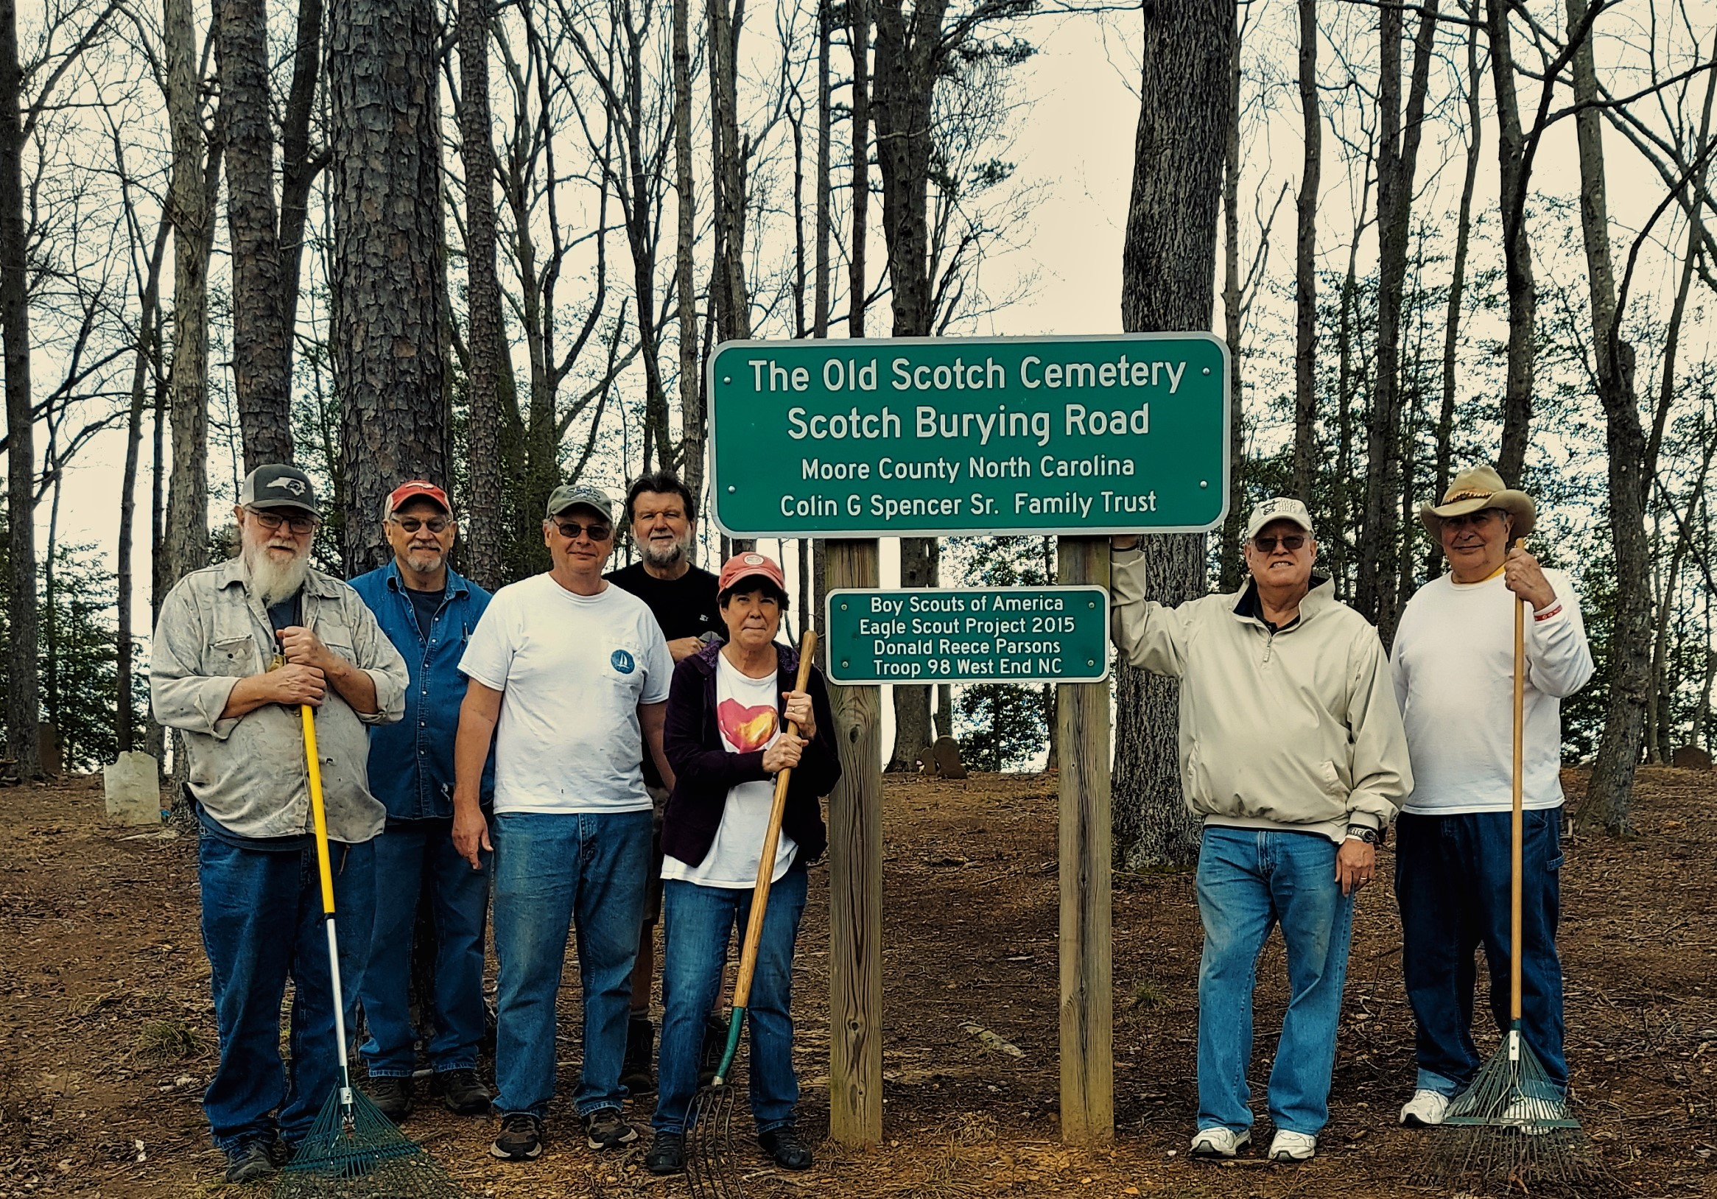

- Old Scottish Cemetery in Moore County –
One grave headstone - “Sacred to the memory of Neil McIntosh who was born Old Christmas 1772 in Scotland on the Isle of Skye and died the 29th of June 1845, aged 74 years 3 months 27 days”

The headstone is among approximately 65 markers in the Old Scottish in rural Moore County half a dozen miles west of Carthage. A thick bed of leaves carpets the sunken graves on the wooded site. Lichens and moss cover the quaintly inscribed granite and marble stones which almost blend into the surrounding oak trees. Some stones are broken.

“They came in from all around to be buried there.” Gaelic speaking Scottish Highlanders began settling in Southeastern North Carolina around 1739. The breakdown of the clan system after the defeat of the Highlanders in the Battle of Culloden in 1746 by the English resulted in more migration to North Carolina.
The Sottish settlers came from the Kintyre peninsula and the Western Isles of Jura, Islay and Skye. “They feared the whole Isle of Skye was coming to North Carolina,” said historian James Donald MacKenzie.

Scottish immigrants went up the Cape Fear River from Wilmington to Fayetteville to beyond Lillington. The English crown encouraged loyalist settlers in North Carolina to prevent the uniting of separatist in the northern and southern colonies. The Scots generally settled to the west of the Cape Fear River and the English to the East.

“This property was known as the Peter Bethune Place and, more recently, the Old Barrett Place.” Parker said. Bethune’s grave probably is the oldest in the graveyard, he said. Peter Bethune was born c. 1746 Isle of Skye, Scotland and died 1805 in Moore County NC

