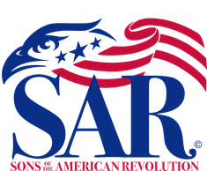

SAVE THE DATE

Searching For Your Patriots

Tuesday, April 19th 2022 Sandhills SAR Chapter Meeting
6:00 PM
Pinehurst Village Chapel

Fellow Sandhills Compatriots.

Since receiving our SAR Charter in 2020, we have been working to make arrangements to conduct a genealogy search training class for our Compatriots and Chapter Associates, who are working on their SAR applications or Supplement Applications.

Finally, we are happy to announce that Michele Horner will conduct a genealogy search class at our April 19th chapter meeting. Michele will teach us how to improve our Patriot and Family searches during her class, “Searching For Your Patriots”. She will give important; search & Organization process hints, short cuts, and share other important genealogy practices to help us.

Michele Horner is a board member of the Moore County Genealogy Association.



