Sandhills SAR Chapter Meeting – “Washington’s Spies Presentation”

February 15th, 2020, 6:00 PM
Pinehurst Village Chapel Hall
10 Azeala Rd., Pinehurst , NC 28374
----- Public is Invited -----
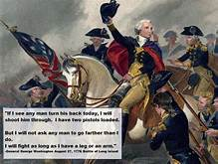
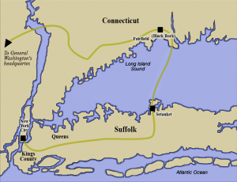

The Compatriots of the Sandhills Chapter of the Sons of the American Revolution, invites the public to join their George Washington’s Birthday Celebration meeting, at the Pinehurst Village Chapel, to hear the story about the spy network that George Washington used to keep informed about British plans to defeat the Continental Army and crush the American movement for independence from Britain.

The speaker, Mr. Franklin Merrell, a SAR Compatriot of Salisbury, North Carolina, is the retired Chair of the Industrial Engineering Program at Rowan Cabarrus Community College and the current President of the Salisbury Chapter of the North Carolina SAR. He is also an adjunct faculty member in the Systems Engineering program at UNCC, where he teaches Project Management and Quality Systems.
This presentation is about the Long Island Spy ring that Gen. Washington
developed after the disastrous Revolutionary Battle of Long Island and Manhattan.It is based on the same material as the TV series "Turn", but without the creative liberties taken by script writers. It traces the activity of the spy ring that was so deep that they were not found out until the
1930s when someone stumbled on some old family papers.

Anyone interested in learning more about the Sons of the American Revolution, please contact Mr. Jack Laflin, the Sandhills SAR Chapter, Registrar at laflin47@gmail.com.

For questions about the details this presentation, please contact Bruce Fensley at b0408fensley@gmail.com

