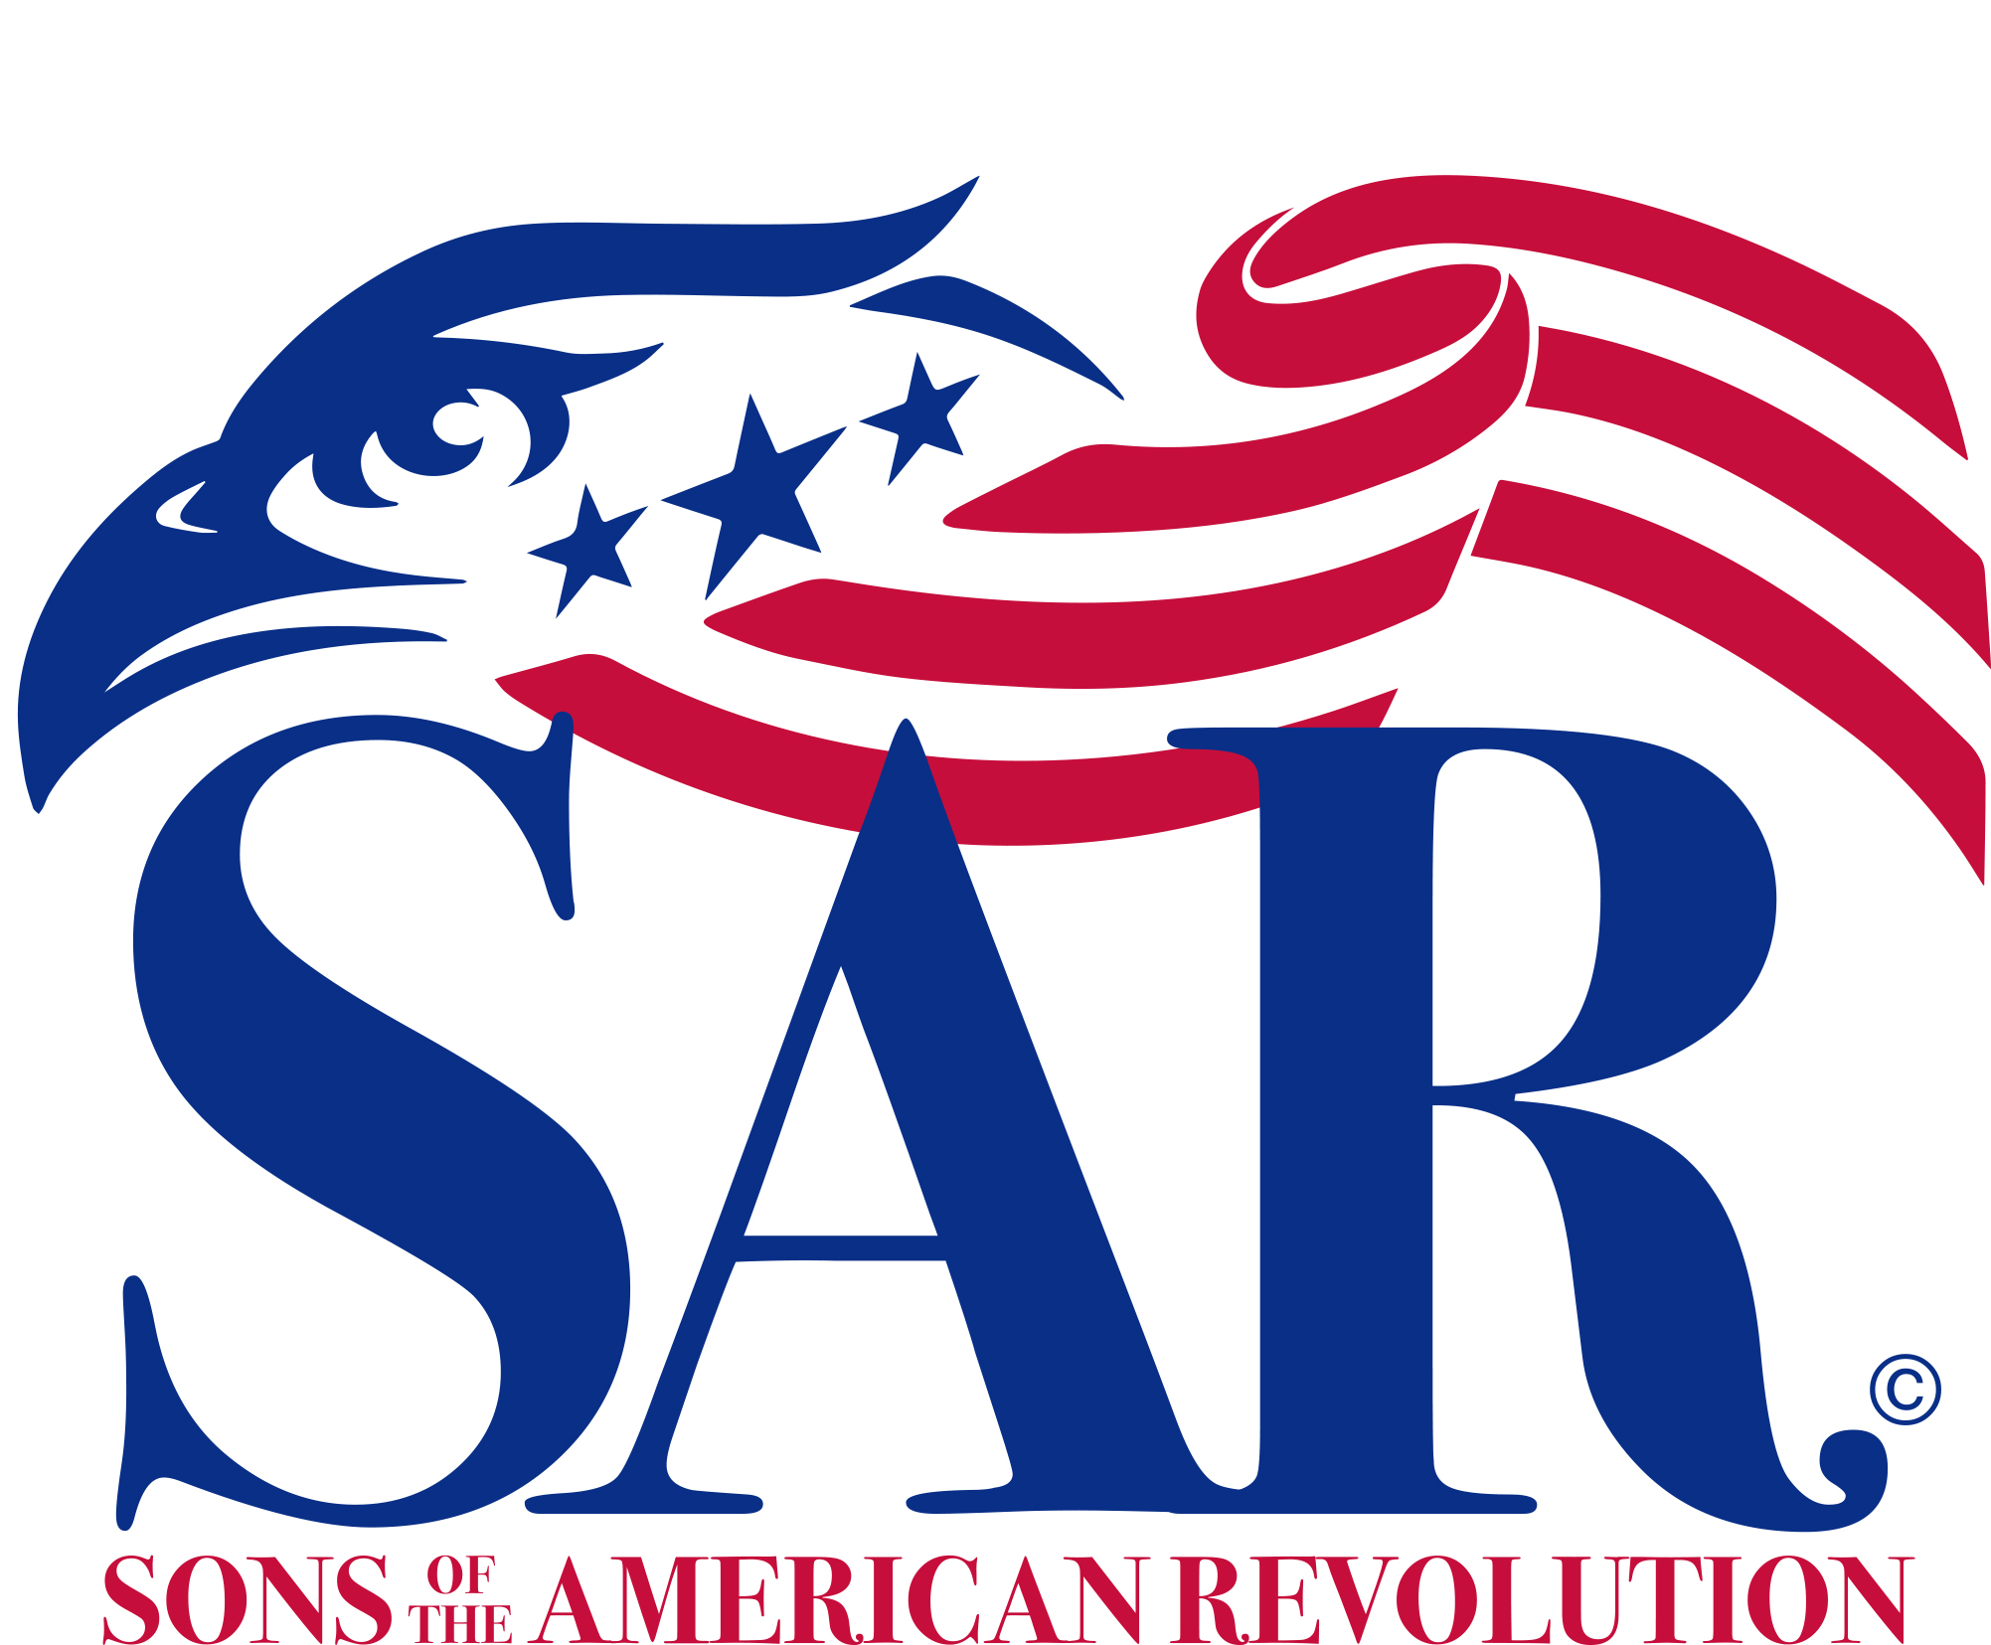

_____________________ Chapter

New Member
Guidebook
for
___________________________(Member)
___________________________(Mentor)

North Carolina Society
of the
Sons of the
American Revolution
2022
Table of Contents
Contents
GUIDE FOR NEW MEMBERS 4
NATIONAL SOCIETY OF THE SONS OF THE AMERICAN REVOLUTION 5
Mission 5
The National Headquarters for NSSAR 5
NSSAR Website 5
NSSAR Museum 5
NSSAR Store 6
NSSAR Library 6
NSSAR Pledge 6
NSSAR Recessional 6
Protocol 6
Insignia 7
National (NSSAR) Publications 8
NSSAR Handbook and National Bylaws 8
NSSAR Magazine 8
NORTH CAROLINA SOCIETY OF THE SONS OF THE AMERICAN REVOLUTION (NC SAR) 8
NC SAR History 8
NC SAR Organization 8
State (NC SAR) Online Presence 9
A BRIEF HISTORY OF THE ____________ CHAPTER……………………...……………….…………9
TYPICAL ORGANIZATION OF A NCSSAR CHAPTER………………………...……….………….9
Chapter Meeting…………………………………………………………………………...………….…..9
Chapter Mentor Program……………………………………………………………………………10
Patriot Ancestor Biography ……………………………………………………………10
Opportunities for Participation 10
Color Guard 11
JROTC 11
Scouts-Eagle Scout Recognition and Scholarship Program 11
Awards Committee 11
Veteran Committee 11
Communications Committee 11
Patriot and Compatriot Grave Marking Committee 11
Membership, Recruitment and Retention Committee 12
Educational Program Committee 12
Wreaths Across America Committee 12
Flag Committee 12
Youth Awards 12
Public Service Awards 14
Addendum I - Chapter Officers 15
Addendum II - Upcoming Events 16
Addendum III - Chapter Bylaws……………………………………………………………………… 17
Addendum IV - Common SAR Terms Defined………………………………………………… 18

GUIDE FOR NEW MEMBERS

Welcome Aboard!

CONGRATULATIONS and welcome aboard to the North Carolina Sons of the American Revolution! You have spent a considerable amount of time and effort to reach this goal! But it is a beginning - not an ending. Your Patriot Ancestor, who placed life and property in harm’s way to establish our great country, would want you to continue the work of preserving the principles of the government founded by our forefathers.

The objects of the Sons of the American Revolution are declared to be patriotic, historical and educational. Our goals are to inspire the American community at large with a profound reverence of true patriotism and to maintain and extend the institution of American Freedom.

We endeavor to do this in a variety of ways - through youth programs such as elementary, middle and high school American history contests, Eagle Scout recognitions, awards and essay contests, JROTC awards and youth scholarships and service awards. We give community service awards - Law Enforcement and Fire Safety awards and special awards for Heroism. We participate in parades, presentations at public affairs and dedications. Veterans are recognized and services are provided to those in need. We have periodic chapter meetings with a guest speaker and we work with our related organizations - the Daughters of the American Revolution (DAR) and The Children of the American Revolution (CAR).

This Guide for New Members is part of our chapter’s Mentoring program and is intended to assist you in your journey with this multi-faceted organization. Compatriot ____________________ has been assigned as your mentor. He will help guide you through your introduction to Chapter activities and events and will encourage you to become an active and participating member of the Chapter. Your chapter leadership will also help integrate you into the Chapter and are also available to answer your questions. List of Chapter Officers are provided in Addendum I.

In order to achieve the SAR goals, we will need your help. Do not become just a “card carrying” member of this great organization. The tasks are many but the rewards are great. There are some who cannot help due to health or work reasons, but those who can are in great demand.

If there is an area or position you would like to volunteer for, please let the Chapter President or Vice President know and you will be contacted regarding an assignment. Someone once said “many hands make light work” - it is true! Compatriot - we need you!

Again, welcome aboard!

NATIONAL SOCIETY OF THE SONS OF THE AMERICAN REVOLUTION

The National Society of the Sons of the American Revolution (NSSAR) was organized on April 30, 1889 -- the 100th anniversary of the inauguration of George Washington as our Nation's first President. The NSSAR was conceived as a fraternal and civic society composed of lineal descendants of the men who wintered at Valley Forge, signed the Declaration of Independence, fought in the battles of the American Revolution, served in the Continental Congress, or otherwise supported the cause of American Independence. The National Society was chartered by an Act of the United States Congress on June 9, 1906. The charter was signed by President Theodore Roosevelt, who was a member of the NSSAR.

The NSSAR, the largest male lineage organization in the US, consists of 50 societies with more than 500 local chapters, several international societies (including Canada, France, Germany,
Mexico, Spain, Switzerland and the United Kingdom), and over 33,000 members. Prominent
NSSAR members include sixteen U.S. Presidents, Sir Winston Churchill, and Kings Juan Carlos I
and Felipe VI of Spain.

NSSAR Compatriots have answered their country’s call in every major American conflict beginning with the battle of Lexington and Concord on April 19, 1775, and continuing to present day, including Operation Desert Storm, Bosnia, Afghanistan, and Iraq. NSSAR members have received the highest awards America can bestow, including the Medal of Honor.

Mission. The NSSAR is a historical, educational, and patriotic "lineage" society comprised of male descendants of patriots who supported the cause of American Independence during the years
1774-1783. It seeks to maintain and expand the meaning of patriotism, respect for our national
symbols, the value of American citizenship, and the unifying force of "e pluribus unum" that was
created from the people of many nations -- one nation and one people.

The National Headquarters for NSSAR, was originally located at 16th St NW in Washington, DC from 1927 - 1959. As the society grew more space was needed so the National Headquarters was relocated to 2412 Massachusetts Ave from 1959 - 1977. Continued growth required even more space so the National Headquarters was relocated to its current home in Louisville, KY.

809 West Main Street
Louisville, Kentucky 40202
(P) 502.589.1776 | (F) 502.589.1671

NSSAR Website - Any visitor interested in accessing the features and functions of the
NSSAR website should complete the log-in forms and create a user profile. After successfully setting up a user or membership profile, you will have access to the many tools at SAR online. The NSSAR webpage may be accessed at: www.sar.org.

NSSAR Museum - The Museum collection has grown to include artifacts from the period of America’s War for Independence and some of its most notable members. There is also a sizable collection of art work including a portrait of George Rogers Clark painted by Otto Stark and a reproduction of Houdon’s bust of George Washington. The museum is currently located in the NSSAR Administration Building in Louisville, KY.

NSSAR Store - A store for members to purchase items for the operation of Chapter, awards, NSSAR logo items and more is in operation at the National Headquarters. The NSSAR Store is where members may purchase a nametag with the NSSAR Logo, personal name and chapter name. The NSSAR Store is accessed online at the NSSAR website. Click on “Store” after establishing an account and logging into the site.

NSSAR Library - Established in 1927, the NSSAR created its library in its Washington,
DC headquarters. In 1978 the NSSAR moved its headquarters to Louisville, KY and has now grown to over 58,000 items and includes family histories, state genealogy materials, federal censuses, Revolutionary War pension applications, and CD collections. The library is open to the public and free of charge to NSSAR members, and its online catalog and other information is available at the NSSAR website. Click on “Library”.

NSSAR Pledge - We, descendants of the heroes of the American Revolution who, by their
sacrifices, established the United States of America, reaffirm our faith in the principles of liberty
and our Constitutional Republic, and solemnly pledge ourselves to defend them against every foe.

NSSAR Recessional - Until we meet again, let us remember our obligations to our forefathers,
who gave us our Constitution, the Bill of Rights, an independent Supreme Court, and a nation of
free men.

Protocol - The principles of protocol are dictated by ethics, manners, tradition, and common
sense. The basic procedures outlined in the NSSAR Handbook, in Volume 2 under Protocols, and
online on the National Website assure that most events may proceed in an orderly manner. The
following guidelines should assist every member:

1. The President General is the highest-ranking officer of the National Society and is the honored guest at any NSSAR function. The State President is the highest-ranking officer in his state.

2. NSSAR Members refer to each other as Compatriots.

3. Current and past National General Officers, State Presidents and Chapter Presidents can be identified by the neck ribbons they wear with their respective office medallions on them.

4. NSSAR meeting procedures follow Robert’s Rules of Order, Newly Revised, unless otherwise dictated by the National Society.

5. Compatriots should remain standing until the Opening Ritual is completed which includes:
Invocation, Pledge of Allegiance to the Flag of the United States of America and the NSSAR Pledge.

6. Compatriots should remain standing until the Closing Ritual is completed which includes:
Benediction, Retiring of the Colors, and the NSSAR Recessional.

Insignia
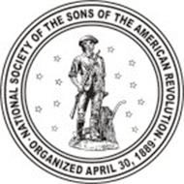
The Seal - The seal of the Society is a figure of a Minuteman grasping a musket in his right hand, surrounded by a constellation of thirteen stars which shall be depicted in the period of the American Revolution, in the act of deserting the plough for the service of his country; the whole encircled by a band with the legend, " National Society of the Sons of the American Revolution, organized April 30, 1889." The seal of the Society shall be used upon all documents and large certificates.

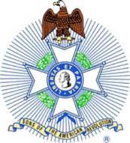
The Emblem - The emblem of the Society shall comprise (1) a silver cross of four arms covered in white with 8 gold points, and a gold medallion in the center bearing a bust of Washington in pro-file and on reverse a minuteman surrounded by ribbon enameled in blue, with the motto, "Libertas et Patria," on the obverse, and the legend, "Sons of the American Revolution," on the reverse, both in letters of gold, surrounded by an eagle in gold, (2) a rosette. The Insignia is depicted on page 1 of this Guide.

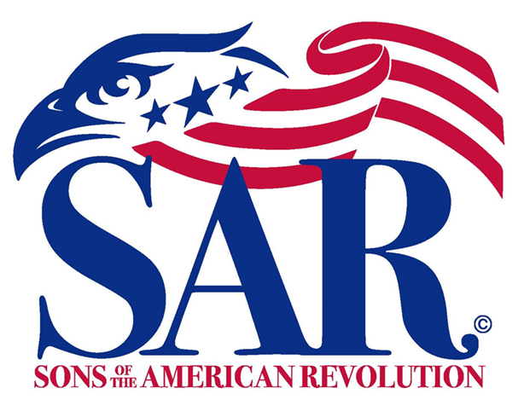
The Logo – Use of the Logo is defined in the “SAR BRAND IDENTITY GUIDE” accessible on the www.SAR.org website list of Committees (Other Committees/Branding and Engagement). State

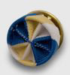
Rosette - The rosette may be worn by all members, at their discretion, on the left lapel of the jacket or shirt collar. The rosette is informal and therefore is not appropriate for formal wear. The rosette should never be worn when wearing the NSSAR Badge.

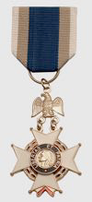
NSSAR Badge - Members may wear the NSSAR Badge bearing the Insignia on the left breast of a jacket from a chest ribbon, while current or former General Officers, National Trustees, and State Society or Chapter Presidents may wear the NSSAR Badge suspended from a neck ribbon. The chest and neck ribbons are of the NSSAR colors, with a deep blue center flanked by buff and white stripes.

Supplemental Star - The supplemental star is a gold, one quarter inch diameter, five-pointed star used to denote additional Revolutionary War ancestors that have been approved by the National Society. Supplemental stars may be displayed on the NSSAR chest ribbon.

Other Awards - Numerous Awards in the form of medals are presented to NSSAR members for their service. Each of these awards has specific requirements which must be met to receive the award, and as such each has its own hierarchy position in the protocol. These can be viewed in the NSSAR Handbook Volume 3, found online at the NSSAR website.

National (NSSAR) Publications

NSSAR Handbook and National Bylaws - This official handbook, printed after each Annual National Congress, contains the most current National Bylaws plus complete information about every aspect of the National Society. The NSSAR Handbook is an essential tool for members and provides point-to-point instructions for membership procedures, committees, contests, etc. The most current National Handbook, Bylaws and Protocol, forms and committee information can always be found online at the NSSAR website.

NSSAR Magazine - Published quarterly by the National Society, the NSSAR Magazine is a
professionally produced magazine available to its adult members, and is paid for by your national dues. It includes articles on patriotic endeavors, historic sites, people, artifacts and events, genealogy, and more. Archived editions can be found at the NSSAR website.

NORTH CAROLINA SOCIETY OF THE SONS OF THE AMERICAN REVOLUTION (NC SAR)

NC SAR History - The North Carolina SAR was chartered on February 22, 1911. The people, places and events of North Carolina during the Revolutionary War played the pivotal role in bringing the War to a victorious conclusion in Yorktown. There are so many historic battles, places and cemeteries located across the Old North State. We join together every month as chapters and compatriots to mark and honor the men, women and children who fought to bring freedom to our great country. A list of upcoming events is provided in Addendum II.

NC SAR Organization - The North Carolina SAR is an active organization of 1,000+ members located across the state in 5 regions and 27 chapters. The Chapters are divided into five regions. The NC SAR is consistently ranked and awarded as one of the top SAR state societies every year.

The NC SAR has grown in recent years with emphasis placed on:
- Perpetuating the memory of Revolutionary War Patriots.
- Promoting fellowship among their descendants.
- Inspiring the community with a reverence for the principles of government founded by our forefathers.
- Encouraging historical research of the American Revolution.
- Preserving the records of Revolutionary War Patriots.
- Marking the locations of the Revolution events and its soldiers.
- Celebrating anniversaries of the Revolution.
- Fostering true patriotism.
- Maintaining and extending institutions of American freedom.
- Carrying out the purposes of the Preamble of the Constitution.
- Following the injunctions of Washington’s farewell address to the American people.
The NC SAR Bylaws and Handbooks are the governing documents of the State Society, and its Chapters. Highlighted information contained in these documents include State Meetings, State Officers and Committee responsibilities, and Color Guard and Chapter activities. These documents also define State Meeting procedures, delegates, quorums, and elections. The NC SAR governing documents can be found online at: www.NC SAR.org/join/fees-dues/.

State (NC SAR) Online Presence

NC SAR Facebook Page - This is a Blog format with the Blog providing important
information about members who have passed away, new members who have joined,
NSSAR projects across the state, along with member contributed historical, educational
and patriotic submissions. The North Carolina SAR Facebook Page can be found at https://www.facebook.com/NorthCarolinaSAR/

NC SAR Website - The home page for NC SAR is: www.NC SAR.org. This website offers general information about NC SAR in North Carolina for non-members, complete with a list of chapters located throughout the state. Members can also find information about,
State Meetings, Youth Activities, Calendar, and more.

A BRIEF HISTORY OF THE____________ CHAPTER

[Place a brief chapter history and list of past chapter presidents here.]

TYPICAL ORGANIZATION OF A NCSSAR CHAPTER

Chapter Meeting A typical Chapter meeting agenda is:

Invocation
Pledge of Allegiance
NSSAR Pledge
Introduction of guests and members
Educational program
Officer Reports
Committee Reports
Old (Unfinished) Business
New Business
NSSAR Recessional
Benediction
Adjournment

Chapter Mentor Program - Our Mentor Program is managed within the Membership, Retention and Recruitment Committee (MRRC) led by the Chapter Vice President. The purpose of the Mentor Program is to ensure new members are smoothly transitioned into the Chapter, so they understand the scope of Chapter Activities and the various Committees Responsible for execution of those activities. It is our belief that a new member properly introduced to Chapter membership and activities will become active in the Chapter. An active and involved member is more likely to be a long-term member of NC SAR. The Mentor may be any of the following members: 1) a friend or associate of the new member; 2) a member of the Registrar team; or 3) a Compatriot assigned by the MRCC Chair or Vice President with concurrence of the new member.

Patriot Ancestor Biography – As a new member in the SAR, one of your first tasks will be to write a short biography (1-1.5 pages long) on your Patriot Ancestor which will then be uploaded into the SAR Patriot Ancestor database. The intent of this biography is to honor your Patriot Ancestor by telling more of their lives, bringing them to life with information that goes beyond the bare facts called for on the membership application. The contents can vary considerably, from simple statements of vital statistics to detailed summaries of their entire lives.

As a starting point, the information called for on your membership application will almost always be included in a biography. The information should include their date and place of birth, death, and marriage; their military, judicial, business, or legislative service; names of parents; names and dates of birth and death of children; as well as identifying which specific applications, grave information, and biographies relevant to your respective Patriot Ancestor.

Try to identify sources of evidence/references for your information...similar to footnotes or endnotes. These sources do not have to meet SAR’s current genealogical standards and service proof standards as they do for the membership application. These sources may help provide hints to guide further research by you or other family members in the future. Your mentor or a Chapter officer will provide you with some examples to help you craft your Patriot Ancestor biography.

OPPORTUNITIES FOR PARTICIPATION

The Chapter will succeed only if each member is dedicated to the goals of the SAR and lend a hand in one or several activities. To accomplish this, we will:

- Honor individuals for outstanding and unusual patriotic achievement on a national, regional, and local level.
- Honor persons for outstanding bravery and self-sacrifice in the face of imminent danger.
- Honor members of the United States Congress for outstanding service to the nation.
- Honor outstanding high school students annually with the presentation of a Bronze Good Citizenship Medal.
- Honor outstanding JROTC cadets annually with the Bronze JROTC Award.
- Honor Law Enforcement officials for outstanding service with a Law Enforcement Commendation Medal.
- Select an outstanding Eagle Scout annually at the chapter, state, and national level. The national winner receives a college scholarship.
- Honor an outstanding student for winning the Knight Essay Contest.
- Assist veterans in Veterans hospitals or homes.
- Conduct a high school historical orations contest annually.
- Sponsor Boy Scout troops and chapters of the Children of the American Revolution.
- Place SAR Markers at the grave sites of Revolutionary War Patriots and SAR Members.
- Commemorate Revolutionary War Patriots with appropriate ceremonies.
- Participate in new citizenship swearing-in ceremonies.
- Observe patriotic anniversaries.
- Collaborate with the National Society of the Daughters of the American Revolution and the Children of the American Revolution in the promotion of patriotism.

Through the following committees and activities, each chapter member has the opportunity to contribute to the overall success of the goals set by the President of the Chapter, NSSAR and NC SAR. If you have a particular interest or idea that furthers the mission of education, history and patriotism please share that idea with our Chapter Officers or committee heads. Please consider joining any of these efforts.

Color Guard - Many members enjoy wearing the uniforms of their Patriot Ancestor(s) to parades, public events, NSSAR meetings, naturalization ceremonies, grave dedications, school programs and more. Uniforms worn by our members reflect the many types of uniforms worn by
Revolutionary War soldiers. Some members wear Continental Army uniforms, others wear the
“Uniform” or clothing of Militia soldiers. Some members demonstrate the Brown Bess or
Charleville flint-lock muzzle-loading musket used by Revolutionary War soldiers.

JROTC - Recognizing future leaders of our armed forces who stand out in their service continues the tradition of honoring the Patriots who served and granted us freedom.

Scouts-Eagle Scout Recognition and Scholarship Program - This scholarship is open only to Eagle Scouts under the age of 19 and recognizes those who stand out as tomorrow’s leaders. Winners from the chapter level are advanced to the state level. If the state winner has provided a high-quality presentation, the NC SAR enters them in the NSSAR level competition.

Awards Committee - The Awards Committee is responsible for the development and execution
of the Chapter’s Awards Program. They shall recommend honorees for both intra-SAR service,
achievement and appreciation and awards for deserving non-NSSAR persons in fields such as
Scouting, proper display of the U.S. Flag, education, public safety (i.e., police, EMT, fire safety and prevention, and other first responders), military service & achievement, writing, and similar fields relating to the objectives of NSSAR.

Veterans Committee – This committee executes activities that serve the Veteran Community
including: recognition of Chapter members serving or who have served their country through military service during periods of peace or war; partnering with the Craven County Veterans Council to respond to requests for assistance with operations or other activities/events; and organizing participation of the Chapter members in the Veterans Day events.

Communications Committee -The Communication Committee includes the activities of the
newsletter editor, Chapter Facebook editor/developer, Chapter webmaster, development and
maintenance of a Chapter brochure, production of meeting programs, and public affairs.

Patriot and Compatriot Grave Marking Committee - This committee is responsible for
identifying unmarked Patriot Graves and coordinating a formal Grave Marking ceremony. These
ceremonies typically involve members in uniform, a color guard to present and retire colors, a
musket salute (if available), playing of taps, and placement of a bronze NSSAR Patriot medallion.
If a descendant of the Patriot can be located they are invited to speak about the Patriot and his
family. When a Compatriot passes, a NSSAR Member marker may be placed on his grave. The
process of placing a Compatriot grave marker mirrors that of a Patriot.

Membership, Recruitment and Retention Committee - The Committee is not only responsible for recruiting new members, but to ensure new members are welcomed, integrated and retained in the Chapter. They are the Chapter point of contact for identifying recruiting opportunities, recommending them to the Executive Board, and budgeting and executing these activities.

Educational Program Committee - The Program Committee is responsible for both the development and content of programs including speaker selection, necessary arrangements for presentation, and the order of conduct of the meeting. The Committee also encourages members who are good speakers to become lecturers as part of the NC SAR Speaker’s Bureau.

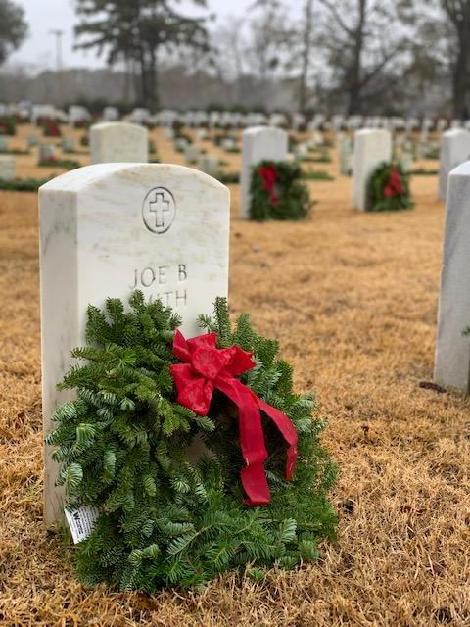
Wreaths Across America Committee – The Wreaths Across America Program partners nationally with nonprofits [501(c3)] in order to give back to the veteran and military communities through our own programs. As a fundraising event, sponsored wreaths are placed in honor of an American hero on the 7,000 graves at the National Cemeteries and state veterans cemeteries on a specified Saturday in December each year. The Chapter will use these funds to support our annual programs such as youth awards, American flags for Habitat for Humanity homes, and Veteran recognition programs.

Flag Committee - The Flag Committee develops programs to encourage patriotic respect for the flag of the United States, including Flag Day programs for the week ending June 14th each year. The committee identifies and develops resources on the history of the U.S. Flag for use by the local community. The committee also coordinates the chapter’s participation in home dedication ceremony for Habitat for Humanity.

Youth Awards

The SAR invests in our nation's young people to ensure the principles of the SAR are continued into the future. The SAR honors the leadership development and the public service commitment of young people with awards. These awards are aimed toward about 2,500 Eagle Scouts, 2,500 JROTC cadets (high school), 500 ROTC cadets (college), and one senior at each of the U.S. military service academies (Army: West Point; Navy: Annapolis; Air Force: Colorado Springs; and Coast Guard: New London). We also provide opportunities for youths to participate in several local, North Carolina state, and national competitions to deepen their understanding and appreciation of our Nation’s founding through art, writing, and oration. The details of each program and award are presented on the NC SAR site. A synopsis of the awards follows:

- American Elementary School Poster Contest: The North Carolina Americanism Poster Contest is intended to stimulate interest in American History in support of the established school curriculum. This contest is directed at students in the 3rd-5th grades, depending on which year the American Revolution is taught in their educational system – including ecumenical and home-schooled students. The contest is also open to members of the Cub Scouts, Brownies, and CAR whose school system may not be participating in the contest. In the case where the local school system, or its equivalent, is participating, the young person must enter the contest through the school and not as a separate entry.

- American Middle School Brochure Contest: The aim of this contest is to stimulate interest in American History in support of the established school curriculum. This contest is directed at students in the 7th or 8th grades, depending on which year the American Revolution is taught in their educational system – including ecumenical and home-schooled students. This completion was begun to aid studies at the school grades following elementary school and before the sophomore grade in high school. If the American Revolution period of American History is technically not specifically covered during these middle school grades, an entry will still be accepted for the competition by the state society.

- Dr. Tom & Betty Lawrence American History Teacher Award: The SAR aims to identify, recognize, and commend outstanding social studies teachers. These extraordinary educators at private, public, and parochial institutions, who teach our children in a middle or high school setting, will be recognized for actively addressing the history of the American Revolution era. The award winner will be able to choose a trip to one of the following:

- Freedoms Foundation Summer Teacher Graduate Workshop, Valley Forge, PA.
- Colonial Williamsburg Summer Teacher Workshop, Williamsburg, VA.
- Jefferson Symposium at the University of Virginia, Charlottesville, VA.
- SAR Annual Conference on the American Revolution.

This award, valued at $1,400, will reimburse the winner for expenses including tuition, room and board, and transportation. The SAR will provide this professional educational opportunity to an educator who will bring back to the classroom a heightened level of creativity and enthusiasm to their students of the American Revolutionary era.

- Eagle Scout Recognition and Scholarship Program: For many years the SAR has recognized the many common bonds of purpose and principles shared by the SAR and the Boy Scouts of America. Young men achieving the rank of Eagle Scout have demonstrated their belief in these common principles. For this reason, the SAR believes that Eagle Scouts are deserving of special recognition for their dedication and accomplishment. There is a recognition of all new Eagle Scouts. This does not depend on any later decision by the new Eagle Scout about whether to compete for the scholarships available. It merely requires someone in the scout troop adult leadership to send a request for the SAR Eagle Scout Recognition Certificate.

- Junior ROTC Recognition: The SAR awards bronze Minuteman medals and a certificate to the outstanding JROTC cadet in each unit across the State. In 1998 the program was expanded to recognize outstanding cadets at the state and national levels as well. Cadets are nominated to the state competitions by their unit’s Senior Military Science Instructor. Nominees to this program must be in their next-to-last year of JROTC (e.g., a third-year cadet in a four-year program or a second-year cadet in a two-year program). Selection criteria: patriotism, leadership, military bearing, and scholarship. Nominated cadets must rank in the top 25% of their high school class and in the top 10% of the JROTC cadets.

- Joseph S. Rumbaugh Historical Oration Contest: The Joseph S. Rumbaugh Historical Oration Contest is open to all students attending home schools, public, parochial, or private high schools in North Carolina and who are in Grades 9-12. It is sponsored by the North Carolina Society. The winner of the NC contest will be awarded a $750 cash prize and a certificate and will be entered into the national contest, if they so desire. The rules and prizes are the same as those described on the National Society website under Youth and Educational Outreach Programs.

- North Carolina Knight Essay Contest: This contest was originally named in honor of SAR Compatriot President Calvin Coolidge who won an SAR essay contest while a student at Amherst. Compatriot McCarthy DeMere reestablished the contest in 1988. In 1995, the contest was renamed the George S. and Stella M. Knight Essay Contest in honor of their generous gift to the SAR to support this contest. The contest is designed to give high school students an opportunity to explore events that shaped American History.

Public Service Awards

- Law Enforcement Commendation Medal: The Law Enforcement Commendation Medal is presented to those who have served with distinction and devotion in the field of law enforcement. The medal is intended to recognize exceptional service or accomplishment in the field of law enforcement. Eligibility is not limited to peace officers but extends to the entire range of persons who make and enforce the law to include but not limited to peace officers, attorneys, judges, prosecutors and legislators who have performed an exceptional act or service beyond that normally expected. The medal may be presented posthumously.

- Fire Safety Commendation Medal: The Fire Safety Commendation Medal is presented to an individual for accomplishments and/or outstanding contributions in an area of fire safety and service. The award is not limited to firefighters. It may be presented to recognize a variety of fire safety and service that has evolved into a highly technical and skilled profession with constant study, development and involvement by numerous dedicated citizens with a single goal - protect human life and property by preventing injuries or casualties due to fire and chemicals. The medal may be presented posthumously.

- Emergency Medical Services (EMS) Commendation Medal: The Emergency Medical Services Commendation Medal is presented to an individual for accomplishments and/or outstanding contribution in an area of emergency medical services. The award is intended for paramedics and certified Emergency Medical Technicians and others in the emergency medical field who have performed an act or service beyond that normally expected. The medal may be presented posthumously.

- Heroism Medal: This medal recognizes outstanding bravery and self-sacrifice in the face of imminent danger, that is, acts which involve great personal courage and risk to the recipient. It is intended primarily for acts by civilians not in uniform but does not exclude police, firemen, and SAR members. It is not intended to recognize acts that would have been covered by Armed Forces medals for valor. The medal may also be presented posthumously.

Addendum I - Chapter Officers

• President: ________________
Phone Cell:
Phone Home
Email:

• Vice President: ________________
Phone Cell:
Phone Home
Email:

• Treasurer: ________________
Phone Cell:
Phone Home
Email:

• Secretary: ________________
Phone Cell:
Phone Home
Email:

• Registrar: ________________
Phone Cell:
Phone Home
Email:

• Chaplain: ________________
Phone Cell:
Phone Home
Email:

• Historian: ________________
Phone Cell:
Phone Home
Email:

• Other Officer: ________________
Phone Cell:
Phone Home
Email:

Addendum II - Upcoming Events
Date of Event | Event | Historic Date | National  Event | State  Event | Responsible Chapter
Jan 16, 2022 | Battle of Cowpens | Jan 17, 1781 | Yes |  | SCSSAR Daniel Morgan
Jan 29, 2022 | Battle of Cowan’s Ford | Feb 1, 1781 | Yes |  | Mecklenburg
Feb 21, 2022 | George Washington Birthday | Feb 22, 1732 | Yes |  | Various
Feb 267, 2022 | Battle of Moores Creek Bridge | Feb 27, 1776 | Yes |  | Lower Cape Fear
Mar 12, 2022 | Battle of Guilford Courthouse | Mar 15, 1781 | Yes |  | Nathaniel Greene
Apr 12, 2022 | Halifax Resolves | Apr 12, 1776 | Yes |  | Halifax Resolves
May 14, 2022 | Patriot’s Day at Alamance | May 16, 1771 |  | Yes | Alamance Battleground
May 30, 2022 | Memorial Day | May 30, 1868 | Yes |  | Various locations
Jun 4, 2022 | Battle of Ramsour’s Mill | Jun 20, 1780 | Yes |  | Catawba Valley
Jun 18, 2022 | Liberty Point Resolves | Jun 20, 1775 |  |  | Le Marquis de Lafayette
Jun 14, 2022 | Flag Day | Jun 14, 1777 | Yes |  | Various
Jul 4, 2022 | Fourth of July | Jul 4, 1776 | Yes |  | Various
Jul 23, 2022 | Battle of Colson’s Mill | Jul 21, 1780 |  | Yes | Colson’s Mill
Jul 30, 2022 | Battle of Rockfish Creek | Aug 2, 1781 |  |  | Col Alexander Lillington
Aug 6, 2022 | House on the Horseshoe | Aug 5, 1781 |  | Yes | Le Marquis de Lafayette
Aug 13, 2022 | Tryon Resolves | Aug 14, 1775 |  | Yes | Battle of Kings Mountain
Aug 27, 2022 | New Bern Resolves | August 28, 1774 |  |  | New Bern
Sep 17-23, 2022 | Constitution Week | Sep 17-23 | Yes |  | Various
Oct 7, 2022 | Battle of Kings Mountain | Oct 7, 1780 | Yes |  | Battle of Kings Mountain
Oct 15, 2022 | Battle of Shallow Ford | Oct 14, 1780 |  | Yes | Bethabara
Oct 19, 2022 | Yorktown Victory Day | Oct 19, 1781 | Yes |  | VASSAR Thomas Nelson, Jr.
Nov 11, 2022 | Veterans Day | Nov 11, 1918 | Yes |  | Various
Dec 3, 2022 | Battle of Great Bridge | Dec 9, 1775 | Yes |  | VASSAR Norfolk
Dec 17, 2022 | Wreaths Across America | Dec 15, 1992 | Yes |  | Various

Addendum III
Chapter Bylaws
Bylaws
______________ Chapter of the North Carolina Society
Sons of the American Revolution
- Updated _______ 20xx -

[Place Chapter Bylaws here]

Addendum IV – Common SAR Terms Defined

Compatriot is the official designation of a member of the National Society of the Sons of the American Revolution.
Membership categories are Regular Member or Regular Life Member the age of 18 years and older, Junior Member under the age of 18 years, and Memorial Membership for a deceased male of the same family as current members.
SAR (always pronounced as letters, never as a one syllable term) is the acronym for National Society of the Sons of the American Revolution.
SAR Member Badge is worn by a compatriot at SAR functions and when presenting the SAR. It is a Maltese cross of four arms and eight points with a bust of George Washington at its center and available from the SAR Store at https://store.sar.org/product/member-badge.
SAR Rosette is worn by a compatriot, at his discretion, on the left lapel of his jacket, but is not worn simultaneously with the SAR Member Badge. It may be purchased from the SAR Store athttps://store.sar.org/product/member-rosette.
Annual Congress, sometimes simply called “Congress,” is the yearly convention of the National Society hosted by a State Society. State Societies select delegates based upon its membership but every compatriot is welcome to attend; spouses and family members are also welcome.
General Officer is the term given to the National Society officers elected at the Annual Congress to one year terms. The President General is the Chief Executive Officer of the National Society, followed in descending rank by Secretary General, Treasurer General, Chancellor General, Genealogist General, Registrar General, Historian General, Librarian General, Surgeon General, and Chaplain General. A Vice President General is nominated by each District (see below) and elected at Congress.
Trustee is the member nominated by his State Society to serve a one year term and is elected at the Annual Congress to serve on the Board of Trustees; General Officers, Executive Committee Members, and Former Presidents General are also elected to the Board of Trustees.
Board of Trustees manages the business and affairs of the National Society and is the custodian of all National Society property; each State Society is represented by one Trustee.
State Society is chartered by the National Society in any State or Territory, including any foreign country, in which a Society does not exist.
Chapter is the local organization chartered by a State Society to promote growth in membership and interest in the objects of the National Society.
District is group of State Societies served by a Vice President General to strengthen the constituent State Societies.
Leadership Meeting is each fall and spring in Louisville, KY at which National committees meet to make recommendations and the Board of Trustees manages the business and affairs of the National Society.
SAR Education Center and Museum is at 809 West Main, Louisville, KY. SAR is active in education and raising funds to complete the SAR Education Center and Museum.
SAR Color Guard is the compatriots who attend SAR meetings and events properly uniformed as either Continental Soldiers or Militiamen, or attired as Revolutionary-era clergymen.
Ladies’ Auxiliary provides assistance to SAR at Chapter, State Society, and National Society levels. Membership is open to ladies who are related by marriage or blood line to SAR Members in good standing

