Sandhills SAR Chapter
Respectful US Flag Retirement Program

Sandhills SAR Chapter Compatriot, Army MAJ (Ret.) Charles (Chuck) Spelman of Seven Lakes, NC, designed and built two containers (Pictured Below) for the Public to use to retire weather worn US Flags. Chuck is also the Chairman of the Sandhills Chapter Veterans Recognition Committee. One the containers was placed in the lobby of the Moore County Public Offices, near the Veterans Services Office. The other container was placed at the entrance to the Veterans Memorial Park in Carthage, NC.

Worn US Flags should never be disposed of in trash collections. Flag Law - US Code, Title 4, Chapter. 1, The Flag, Sect. #8, Respect for the Flag, Para. (k) “the flag, when it is in such condition that it is no longer a fitting emblem for display, should be destroyed in a dignified way, preferably by burning”.

The public response to this Flag Retirement program has been outstanding. In only a few months, 74 weather worn US Flags have been folded and deposited. These flags are provided to local crematoriums and are made available to the families for our fallen Veterans.

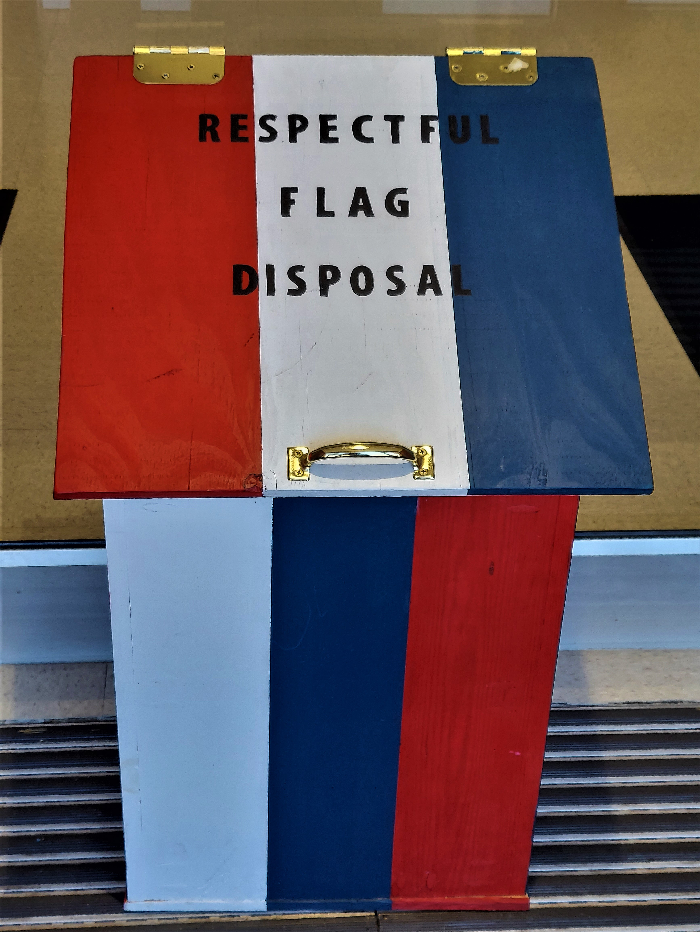
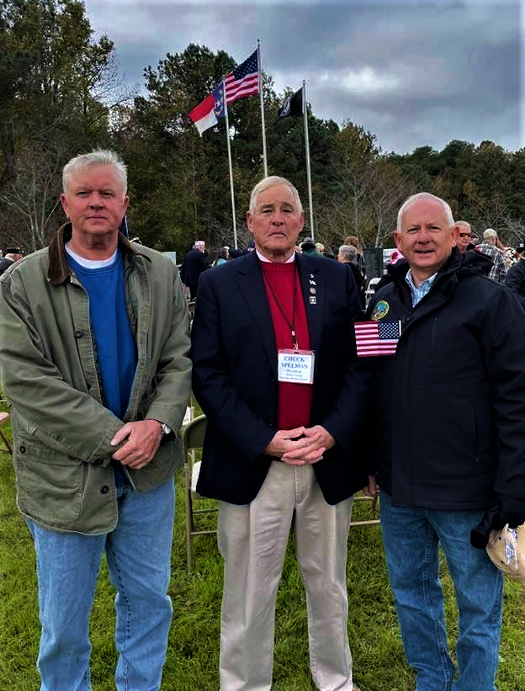
Compatriot Charles Spelman (Pictured Center)
Veterans Memorial Park, Carthage, NC

