MOAA Veterans Day Ceremony
November 11, 2011

Members of the Sandhills SAR Chapter joined the Sandhills MOAA Veterans Day Memorial Ceremony at the Community Presbyterian Church in Pinehurst, NC.

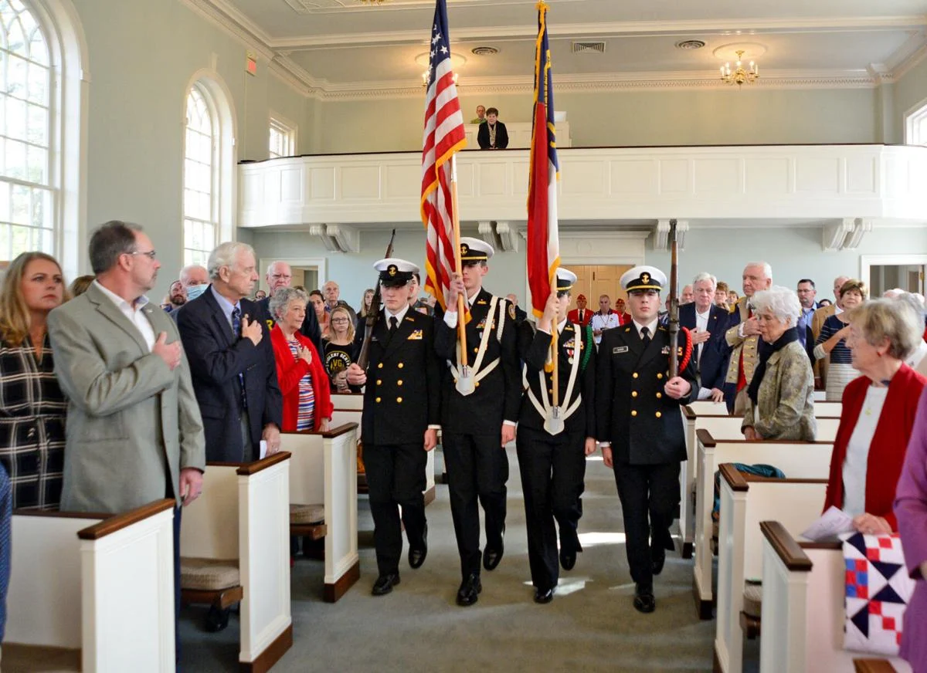
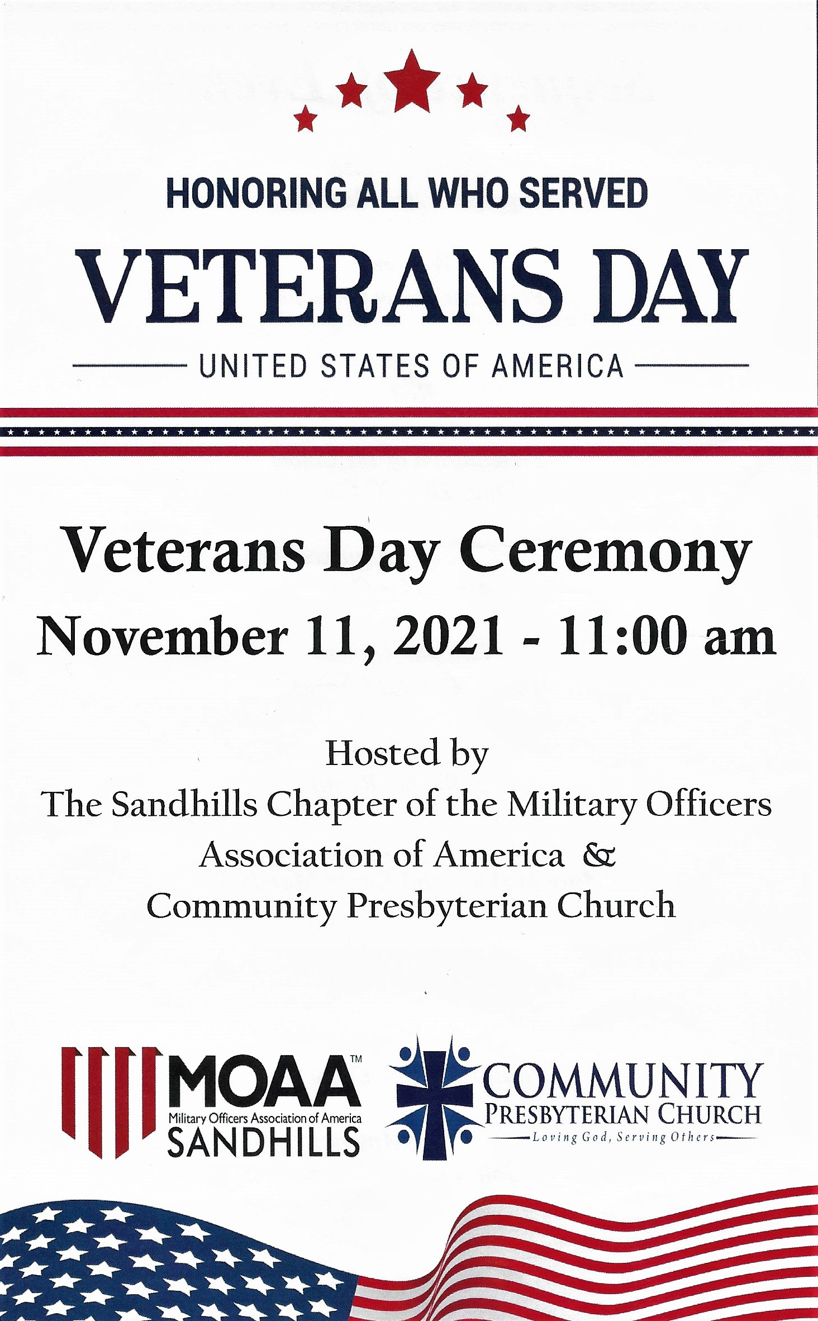
Union Pines JROTC Unit performed an impressive Color Guard presentation during the Ceremony.

Rev. Rod Stone opened the ceremony with his Invocation, followed by Boy Scout Alexander Goss led the assembly with the Pledge Allegiance.

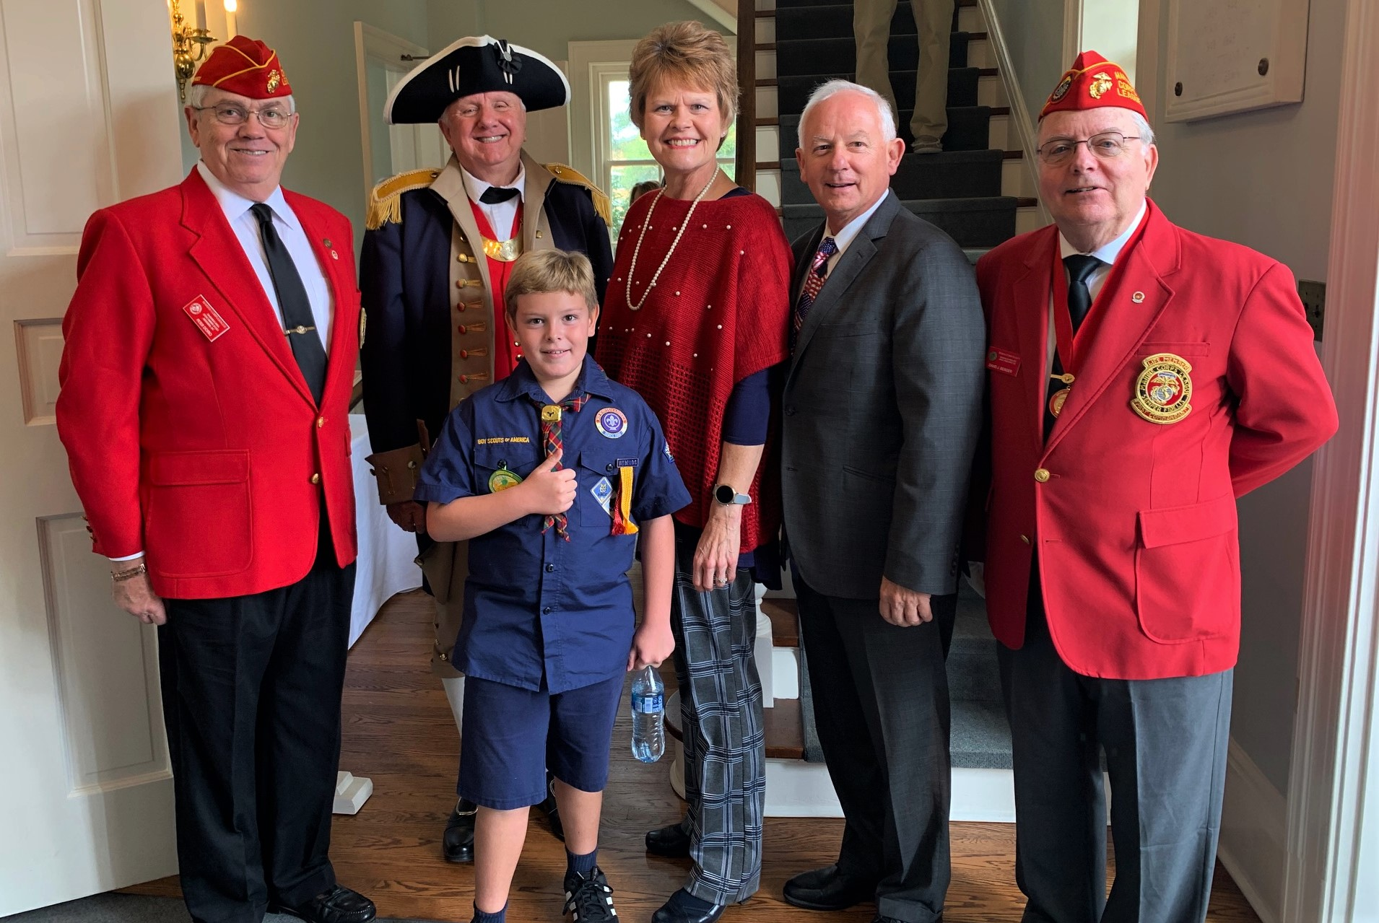

The ladies of the Pinehurst, "Quilts for Valor", presented 6 beautiful patriotic quilts to deserving Military Veterans and active US Military soldiers.

It was an Honor for the Sandhills SAR Chapter to participate in this very special Veterans Day Memorial Event.

