Sunday November 7th, Vietnam Veterans Field of Honor Ceremony

Members of the Sandhills SAR Chapter participated in The Vietnam Veterans of America, Chapter 966 (Moore County) Sponsored the Annual - Field Of Honor- Veterans Day Ceremony, at the West End Fire Dept.

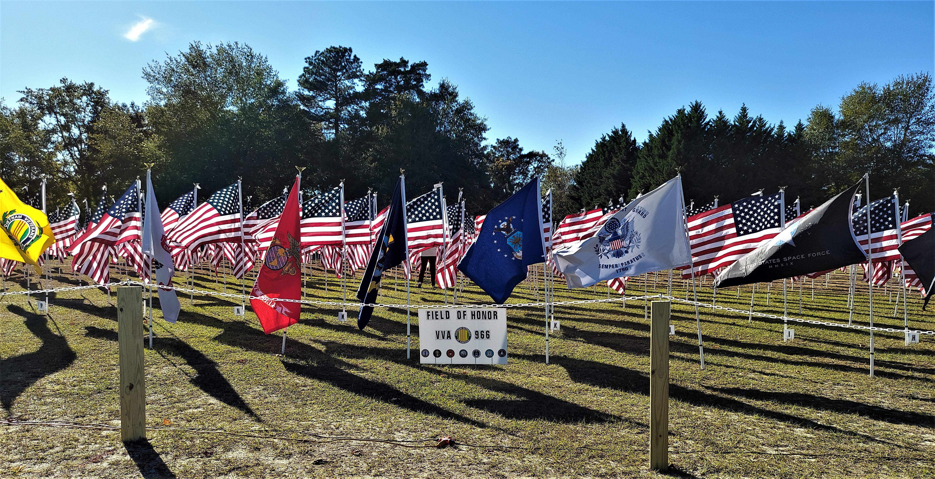
Chapter 966 of the Vietnam Veterans of America created a Field of Honor that included 460 Memorial US Flags. Each Flag had a Veteran’s Name and was dedicated to them and their Service to our Country.

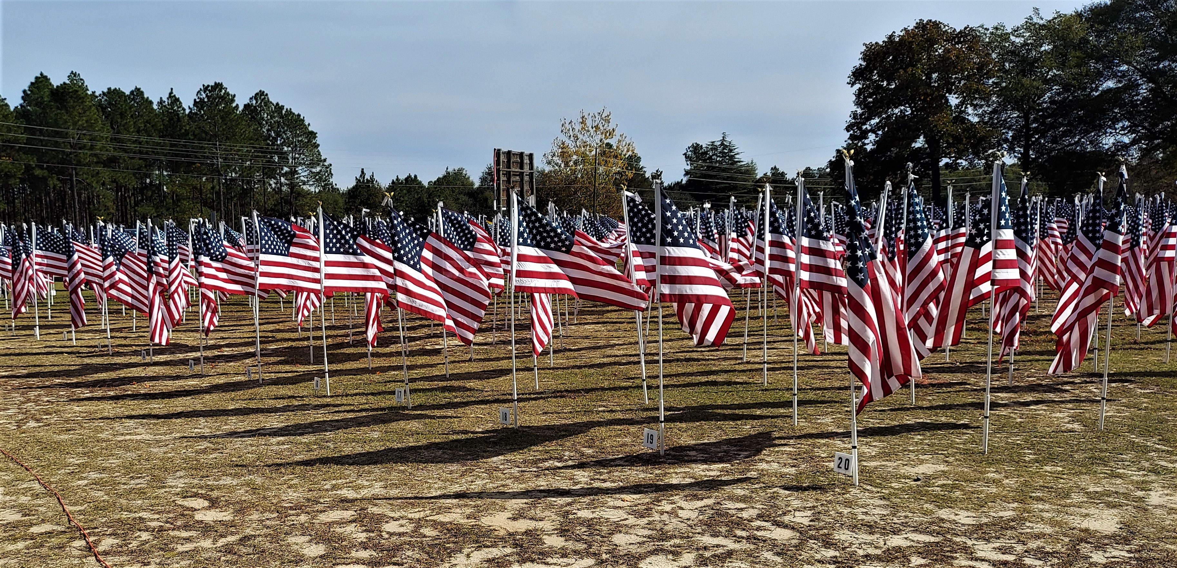

Veterans Field of Honor

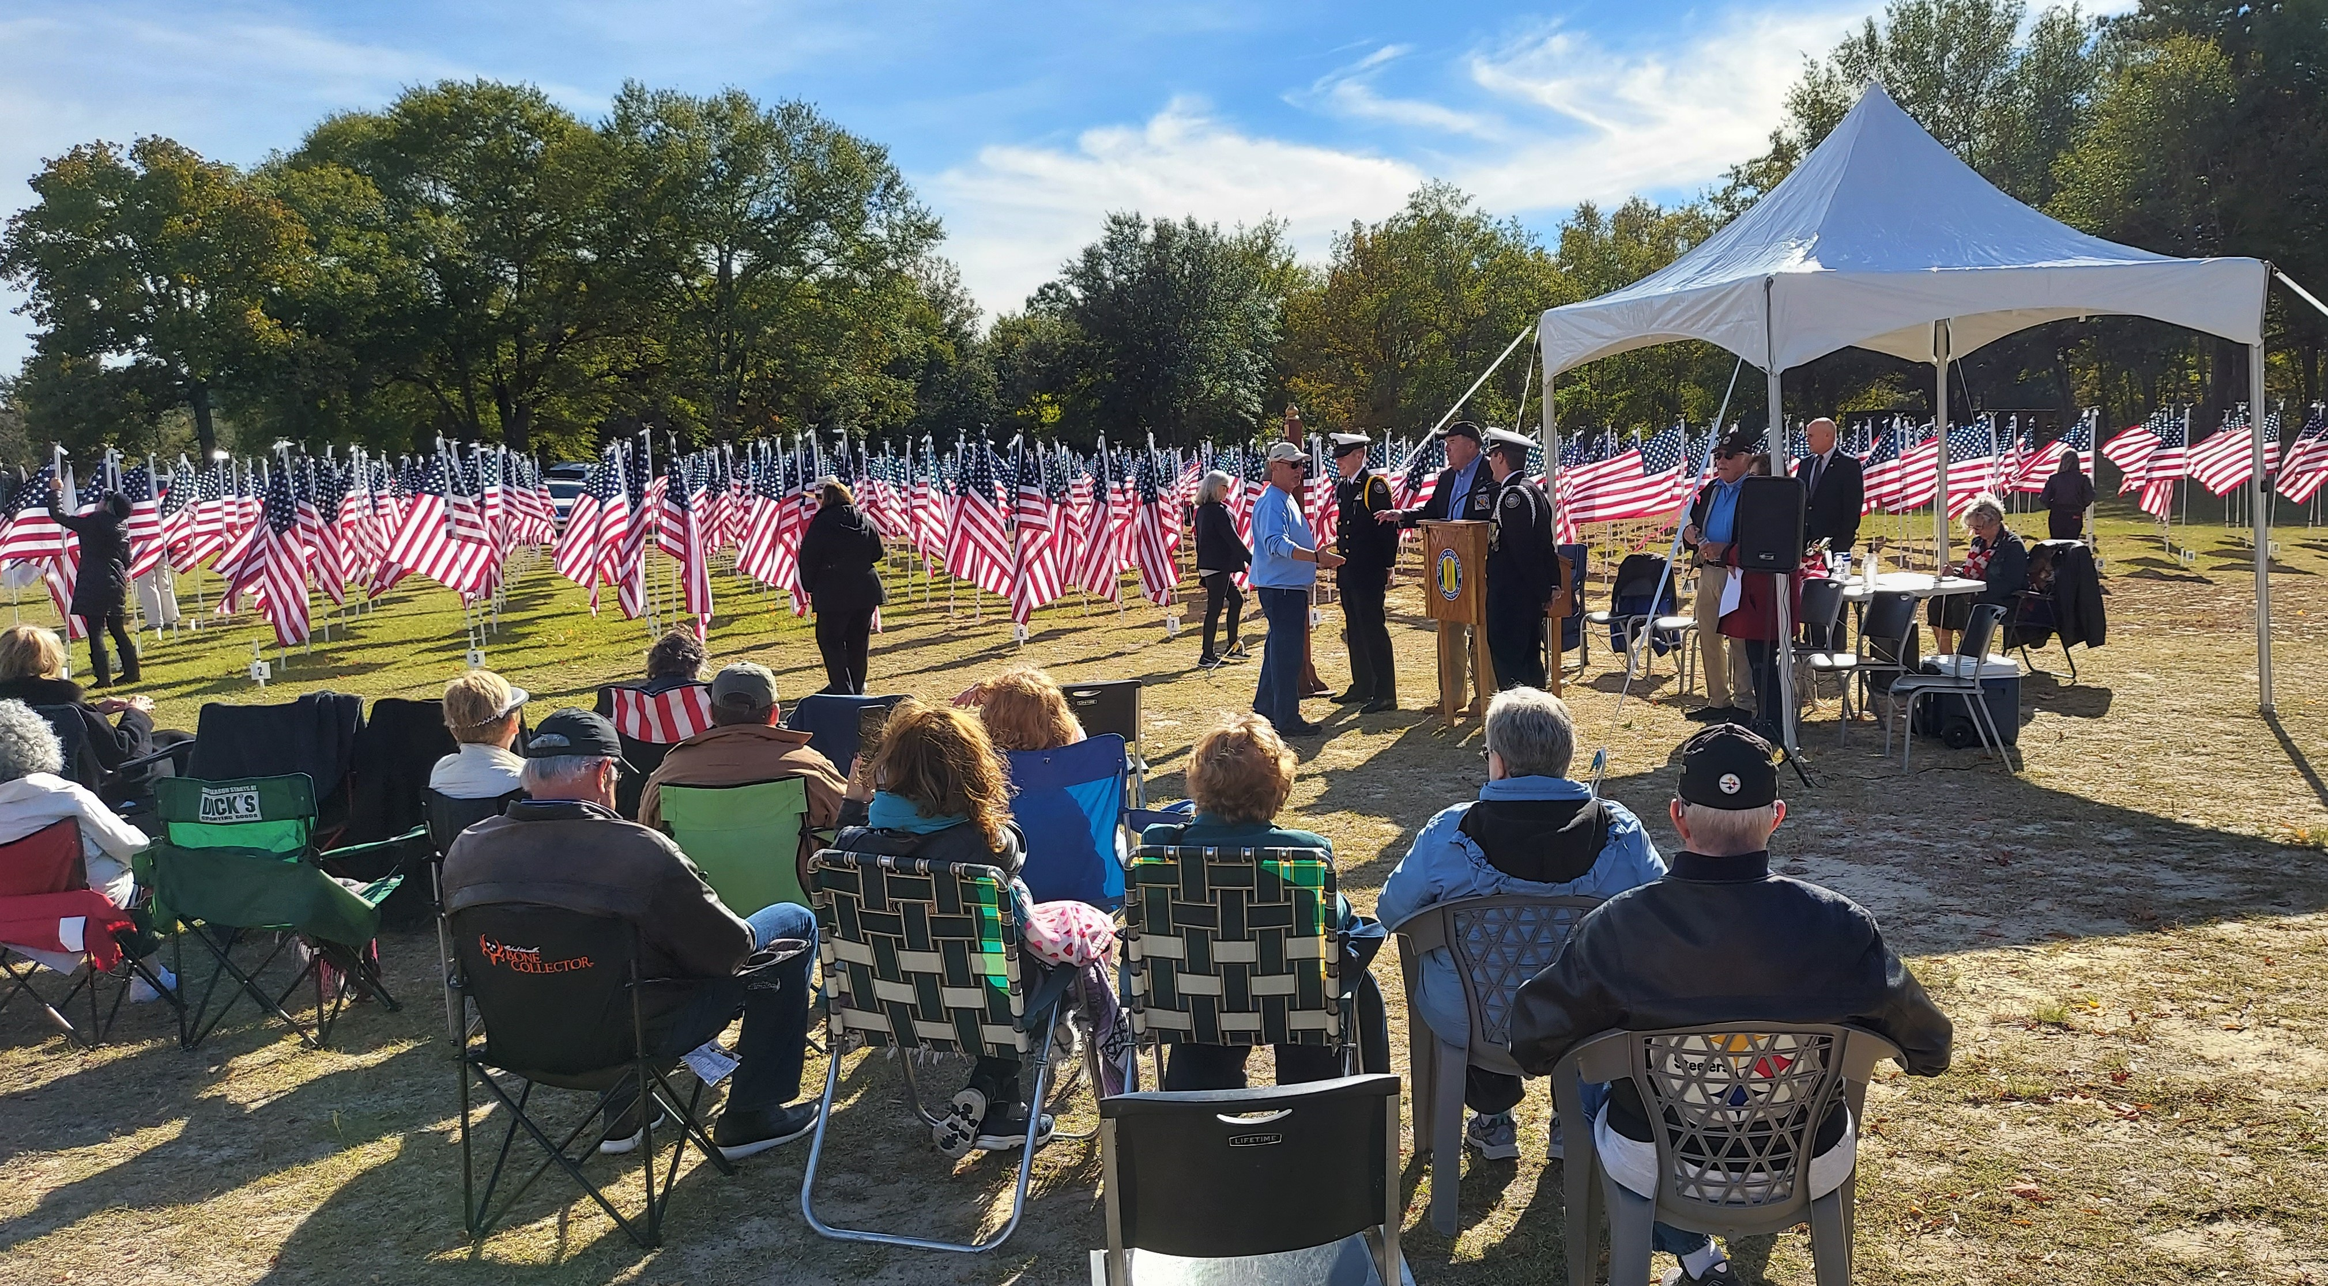
The Reading of the Veteran Names in the Field of Honor

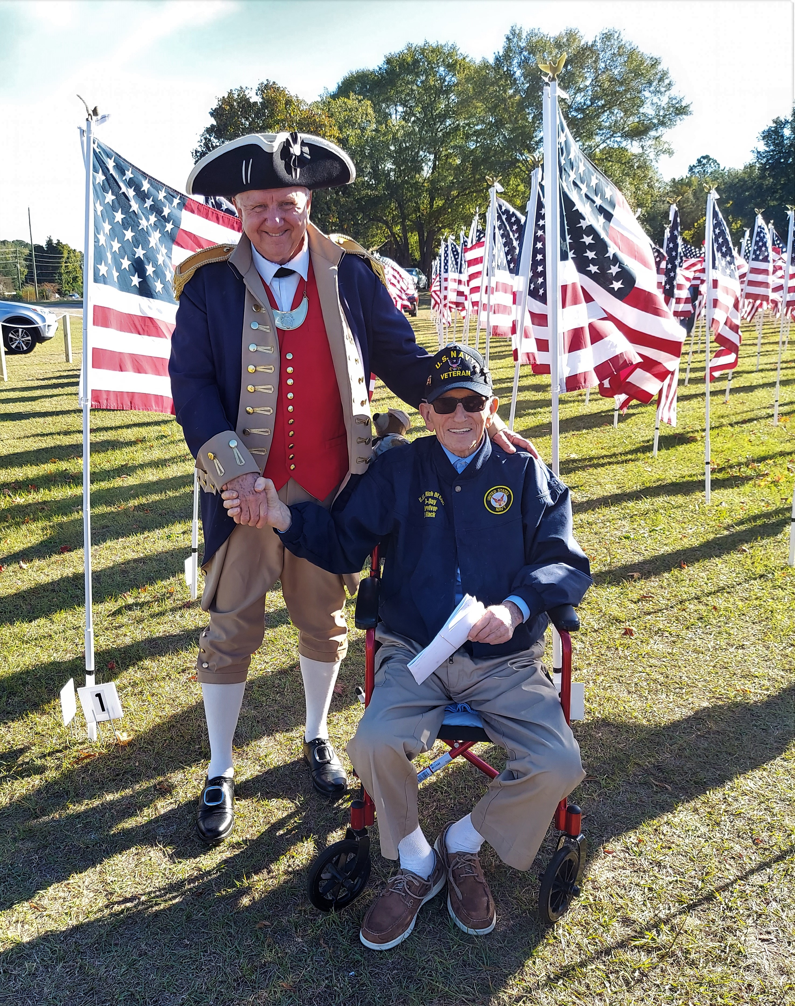

The Honored Guest of this Field of Honor Ceremony was World War II
and The Normandy Invasion Naval Veteran, Mr. Edward Black of Moore County.

