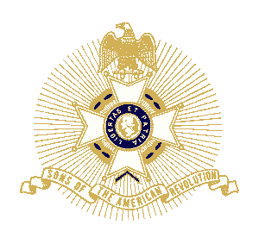

Dear Friend,

Please join the Colson’s Mill Chapter of the Society of Sons of the American Revolution in celebrating the birthday of our founding father,
George Washington

Thursday, February 16 at 6:30pm
Pleasant Grove Baptist Church
(Fellowship Hall)
17236 Frog Pond Road
Oakboro, North Carolina 28129

Guest Speaker
Tom Phlegar
Past President and current member, Mecklenburg Chap, NCSSAR

Mr. Phlegar will share his presentation on
The Southern Campaign of 1780 and 1781

A supper buffet of various Southern dishes will be prepared by
Dwight S. Eudy, Member, Colson’s Mill Chapter
Donations for the meal and the SAR’s ongoing efforts to preserve our Revolutionary War history will be graciously accepted

Sincerely,

Daniel S. Burleson, President, Colson’s Mill Chapter, NCSSAR
Please RSVP me by February 14 with you and your guest’s reservation: dbnut8@yahoo.com or 704-438-1531

Directions to the Colson’s Mill Chapter,
Society of Sons of the American Revolution’s
Annual George Washington Dinner

Pleasant Grove Baptist Church Fellowship Hall
17236 Frog Pond Road
Oakboro, North Carolina 28129
From Albemarle
- Go WEST on NC HWY 24/27 toward Frog Pond
(approximately 8 miles from NC HWY 24/27’s intersection with US HWY 52)
- Turn RIGHT onto Frog Pond Road
(approximately .3 miles)
- The Church’s Fellowship Hall will be on your RIGHT
From Charlotte
- Go EAST from I-485 on NC HWY 24/27 (Albemarle Road) toward Albemarle
(approximately 20 miles)
- Turn LEFT onto Frog Pond Road
(approximately .3 miles)
- The Church’s Fellowship Hall will be on your RIGHT
From Salisbury
- Go SOUTH on US HWY 52 toward Albemarle
(approximately 30 miles)
- Go WEST on NC HWY 24/27 toward Frog Pond
(approximately 8 miles)
- Turn RIGHT onto Frog Pond Road
(approximately .3 miles)
- The Church’s Fellowship Hall will be on your RIGHT
From Wadesboro
- Go NORTH on NC HWY 742 toward Frog Pond
(approximately 25 miles)
- Turn RIGHT onto NC HWY 24/27
(approximately 2.5 miles)
- Turn LEFT onto Frog Pond Road
(approximately .3 miles)
- The Church’s Fellowship Hall will be on your RIGHT
Call Daniel Burleson if you are lost or have any questions: 704-438-1531

